

CAPSTONE PROJECT REPORT
Report 4 – Software Design Specification

– Hanoi, Fall 2025 –

Table of Contents
I. Record of Changes 9
II. Software Design Document 10
1. System Design 10
1.1 System Architecture 10
1.2 Package Diagram 12
2. Database Design 14
2.1. Accounts 15
2.2. Roles 16
2.3. Account_roles 16
2.4. Permissions 17
2.5. Role_permission 17
2.6. Customers 17
2.7. Categories 18
2.8. Suppliers 18
2.9. Products 19
2.10. Product_price 20
2.11. Purchase_order 20
2.12. Purchase_order_detail 21
2.13. Inventory 21
2.14. Inventory_transaction 22
2.15. Orders 23
2.16. Order_detail 23
2.17. Payments 24
2.18. Promotions 25
2.19. Promotion_product 26
3. Detailed Design 27
3.1 Authentication 27
3.1.1 Log in 27
3.1.1.1. Class Diagram 27
3.1.1.2. Sequence Diagram 27
3.1.2 Log out 28
3.1.2.1. Class Diagram 28
3.1.2.2. Sequence Diagram 29
3.1.3 Forgot password 29
3.1.3.1. Class Diagram 29
3.1.3.2. Sequence Diagram 30
3.1.4 Change password 30
3.1.4.1. Class Diagram 30
3.1.4.2. Sequence Diagram 31
3.2 Category management 31
3.2.1 View category list 31
3.2.1.1. Class Diagram 31
3.2.1.2. Sequence Diagram 32
3.2.2 Create category 32
3.2.2.1. Class Diagram 32
3.2.2.2. Sequence Diagram 33
3.2.3 Update category 33
3.2.3.1. Class Diagram 33
3.2.3.2. Sequence Diagram 34
3.2.4 Search category 34
3.2.4.1. Class Diagram 34
3.2.4.2. Sequence Diagram 35
3.2.5 Delete category 35
3.2.5.1. Class Diagram 35
3.2.5.2. Sequence Diagram 36
3.3 Product management 36
3.3.1 View product list 36
3.3.1.1. Class Diagram 36
3.3.1.2. Sequence Diagram 37
3.3.2 View product details 37
3.3.2.1. Class Diagram 37
3.3.2.2. Sequence Diagram 38
3.3.3 Create product 38
3.3.3.1. Class Diagram 38
3.3.3.2. Sequence Diagram 39
3.3.4 Update product 40
3.3.4.1. Class Diagram 40
3.3.4.2. Sequence Diagram 40
3.3.5 Search product 40
3.3.5.1. Class Diagram 40
3.3.5.2. Sequence Diagram 41
3.3.6 Delete product 42
3.3.6.1. Class Diagram 42
3.3.6.2. Sequence Diagram 42
3.4 Order management 43
3.4.1 View order list 43
3.4.1.1. Class Diagram 43
3.4.1.2. Sequence Diagram 44
3.4.2 Create orders 44
3.4.2.1. Class Diagram 44
3.4.2.2. Sequence Diagram 45
3.4.3 View order details 46
3.4.3.1. Class Diagram 46
3.4.3.2. Sequence Diagram 47
3.4.4 Update order 47
3.4.4.1. Class Diagram 47
3.4.4.2. Sequence Diagram 48
3.4.5 Cancel order 49
3.4.4.1. Class Diagram 49
3.4.4.2. Sequence Diagram 50
3.5 Account management 50
3.5.1 View account list 50
3.5.1.1. Class Diagram 50
3.5.1.2. Sequence Diagram 51
3.5.2 View account details 52
3.5.2.1. Class Diagram 52
3.5.2.2. Sequence Diagram 52
3.5.3 Add new account 53
3.5.3.1. Class Diagram 53
3.5.3.2. Sequence Diagram 53
3.5.4 Edit account 54
3.5.4.1. Class Diagram 54
3.5.4.2. Sequence Diagram 54
3.5.5 Delete account 55
3.5.5.1. Class Diagram 55
3.5.5.2. Sequence Diagram 55
3.5.6 Search account 56
3.5.6.1. Class Diagram 56
3.5.6.2. Sequence Diagram 56
3.6 Role Management 57
3.6.1 View role list 57
3.6.1.1. Class Diagram 57
3.6.1.2. Sequence Diagram 57
3.6.2 Add new role 58
3.6.2.1. Class Diagram 58
3.6.2.2. Sequence Diagram 58
3.6.3 Edit role 59
3.6.3.1. Class Diagram 59
3.6.3.2. Sequence Diagram 59
3.6.4 Delete role 60
3.6.4.1. Class Diagram 60
3.6.4.2. Sequence Diagram 60
3.7 Supplier Management 61
3.7.1 View supplier list 61
3.7.1.1. Class Diagram 61
3.7.1.2. Sequence Diagram 62
3.7.2 View supplier details 62
3.7.2.1. Class Diagram 62
3.7.2.2. Sequence Diagram 63
3.7.3 Create supplier 63
3.7.3.1. Class Diagram 63
3.7.3.2. Sequence Diagram 64
3.7.4 Update supplier 64
3.7.4.1. Class Diagram 64
3.7.4.2. Sequence Diagram 65
3.7.5 Search supplier 65
3.7.5.1. Class Diagram 65
3.7.5.2. Sequence Diagram 66
3.7.6 Delete supplier 66
3.7.6.1. Class Diagram 66
3.7.6.2. Sequence Diagram 67
3.8 Customer Management 67
3.8.1 View customer list 67
3.8.1.1. Class Diagram 67
3.8.1.2. Sequence Diagram 68
3.8.2 Add new customer 68
3.8.2.1. Class Diagram 68
3.8.2.2. Sequence Diagram 69
3.8.3 Edit customer 69
3.8.3.1. Class Diagram 69
3.8.3.2. Sequence Diagram 70
3.8.4 Delete customer 70
3.8.4.1. Class Diagram 70
3.8.4.2. Sequence Diagram 71
3.8.5 Search customer 71
3.8.5.1. Class Diagram 71
3.8.5.2. Sequence Diagram 72
3.8.6 View customer detail 72
3.8.6.1. Class Diagram 72
3.8.6.2. Sequence Diagram 73
3.9 Purchase Order Management 73
3.9.1 View purchase order list 74
3.9.1.1. Class Diagram 74
3.9.1.2. Sequence Diagram 74
3.9.2 View purchase order detail 75
3.9.2.1. Class Diagram 75
3.9.2.2. Sequence Diagram 75
3.9.3 Create purchase order 76
3.9.3.1. Class Diagram 76
3.9.3.2. Sequence Diagram 76
3.9.4 Update purchase order 77
3.9.4.1. Class Diagram 77
3.9.4.2. Sequence Diagram 77
3.9.5 Search purchase order 78
3.9.5.1. Class Diagram 78
3.9.5.2. Sequence Diagram 78
3.10 Promotion Management 79
3.10.1 View promotion list 79
3.10.1.1. Class Diagram 79
3.10.1.2. Sequence Diagram 79
3.10.2 View promotion detail 80
3.10.2.1. Class Diagram 80
3.10.2.2. Sequence Diagram 81
3.10.3 Add new promotion 81
3.10.3.1. Class Diagram 81
3.10.3.2. Sequence Diagram 82
3.10.4 Edit promotion 82
3.10.4.1. Class Diagram 82
3.10.4.2. Sequence Diagram 83
3.10.5 Search promotion 83
3.10.5.1. Class Diagram 83
3.10.5.2. Sequence Diagram 84
4. Class Specifications 84
4.1 Controller 84
4.1.1 CategoryController 84
4.1.2 ProductController 85
4.1.3 AccountController 87
4.1.4 SupplierController 89
4.1.5 CustomerController 90
4.1.6 OrderController 91
4.1.7 PromotionController 93
4.1.8 CustomerReportController 94
4.1.9 PosShiftController 95
4.1.10 PurchaseOrderController 97
4.2 Service 100
4.1.1 CategoryServiceImpl 100
4.1.2 ProductServiceImpl 101
4.1.3 AccountServiceImpl 104
4.1.4 SupplierServiceImpl 106
4.1.5 CustomerServiceImpl 108
4.1.6 OrderServiceImpl 110
4.1.7 PromotionServiceImpl 115
4.1.8 PosShiftServiceImpl 118
4.1.9 PurchaseOrderServiceImpl 121
4.3 Entity 124
4.3.1 Account 124
4.3.2 Category 126
4.3.3 Customer 127
4.3.4 Inventory 129
4.3.5 InventoryTransaction 130
4.3.6 Notification 131
4.3.7 Order 133
4.3.8 OrderDetail 135
4.3.9 Payment 137
4.3.10 PosSettings 138
4.3.11 PosShift 140
4.3.12 Product 142
4.3.13 ProductPrice 144
4.3.14 Promotion 146
4.3.15 PurchaseOrder 147
4.3.16 PurchaseOrderDetail 149
4.3.17 Role 150
4.3.17 Supplier 151

I. Record of Changes
Date | A*  M, D | In charge | Change Description
15/10/2025 | A | NamNV | Added 1.System Design
19/10/2025 | M | NamNV | Modified 1.System Design
19/10/2025 | M | HuyNX | Modified 1.System Design
19/10/2025 | M | DatVV | Modified 2. Database Design
20/10/2025 | M | HuyNX | Modified 1.System Design
26/10/2025 | A | DatVV | Added Category Management
28/10/2025 | A | DuongNT17 | Added Product Management
2/11/2025 | A | DuongNT18 | Added Account Management  Added Role & Permission Management
2/11/2025 | A | DatVV | Added Supplier Management
2/11/2025 | A | DuongNT17 | Added Authentication
3/11/2025 | A | HuyNX | Added Order Management
3/11/2025 | A | DuongNT17 | Added Customer Management
4/11/2025 | A | NamVV | Added Receipt Management
4/11/2025 | A | DuongNT18 | Added Promotion Management
5/11/2025 | A | HuyNX | Added System Interaction
*A - Added M - Modified D - Deleted

II. Software Design Document

1. System Design

1.1 System Architecture
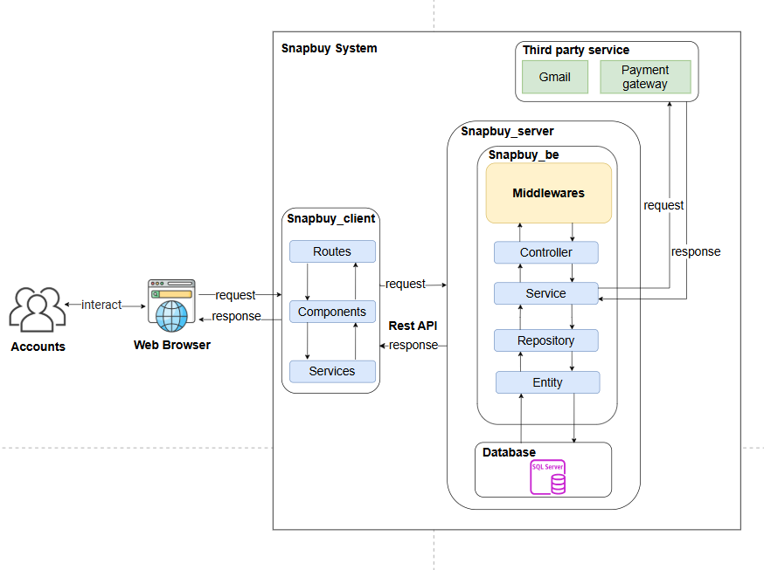
Figure 1.1: Software Architecture
The architecture of the SnapBuy System consists of three main layers and several supporting components that work together to provide a seamless shopping and inventory management experience.
Components of the System:
- Frontend (ReactJS)
  - Description: The client-side interface is developed using ReactJS, allowing users such as Admins, Shop Owners, Sales Staff, and Warehouse Staff to interact with the system for operations like order management, product tracking, and reporting.
  - Interaction: It communicates with the backend (Spring Boot) through RESTful API calls to send and receive data dynamically.
- Backend (Spring Boot)
  - Description: The backend handles all business logic, data processing, and system operations. It follows a layered architecture including Controller, Service, Repository, Entity, and Middleware components to ensure modularity, scalability, and maintainability.
  - Interaction: It processes requests from the frontend, interacts with the database (SQL Server) for data storage and retrieval, and manages integrations with external systems.
- Database (SQL Server)
  - Description: The relational database stores essential system data such as products, orders, customers, inventory, and transaction records.
  - Interaction: The backend communicates with the database through JPA/Hibernate to perform CRUD operations, ensuring data integrity and consistency across all modules.
- Third-Party Integrations
  - Description: The system integrates with external services to enhance functionality and user experience. Examples include Gmail for sending notifications or verification emails, and Payment Gateway services for handling secure online transactions.
  - Interaction: The backend communicates with these third-party services via secure API requests and processes their responses to ensure smooth and reliable operation within the SnapBuy System

1.2 Package Diagram
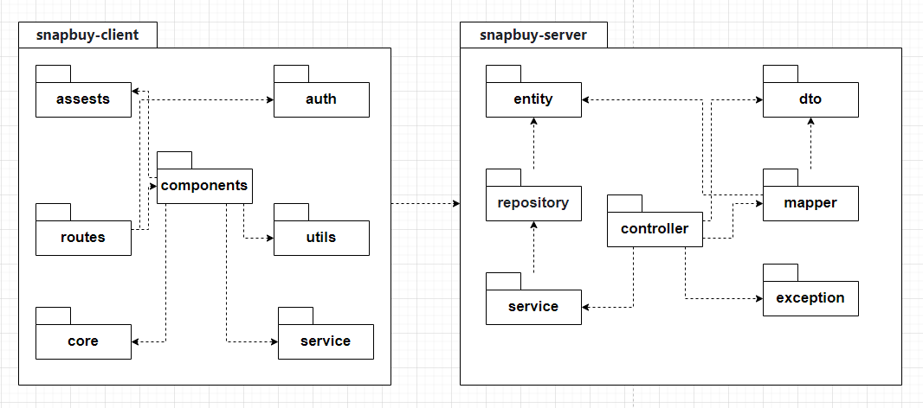
Figure 1.2: Package diagram
Package descriptions

No | Package | Description
01 | snapbuy-client | Contains all frontend components of the SnapBuy system. Responsible for user interface, interactions, API calls to the server, and handling UI logic
02 | assets | Stores static resources such as images, icons, fonts, CSS, and configuration files used in the user interface.
03 | auth | Manages user authentication and authorization, including login, registration, token storage, and access control.
04 | components | Contains reusable UI components such as buttons, forms, modals, and tables for building consistent interfaces.
05 | routes | Defines application routing paths and manages navigation between pages in the client.
06 | core | Provides the core structure, overall configurations, and initialization components for the client application.
07 | utils | Includes common helper functions for data processing, formatting, validation, and other shared utilities.
08 | service(fe) | Handles communication with the backend APIs, defining methods for HTTP requests (e.g., using fetch or axios).
09 | snapbuy-server | Contains all backend components of the SnapBuy system. Handles business logic, database access, object mapping, and responses to client requests.
10 | entity | Defines data model classes (entities) that correspond to database tables.
11 | repository | Data access layer that provides CRUD operations for entities interacting with the database.
12 | service(be) | Contains main business logic; processes data from repositories and passes results to controllers.
13 | controller | Handles incoming HTTP requests from the client, calls the appropriate services, and returns responses.
14 | dto | Defines Data Transfer Objects used to exchange data between client and server, separated from entities.
15 | mapper | Converts data between entities and DTOs to ensure consistency across layers.
16 | exception | Manages and handles exceptions, defining error messages and responses returned to the client.
Table 2.1. Package descriptions

2. Database Design
Link diagram: diagram
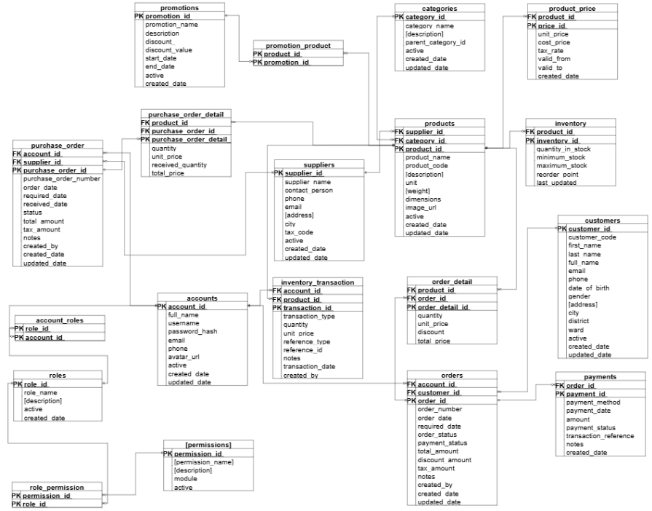
Figure 1.3: Database Design
No | Table | Description
1 | accounts | Primary key: account_id
2 | roles | Primary key: role_id
3 | account_roles | Primary key: (account_id, role_id)  Foreign key: account_id, role_id
4 | permissions | Primary key: permission_id
5 | role_permission | Primary key: (role_id, permission_id)  Foreign key: role_id, permission_id
6 | customers | Primary key: customer_id
7 | categories | Primary key: category_id  Foreign key: parent_category_id
8 | suppliers | Primary key: supplier_id
9 | products | Primary key: product_id  Foreign key: category_id, supplier_id
10 | product_price | Primary key: price_id  Foreign key: product_id
11 | purchase_order | Primary key: purchase_order_id  Foreign key: supplier_id, account_id
12 | purchase_order_detail | Primary key: purchase_order_detail_id  Foreign key: purchase_order_id, product_id
13 | inventory | Primary key: inventory_id  Foreign key: product_id
14 | inventory_transaction | Primary key: transaction_id  Foreign key: product_id, account_id
15 | orders | Primary key: order_id  Foreign key: customer_id, account_id
16 | order_detail | Primary key: order_detail_id  Foreign key: order_id, product_id
17 | payments | Primary key: payment_id  Foreign key: order_id
18 | promotions | Primary key: promotion_id
19 | promotion_product | Primary key: (promotion_id, product_id)  Foreign key: promotion_id, product_id
Table 2.2. Table descriptions

2.1. Accounts
Field Name | Data Type | Key | Allow Null | Description | Note
account_id | UNIQUEIDENTIFIER | Primary Key | No | Unique identifier for each user account. | Default NEWID()
full_name | NVARCHAR(100) |  | No | Full name of the account owner.
username | NVARCHAR(50) | Unique | No | Login username. | Must be unique
password_hash | NVARCHAR(255) |  | No | Hashed password for authentication.
email | NVARCHAR(100) | Unique | No | User email address. | Must be unique
phone | NVARCHAR(15) |  | Yes | Contact phone number.
avatar_url | NVARCHAR(500) |  | Yes | URL to profile avatar image.
active | BIT |  | Yes | Indicates if the account is active. | Default 1
created_date | DATETIME2 |  | Yes | Record creation timestamp. | Default GETDATE()
updated_date | DATETIME2 |  | Yes | Last update timestamp. | Default GETDATE()
Table 2.3. account table design

2.2. Roles
Field Name | Data Type | Key | Allow Null | Description | Note
role_id | UNIQUEIDENTIFIER | Primary Key | No | Unique role identifier. | Default NEWID()
role_name | NVARCHAR(50) |  | No | Role name (e.g., Admin, Sales Staff).
description | NVARCHAR(MAX) |  | Yes | Description of the role.
active | BIT |  | Yes | Indicates if the role is active. | Default 1
created_date | DATETIME2 |  | Yes | Creation timestamp. | Default GETDATE()
Table 2.4. roles table design

2.3. Account_roles
Field Name | Data Type | Key | Allow Null | Description | Note
account_id | UNIQUEIDENTIFIER | Foreign Key | No | Links to accounts(account_id).
role_id | UNIQUEIDENTIFIER | Foreign Key | No | Links to roles(role_id).
— | — | Primary Key | — | Composite key: (account_id, role_id).
Table 2.5. account_roles table design

2.4. Permissions
Field Name | Data Type | Key | Allow Null | Description | Note
permission_id | UNIQUEIDENTIFIER | Primary Key | No | Unique permission identifier. | Default NEWID()
permission_name | NVARCHAR(50) |  | No | Name of the permission.
description | NVARCHAR(200) |  | Yes | Description of the permission.
module | NVARCHAR(50) |  | Yes | Associated module name.
active | BIT |  | Yes | Status of the permission. | Default 1
Table 2.6. permissions table design

2.5. Role_permission
Field Name | Data Type | Key | Allow Null | Description | Note
role_id | UNIQUEIDENTIFIER | Foreign Key | No | References roles(role_id).
permission_id | UNIQUEIDENTIFIER | Foreign Key | No | References permissions(permission_id).
— | — | Primary Key | — | Composite key: (role_id, permission_id).
Table 2.7. role_permissions table design

2.6. Customers
Field Name | Data Type | Key | Allow Null | Description | Note
customer_id | UNIQUEIDENTIFIER | Primary Key | No | Unique identifier for customer. | Default NEWID()
customer_code | NVARCHAR(20) | Unique | Yes | Customer code. | Auto-generated
full_name | NVARCHAR(50) |  | Yes | Customer’s full name.
phone | NVARCHAR(20) |  | Yes | Customer’s phone number.
gender | NVARCHAR(6) |  | Yes | Gender (Male/Female).
active | BIT |  | Yes | Indicates if the customer is active. | Default 1
created_date | DATETIME2 |  | Yes | Record creation date. | Default GETDATE()
updated_date | DATETIME2 |  | Yes | Last update date. | Default GETDATE()
Table 2.8. customers table design

2.7. Categories
Field Name | Data Type | Key | Allow Null | Description | Note
category_id | UNIQUEIDENTIFIER | Primary Key | No | Unique category identifier. | Default NEWID()
category_name | NVARCHAR(100) |  | No | Name of category.
description | NVARCHAR(MAX) |  | Yes | Description of category.
parent_category_id | UNIQUEIDENTIFIER | Foreign Key | Yes | Parent category reference. | References categories(category_id)
active | BIT |  | Yes | Status of category. | Default 1
created_date | DATETIME2 |  | Yes | Created timestamp. | Default GETDATE()
updated_date | DATETIME2 |  | Yes | Last updated timestamp. | Default GETDATE()
Table 2.9. categories table design

2.8. Suppliers
Field Name | Data Type | Key | Allow Null | Description | Note
supplier_id | UNIQUEIDENTIFIER | Primary Key | No | Unique supplier identifier. | Default NEWID()
supplier_code | NVARCHAR(20) | Unique | Yes | Supplier code.
supplier_name | NVARCHAR(100) |  | No | Supplier name.
phone | NVARCHAR(20) |  | Yes | Supplier phone number.
email | NVARCHAR(100) |  | Yes | Supplier email.
address | NVARCHAR(100) |  | Yes | Supplier address.
city | NVARCHAR(50) |  | Yes | City.
ward | NVARCHAR(50) |  | Yes | Ward.
active | BIT |  | Yes | Indicates active status. | Default 1
created_date | DATETIME2 |  | Yes | Record creation date. | Default GETDATE()
updated_date | DATETIME2 |  | Yes | Last update date. | Default GETDATE()
Table 2.10. suppliers table design

2.9. Products
Field Name | Data Type | Key | Allow Null | Description | Note
product_id | UNIQUEIDENTIFIER | Primary Key | No | Unique product identifier. | Default NEWID()
product_name | NVARCHAR(200) |  | No | Product name.
product_code | NVARCHAR(50) | Unique | No | Product code. | Must be unique
description | NVARCHAR(MAX) |  | Yes | Product description.
category_id | UNIQUEIDENTIFIER | Foreign Key | No | References category. | FK → categories(category_id)
supplier_id | UNIQUEIDENTIFIER | Foreign Key | Yes | References supplier. | FK → suppliers(supplier_id)
unit | NVARCHAR(20) |  | Yes | Measurement unit (piece, box…). | Default Piece
dimensions | NVARCHAR(50) |  | Yes | Product size/dimensions.
image_url | NVARCHAR(500) |  | Yes | Product image URL.
active | BIT |  | Yes | Status of product. | Default 1
created_date | DATETIME2 |  | Yes | Creation timestamp. | Default GETDATE()
updated_date | DATETIME2 |  | Yes | Update timestamp. | Default GETDATE()
Table 2.11. product table design

2.10. Product_price
Field Name | Data Type | Key | Allow Null | Description | Note
price_id | UNIQUEIDENTIFIER | Primary Key | No | Unique price record ID. | Default NEWID()
product_id | UNIQUEIDENTIFIER | Foreign Key | No | Linked product ID. | FK → products(product_id)
unit_price | DECIMAL(18,2) |  | No | Selling price.
cost_price | DECIMAL(18,2) |  | Yes | Purchase cost.
tax_rate | DECIMAL(5,2) |  | Yes | Applicable tax rate. | Default 0
valid_from | DATETIME2 |  | No | Start date of validity. | Default GETDATE()
valid_to | DATETIME2 |  | Yes | End date of validity.
created_date | DATETIME2 |  | Yes | Creation timestamp. | Default GETDATE()
Table 2.12. product_price table design

2.11. Purchase_order
Field Name | Data Type | Key | Allow Null | Description | Note
purchase_order_id | UNIQUEIDENTIFIER | Primary Key | No | Unique purchase order ID. | Default NEWID()
purchase_order_number | NVARCHAR(20) | Unique | No | Unique order number.
supplier_id | UNIQUEIDENTIFIER | Foreign Key | No | Linked supplier. | FK → suppliers(supplier_id)
account_id | UNIQUEIDENTIFIER | Foreign Key | No | Created by account. | FK → accounts(account_id)
order_date | DATETIME2 |  | Yes | Order creation date. | Default GETDATE()
received_date | DATETIME2 |  | Yes | Goods received date.
status | NVARCHAR(20) |  | Yes | Order status. | Default PENDING
total_amount | DECIMAL(18,2) |  | No | Total order value. | Default 0
tax_amount | DECIMAL(18,2) |  | Yes | Total tax amount. | Default 0
notes | NVARCHAR(500) |  | Yes | Remarks.
created_date | DATETIME2 |  | Yes | Record creation timestamp. | Default GETDATE()
updated_date | DATETIME2 |  | Yes | Record update timestamp. | Default GETDATE()
Table 2.13. purchase_order table design

2.12. Purchase_order_detail
Field Name | Data Type | Key | Allow Null | Description | Note
purchase_order_detail_id | UNIQUEIDENTIFIER | Primary Key | No | Unique detail ID. | Default NEWID()
purchase_order_id | UNIQUEIDENTIFIER | Foreign Key | No | Related purchase order. | FK → purchase_order(purchase_order_id)
product_id | UNIQUEIDENTIFIER | Foreign Key | No | Product reference. | FK → products(product_id)
quantity | INT |  | No | Ordered quantity.
unit_price | DECIMAL(18,2) |  | No | Product price per unit.
received_quantity | INT |  | Yes | Received quantity. | Default 0
Table 2.14. purchase_order_detail table design

2.13. Inventory
Field Name | Data Type | Key | Allow Null | Description | Note
inventory_id | UNIQUEIDENTIFIER | Primary Key | No | Unique inventory ID. | Default NEWID()
product_id | UNIQUEIDENTIFIER | Foreign Key | No | Linked product. | FK → products(product_id)
quantity_in_stock | INT |  | No | Quantity in stock. | Default 0
minimum_stock | INT |  | Yes | Minimum stock level.
maximum_stock | INT |  | Yes | Maximum stock level.
reorder_point | INT |  | Yes | Reorder alert point.
last_updated | DATETIME2 |  | Yes | Last inventory update. | Default GETDATE()
Table 2.15. inventory table design

2.14. Inventory_transaction
Field Name | Data Type | Key | Allow Null | Description | Note
transaction_id | UNIQUEIDENTIFIER | Primary Key | No | Unique transaction record. | Default NEWID()
product_id | UNIQUEIDENTIFIER | Foreign Key | No | Related product. | FK → products(product_id)
account_id | UNIQUEIDENTIFIER | Foreign Key | No | Processed by the user. | FK → accounts(account_id)
transaction_type | NVARCHAR(20) |  | No | Type of transaction (IMPORT, EXPORT).
quantity | INT |  | No | Quantity involved.
unit_price | DECIMAL(18,2) |  | Yes | Unit price.
reference_type | NVARCHAR(20) |  | Yes | Reference source (Order, Receipt).
reference_id | UNIQUEIDENTIFIER |  | Yes | ID of the reference record.
notes | NVARCHAR(500) |  | Yes | Remarks or details.
transaction_date | DATETIME2 |  | Yes | Transaction timestamp. | Default GETDATE()
Table 2.16. inventory_transaction table design

2.15. Orders
Field Name | Data Type | Key | Allow Null | Description | Note
order_id | UNIQUEIDENTIFIER | Primary Key | No | Unique order identifier. | Default NEWID()
order_number | NVARCHAR(20) | Unique | No | Order number.
customer_id | UNIQUEIDENTIFIER | Foreign Key | No | Customer reference. | FK → customers(customer_id)
account_id | UNIQUEIDENTIFIER | Foreign Key | No | Created by staff. | FK → accounts(account_id)
order_date | DATETIME2 |  | Yes | Order creation date. | Default GETDATE()
order_status | NVARCHAR(20) |  | Yes | Order status. | Default PENDING
payment_status | NVARCHAR(20) |  | Yes | Payment status. | Default UNPAID
total_amount | DECIMAL(18,2) |  | No | Total order value. | Default 0
discount_amount | DECIMAL(18,2) |  | Yes | Discount amount. | Default 0
tax_amount | DECIMAL(18,2) |  | Yes | Tax amount. | Default 0
notes | NVARCHAR(500) |  | Yes | Additional notes.
created_date | DATETIME2 |  | Yes | Record creation date. | Default GETDATE()
updated_date | DATETIME2 |  | Yes | Record update date. | Default GETDATE()
Table 2.17. orders table design

2.16. Order_detail
Field Name | Data Type | Key | Allow Null | Description | Note
order_detail_id | UNIQUEIDENTIFIER | Primary Key | No | Unique identifier for each order line item. | Default NEWID()
order_id | UNIQUEIDENTIFIER | Foreign Key | No | Reference to the parent order. | FK → orders(order_id)
product_id | UNIQUEIDENTIFIER | Foreign Key | No | Reference to the purchased product. | FK → products(product_id)
quantity | INT |  | No | Number of product units purchased. | Must be ≥ 1
unit_price | DECIMAL(18,2) |  | No | Selling price per unit at the time of order.
discount | DECIMAL(5,2) |  | Yes | Discount percentage per item. | Default 0
total_price | AS (quantity * unit_price * (1 - discount / 100)) |  | No | Computed column for total amount per line item. | Auto-calculated
Table 2.18. order_detail table design

2.17. Payments
Field Name | Data Type | Key | Allow Null | Description | Note
payment_id | UNIQUEIDENTIFIER | Primary Key | No | Unique payment record identifier. | Default NEWID()
order_id | UNIQUEIDENTIFIER | Foreign Key | No | Related sales order. | FK → orders(order_id)
account_id | UNIQUEIDENTIFIER | Foreign Key | No | Processed by staff account. | FK → accounts(account_id)
payment_method | NVARCHAR(50) |  | No | Payment method (Cash, Bank Transfer, Card…).
payment_status | NVARCHAR(20) |  | Yes | Payment status (Paid, Pending, Failed). | Default Pending
amount | DECIMAL(18,2) |  | No | Paid amount. | Must be ≥ 0
payment_date | DATETIME2 |  | Yes | Payment timestamp. | Default GETDATE()
reference_number | NVARCHAR(50) | Unique | Yes | Transaction reference number. | For bank/card trace
notes | NVARCHAR(255) |  | Yes | Additional remarks.
created_date | DATETIME2 |  | Yes | Record creation date. | Default GETDATE()
Table 2.19. payments table design

2.18. Promotions
Field Name | Data Type | Key | Allow Null | Description | Note
promotion_id | UNIQUEIDENTIFIER | Primary Key | No | Unique promotion campaign ID. | Default NEWID()
promotion_code | NVARCHAR(20) | Unique | No | Promotion code for identification. | Used in search/filter
promotion_name | NVARCHAR(100) |  | No | Name of the promotion campaign.
description | NVARCHAR(MAX) |  | Yes | Promotion details/conditions.
start_date | DATETIME2 |  | No | Promotion start date.
end_date | DATETIME2 |  | No | Promotion end date.
discount_type | NVARCHAR(20) |  | Yes | Type of discount (Percentage, Fixed). | Default Percentage
discount_value | DECIMAL(18,2) |  | No | Discount value amount or percentage.
min_order_value | DECIMAL(18,2) |  | Yes | Minimum order amount to apply. | Default 0
active | BIT |  | Yes | Indicates if the promotion is currently active. | Default 1
created_by | UNIQUEIDENTIFIER | Foreign Key | No | Created by account ID. | FK → accounts(account_id)
created_date | DATETIME2 |  | Yes | Record creation date. | Default GETDATE()
updated_date | DATETIME2 |  | Yes | Last update date. | Default GETDATE()
Table 2.20. promotions table design

2.19. Promotion_product
Field Name | Data Type | Key | Allow Null | Description | Note
promotion_product_id | UNIQUEIDENTIFIER | Primary Key | No | Unique identifier for each product assigned to a promotion. | Default NEWID()
promotion_id | UNIQUEIDENTIFIER | Foreign Key | No | Linked promotion campaign. | FK → promotions(promotion_id)
product_id | UNIQUEIDENTIFIER | Foreign Key | No | Linked product under promotion. | FK → products(product_id)
discount_value | DECIMAL(18,2) |  | Yes | Product-specific discount value (if overridden). | Optional
created_date | DATETIME2 |  | Yes | Record creation timestamp. | Default GETDATE()
updated_date | DATETIME2 |  | Yes | Record update timestamp. | Default GETDATE()
Table 2.21. promotions_product table design

3. Detailed Design

3.1 Authentication

3.1.1 Log in

3.1.1.1. Class Diagram
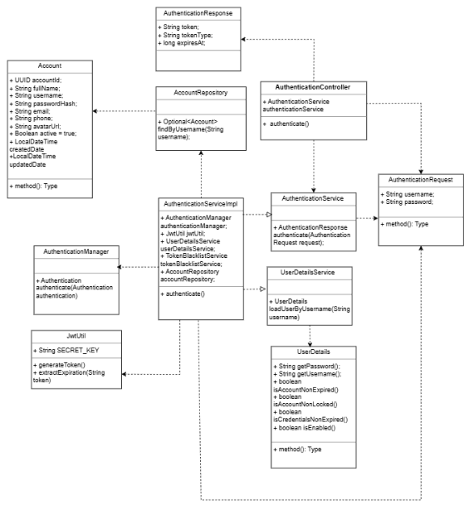

3.1.1.2. Sequence Diagram

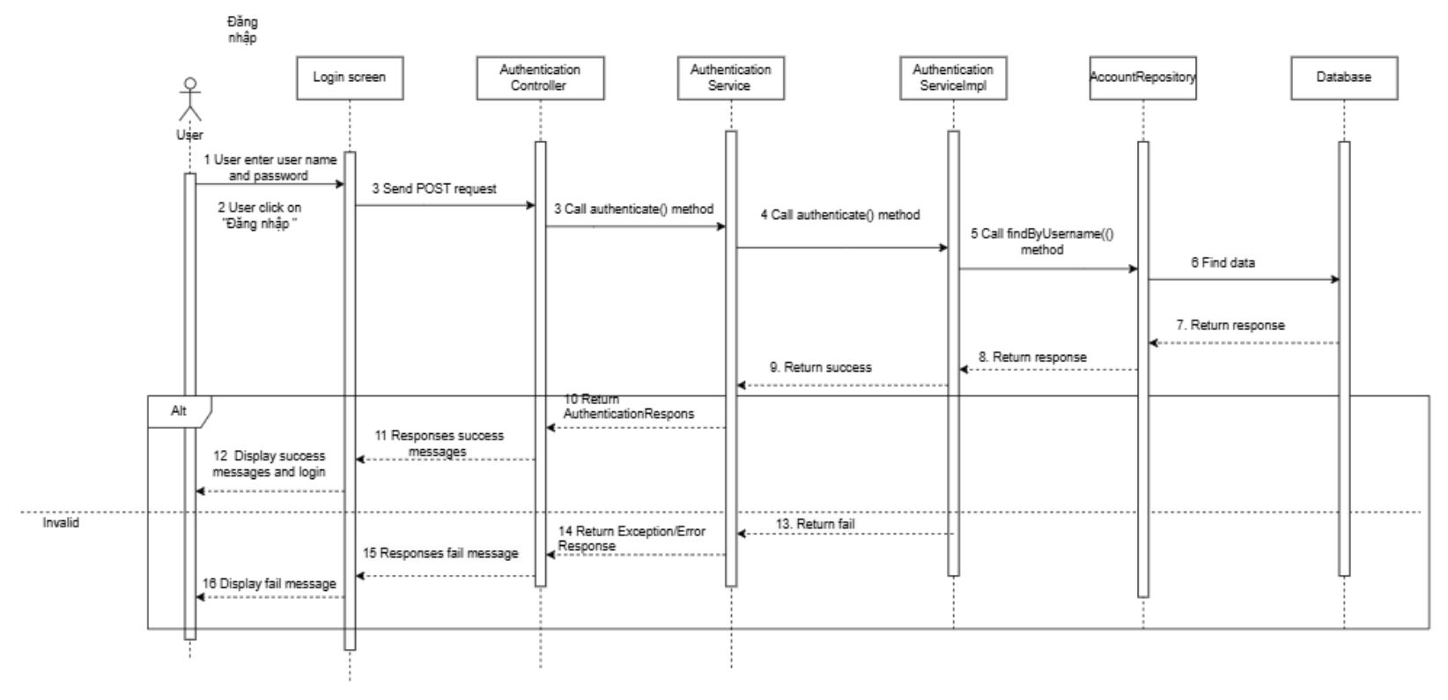

3.1.2 Log out

3.1.2.1. Class Diagram

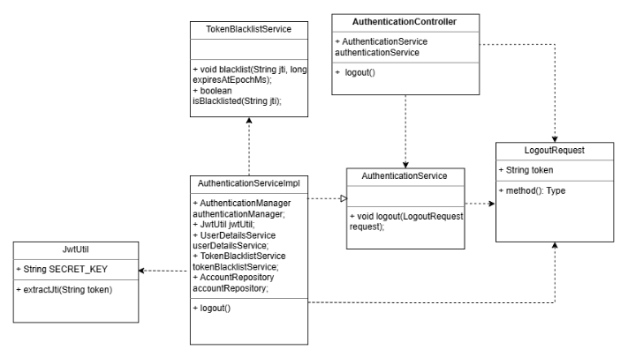

3.1.2.2. Sequence Diagram
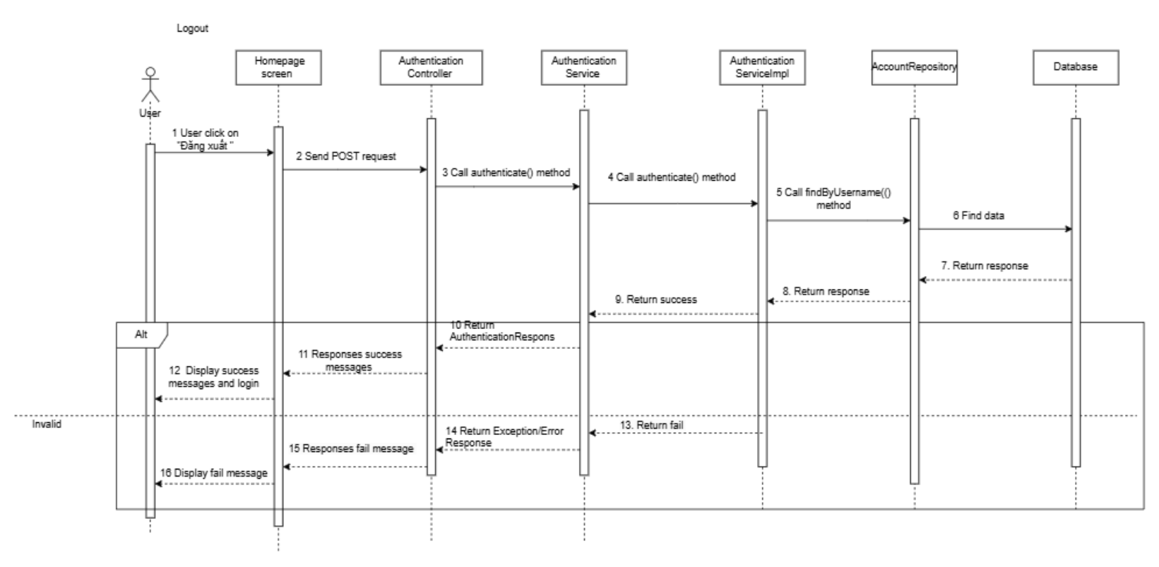

3.1.3 Forgot password

3.1.3.1. Class Diagram
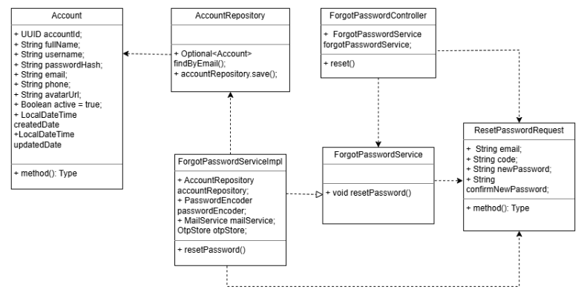

3.1.3.2. Sequence Diagram
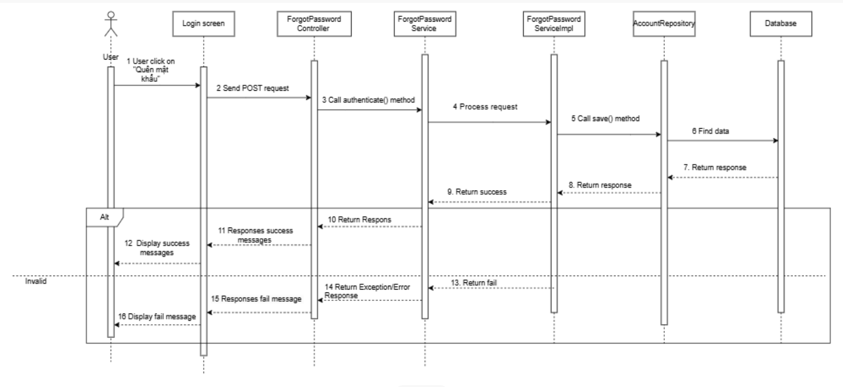

3.1.4 Change password

3.1.4.1. Class Diagram
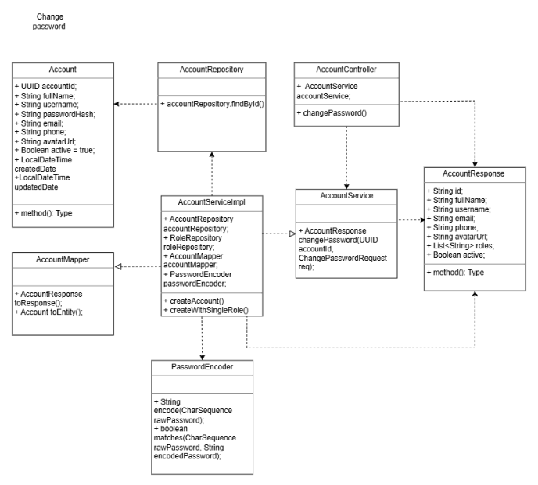

3.1.4.2. Sequence Diagram
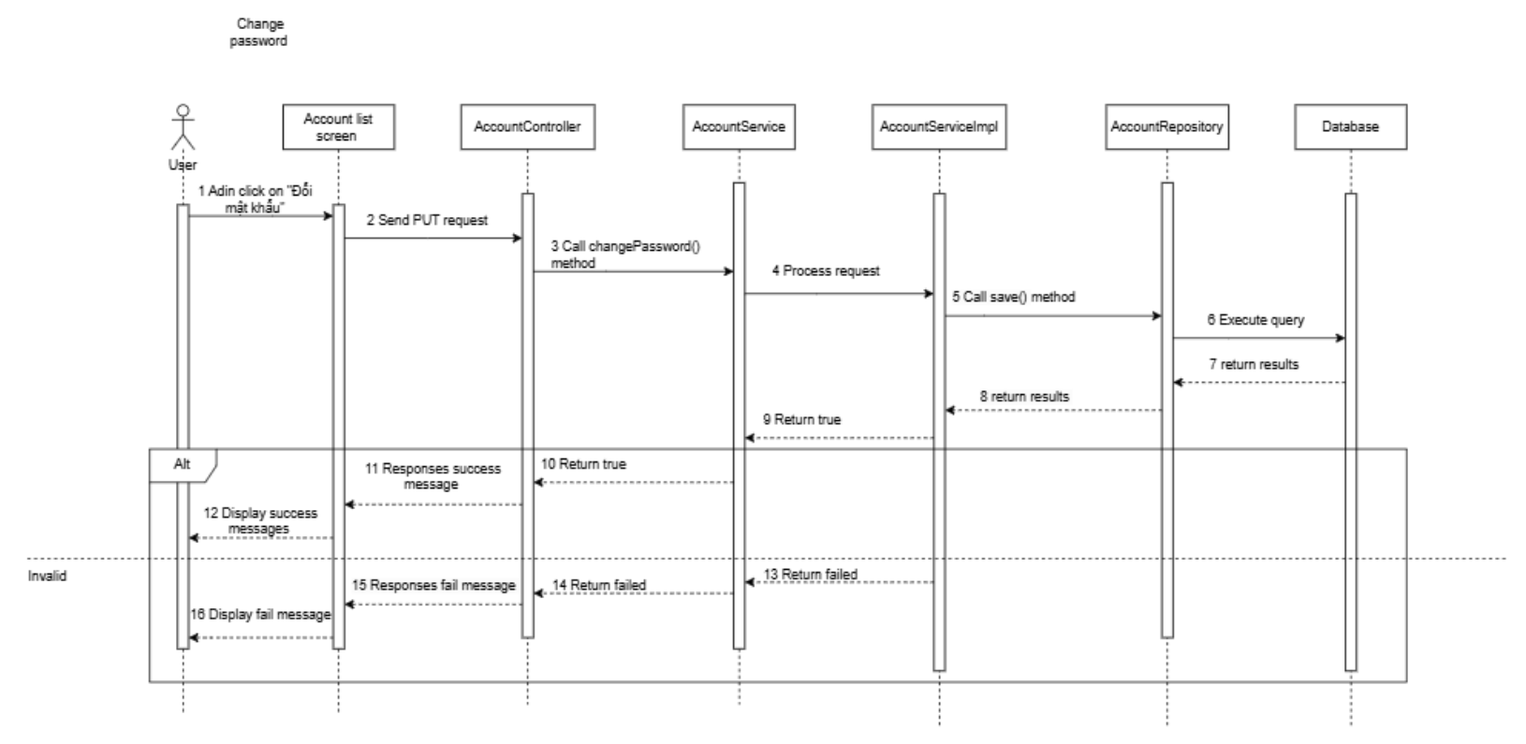

3.2 Category management

3.2.1 View category list

3.2.1.1. Class Diagram

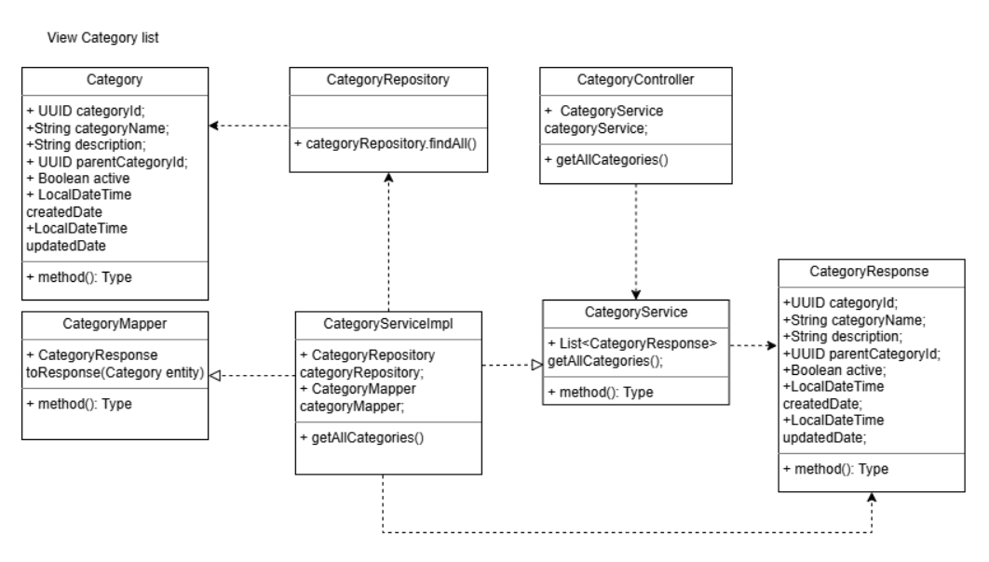

3.2.1.2. Sequence Diagram

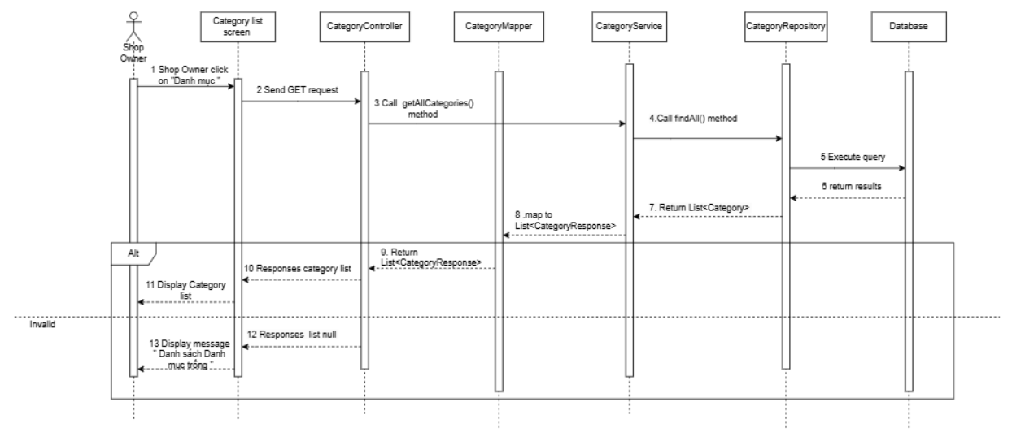

3.2.2 Create category

3.2.2.1. Class Diagram

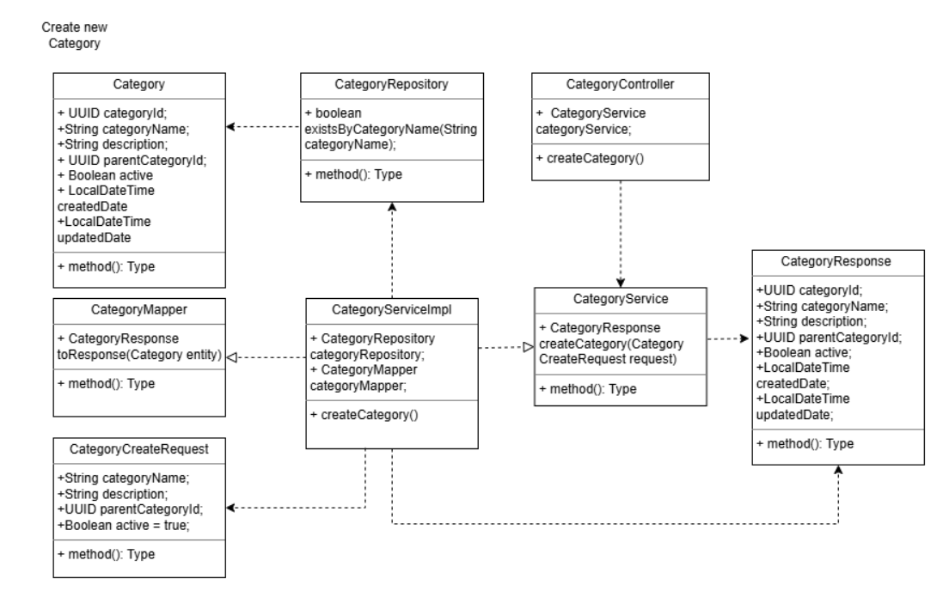

3.2.2.2. Sequence Diagram
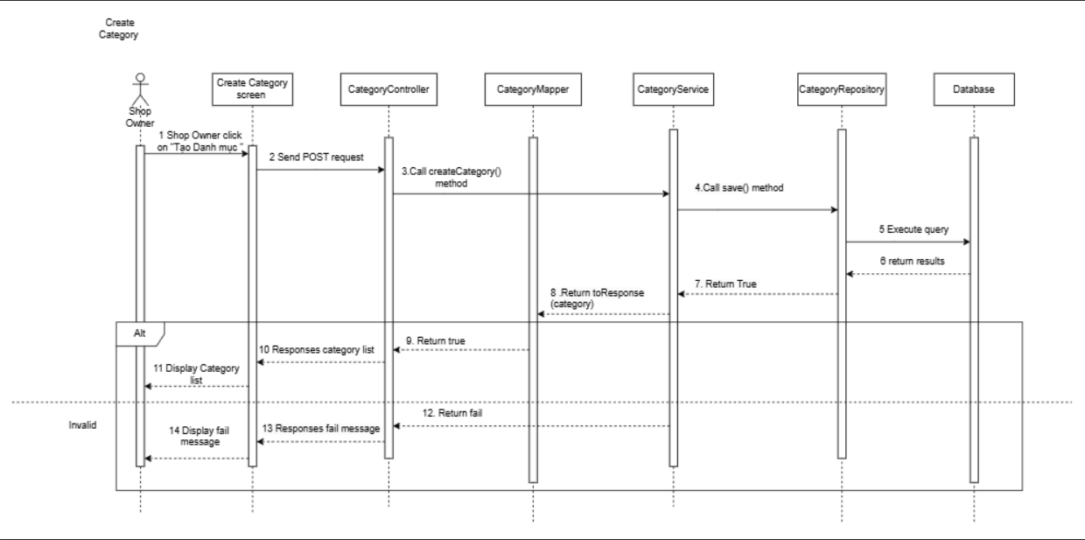

3.2.3 Update category

3.2.3.1. Class Diagram

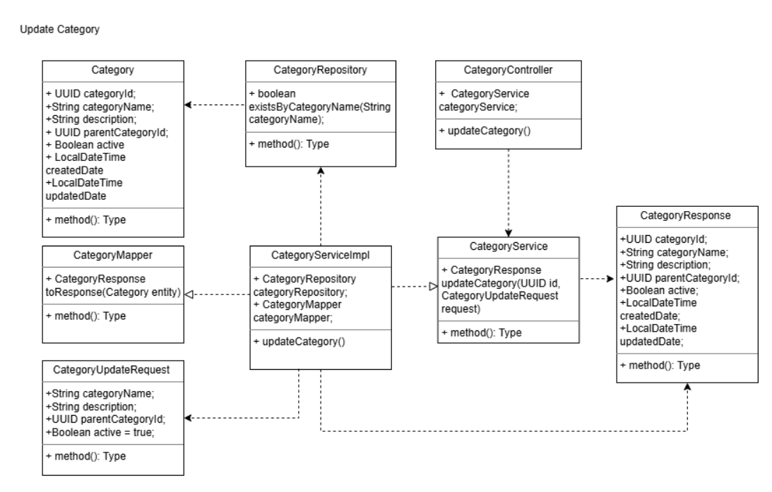

3.2.3.2. Sequence Diagram
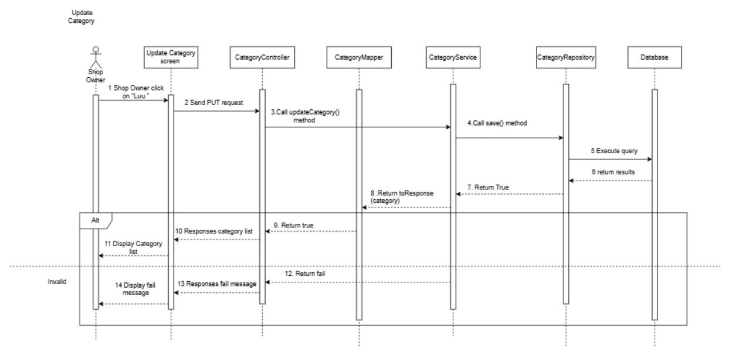

3.2.4 Search category

3.2.4.1. Class Diagram

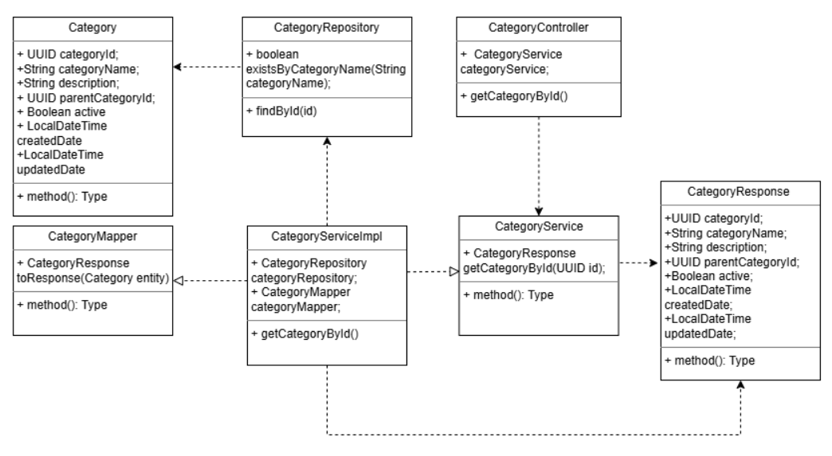

3.2.4.2. Sequence Diagram
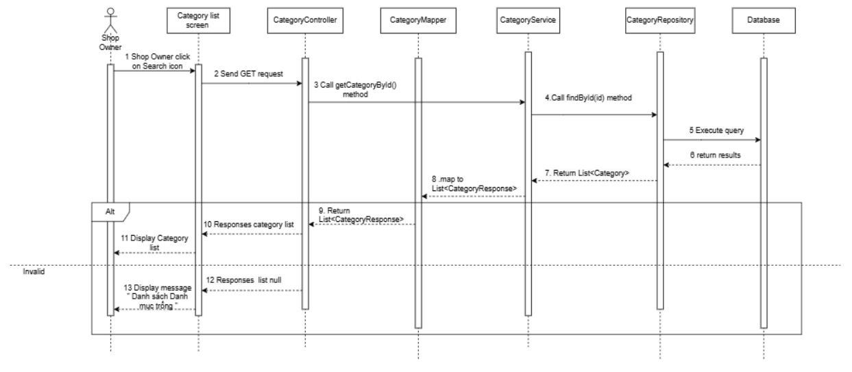

3.2.5 Delete category

3.2.5.1. Class Diagram

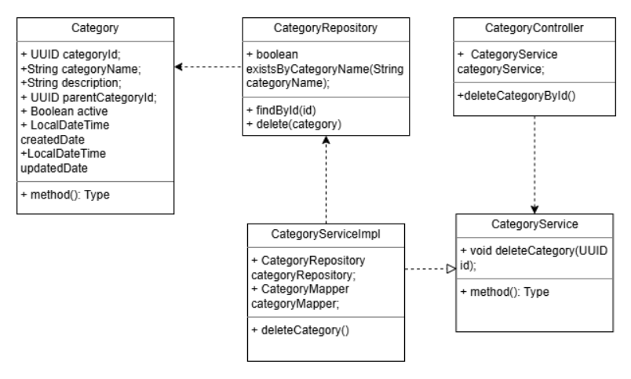

3.2.5.2. Sequence Diagram
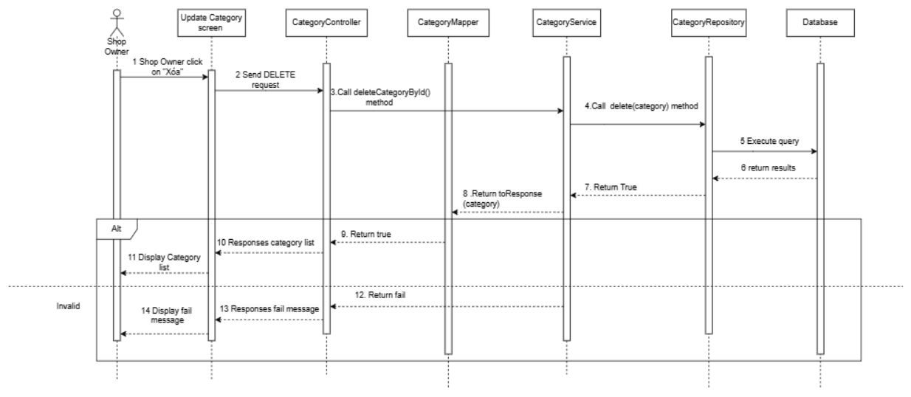

3.3 Product management

3.3.1 View product list

3.3.1.1. Class Diagram
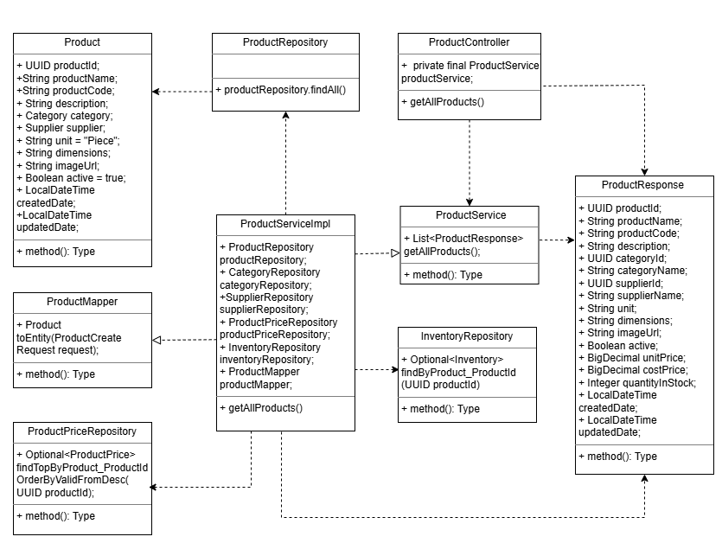

3.3.1.2. Sequence Diagram
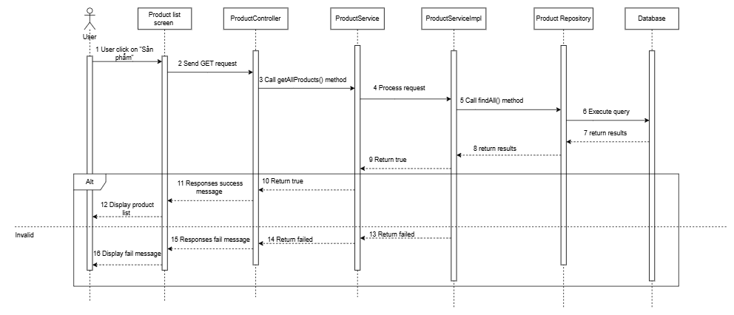

3.3.2 View product details

3.3.2.1. Class Diagram

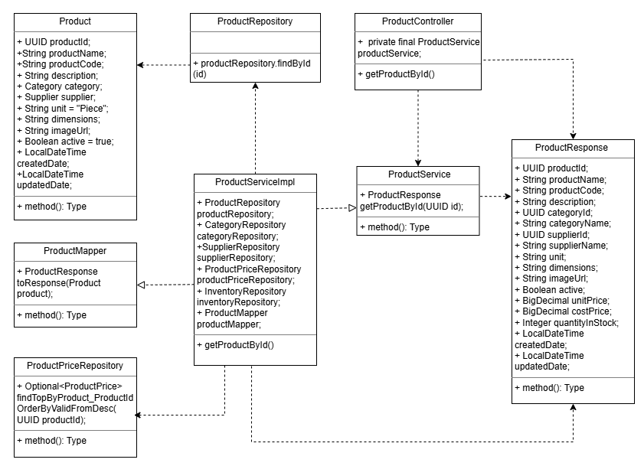

3.3.2.2. Sequence Diagram
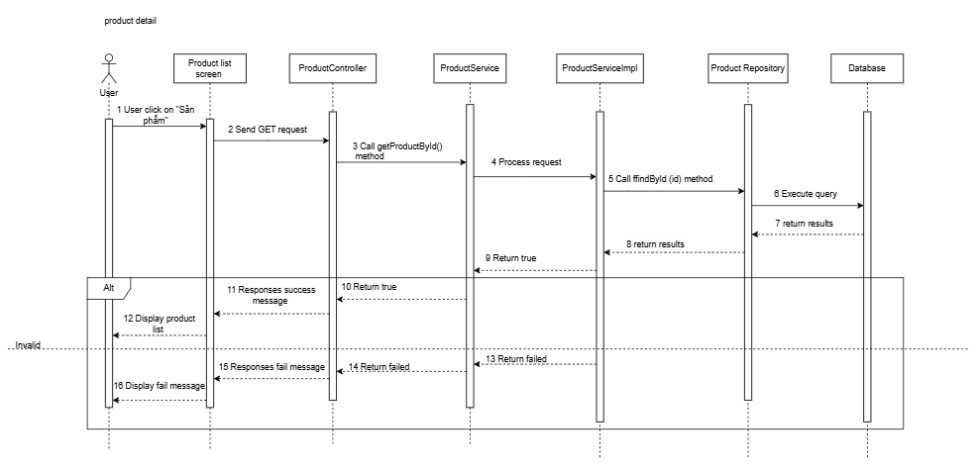

3.3.3 Create product

3.3.3.1. Class Diagram
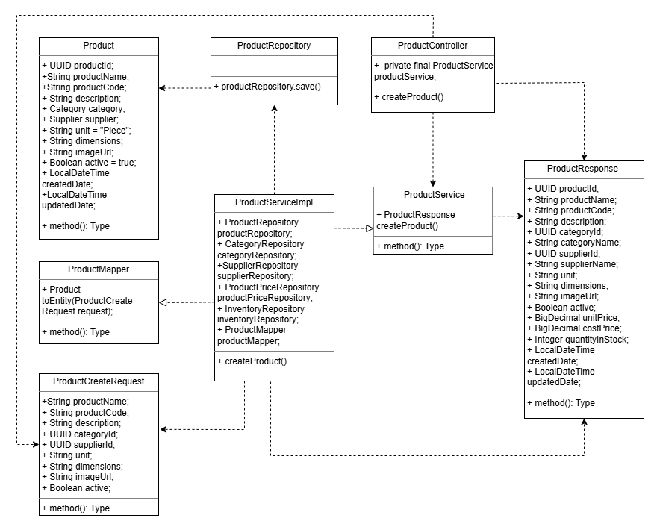

3.3.3.2. Sequence Diagram

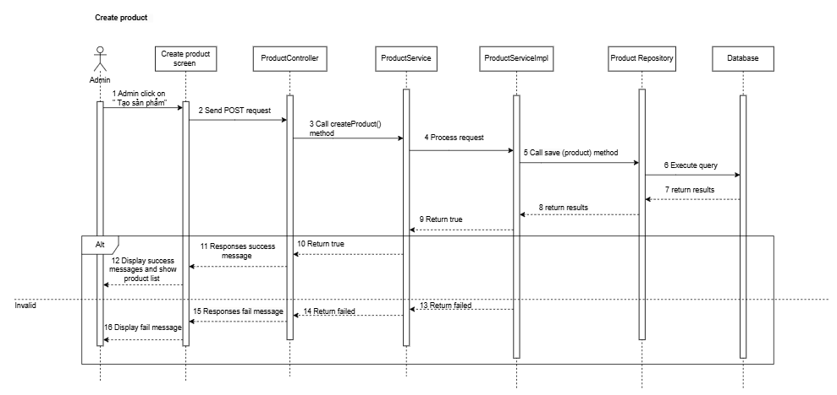

3.3.4 Update product

3.3.4.1. Class Diagram
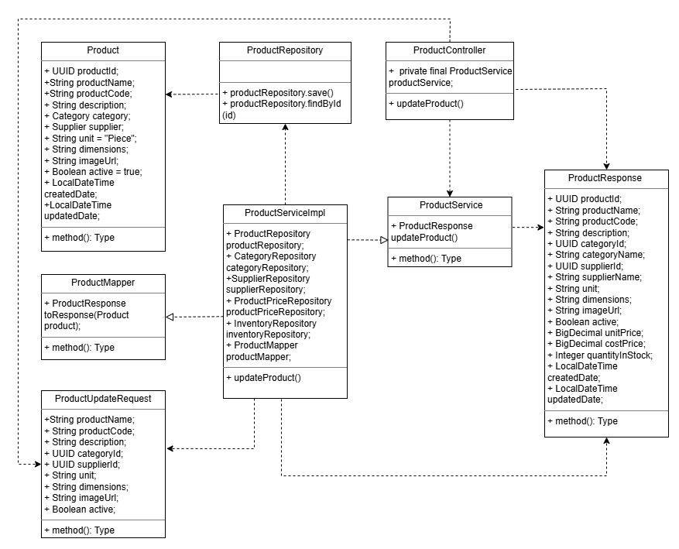

3.3.4.2. Sequence Diagram
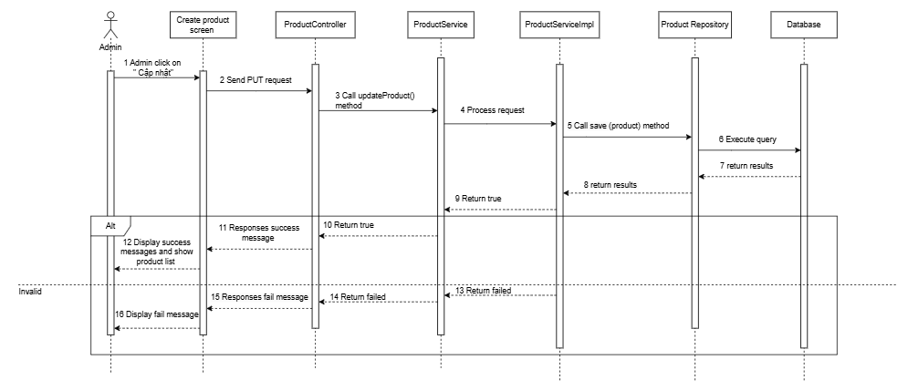

3.3.5 Search product

3.3.5.1. Class Diagram

3.3.5.2. Sequence Diagram

3.3.6 Delete product

3.3.6.1. Class Diagram

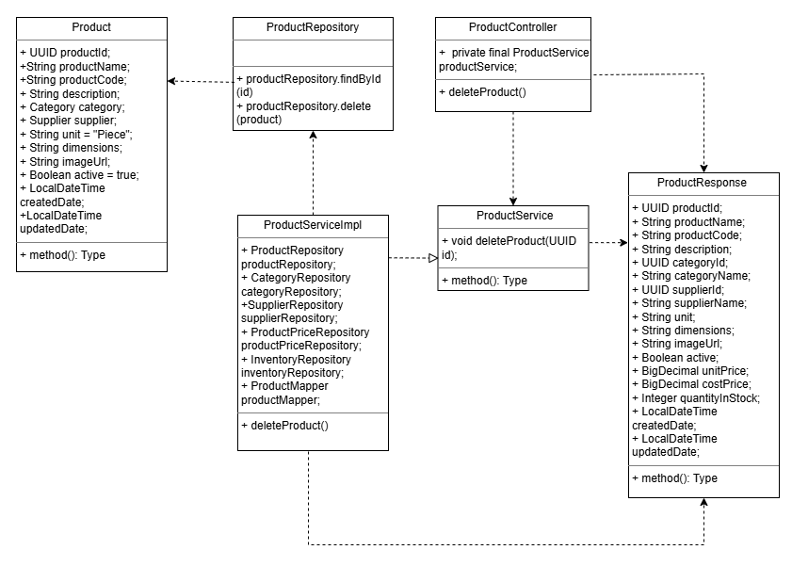

3.3.6.2. Sequence Diagram
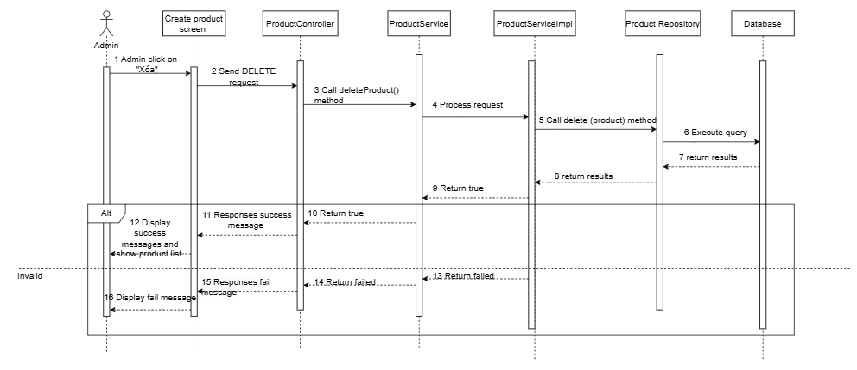

3.4 Order management

3.4.1 View order list

3.4.1.1. Class Diagram

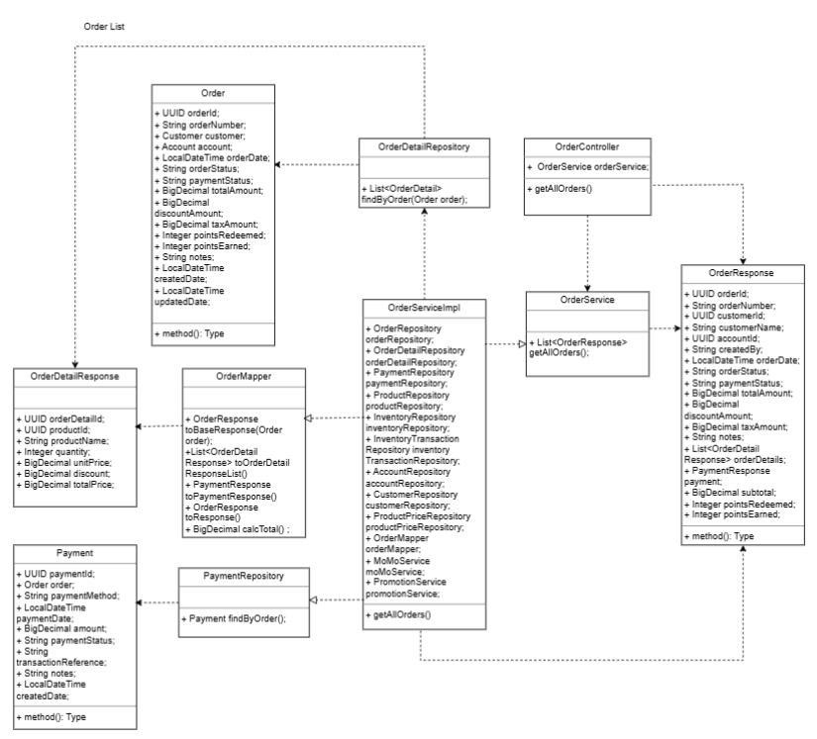

3.4.1.2. Sequence Diagram
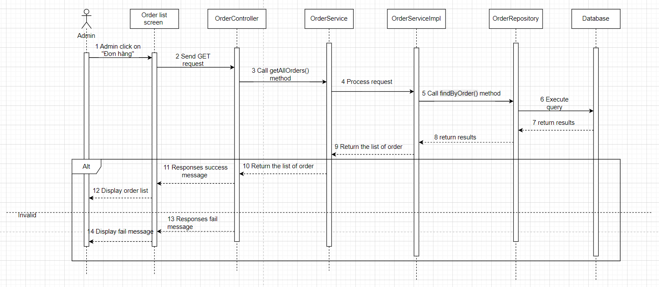

3.4.2 Create orders

3.4.2.1. Class Diagram

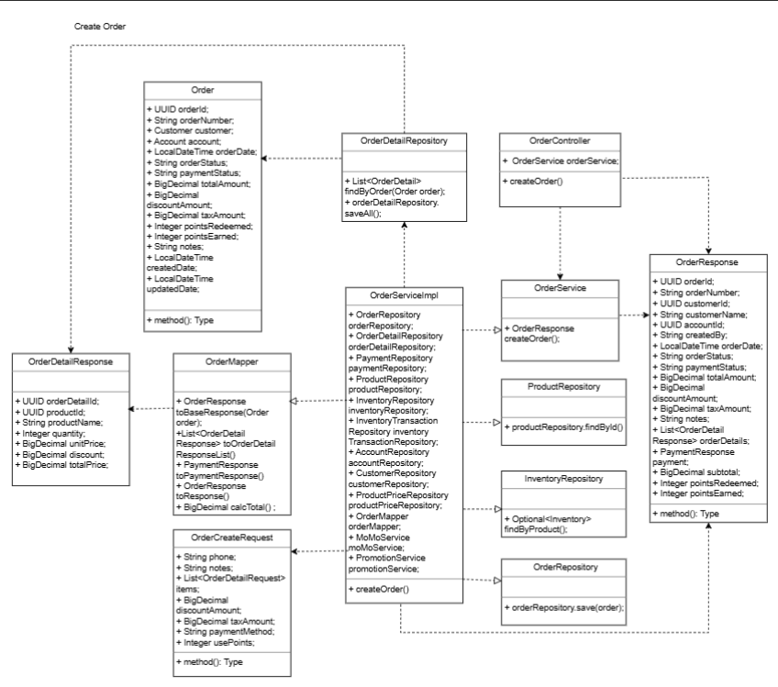

3.4.2.2. Sequence Diagram
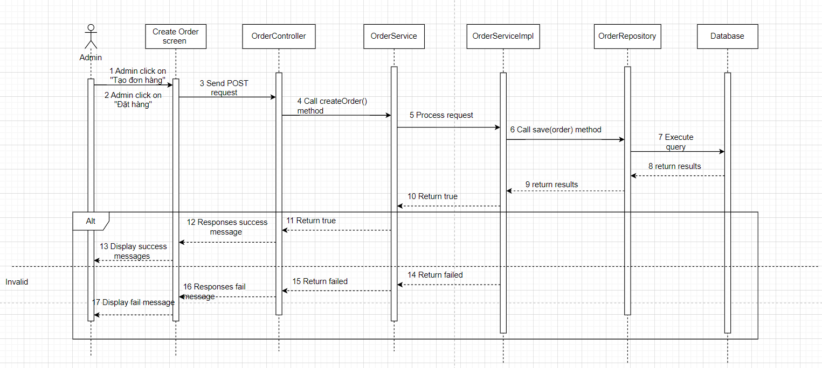

3.4.3 View order details

3.4.3.1. Class Diagram
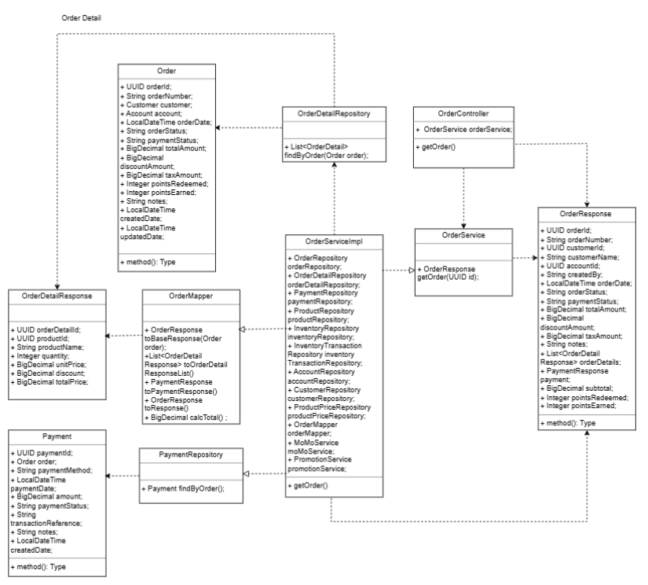

3.4.3.2. Sequence Diagram
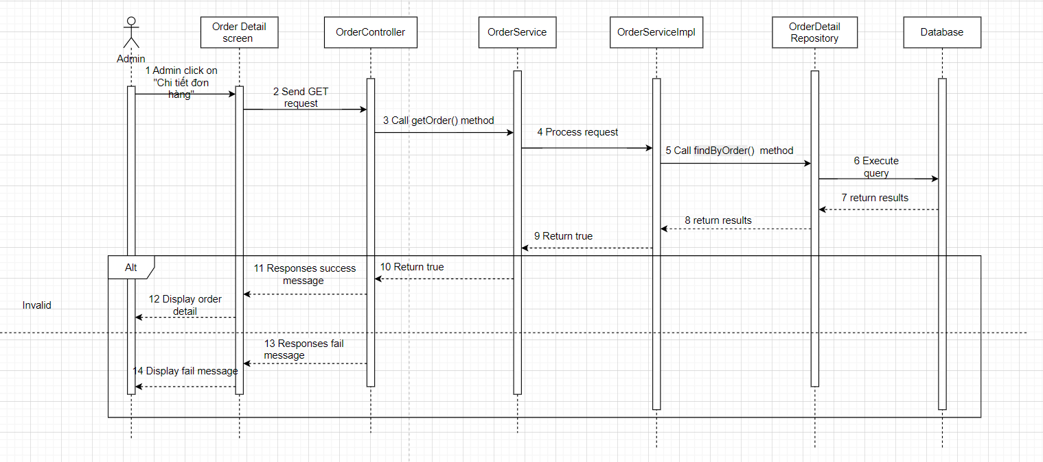

3.4.4 Update order

3.4.4.1. Class Diagram

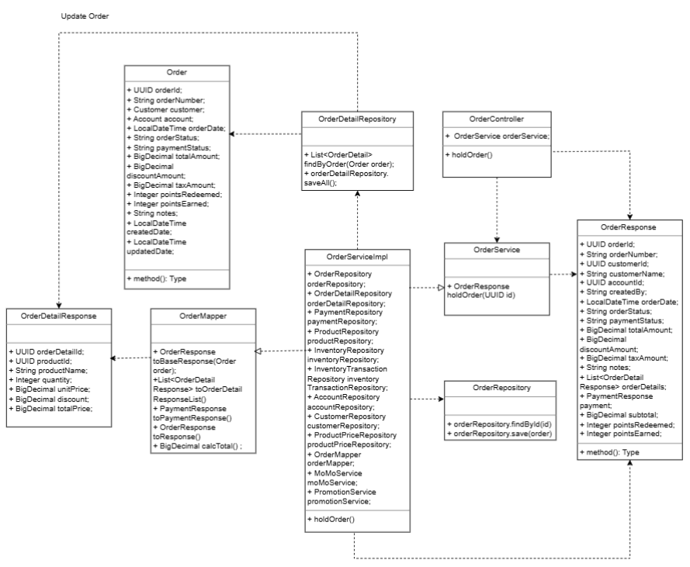

3.4.4.2. Sequence Diagram
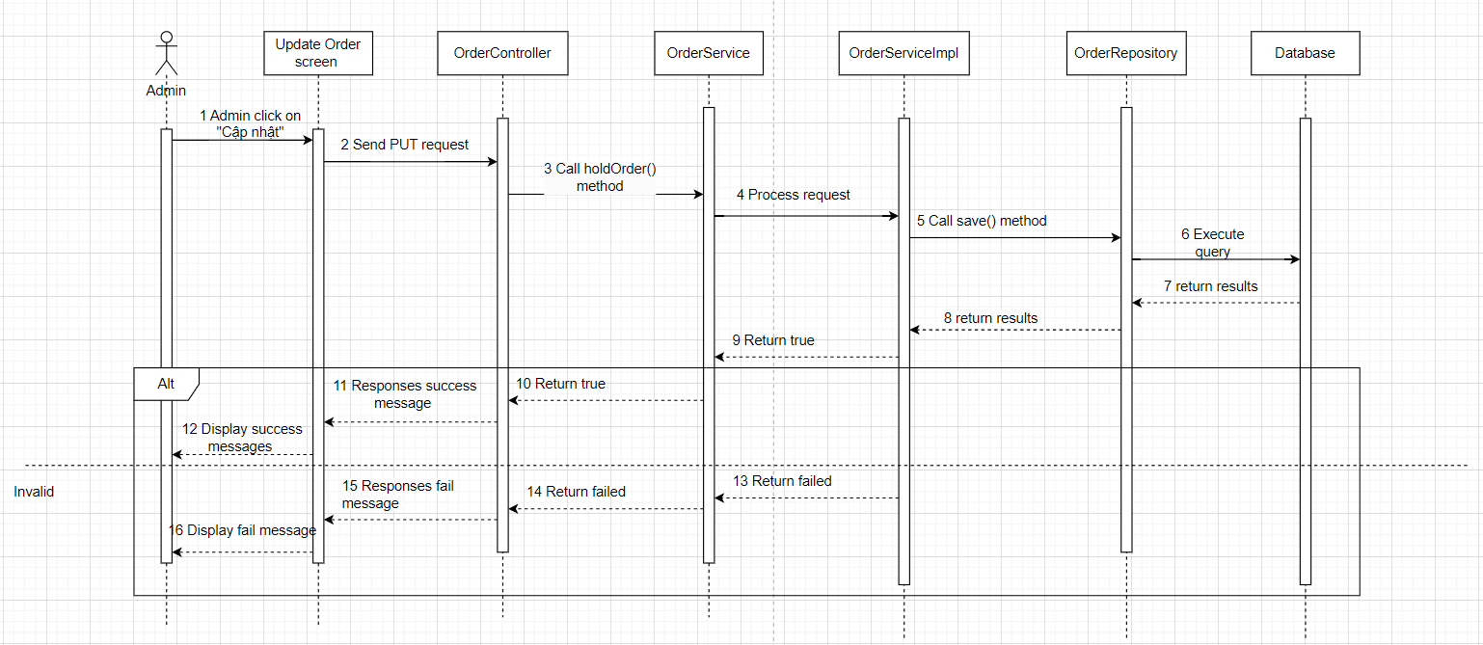

3.4.5 Cancel order

3.4.4.1. Class Diagram
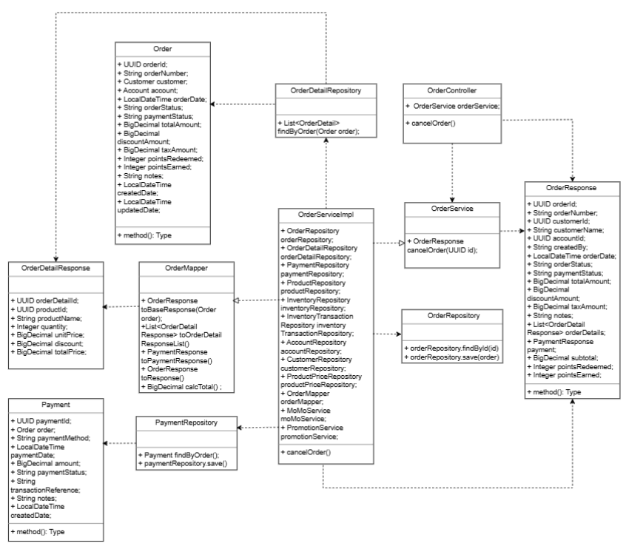

3.4.4.2. Sequence Diagram
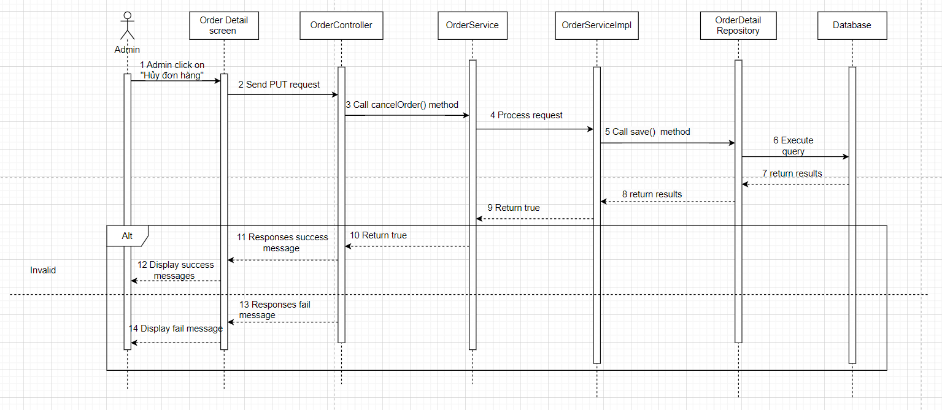

3.5 Account management

3.5.1 View account list

3.5.1.1. Class Diagram

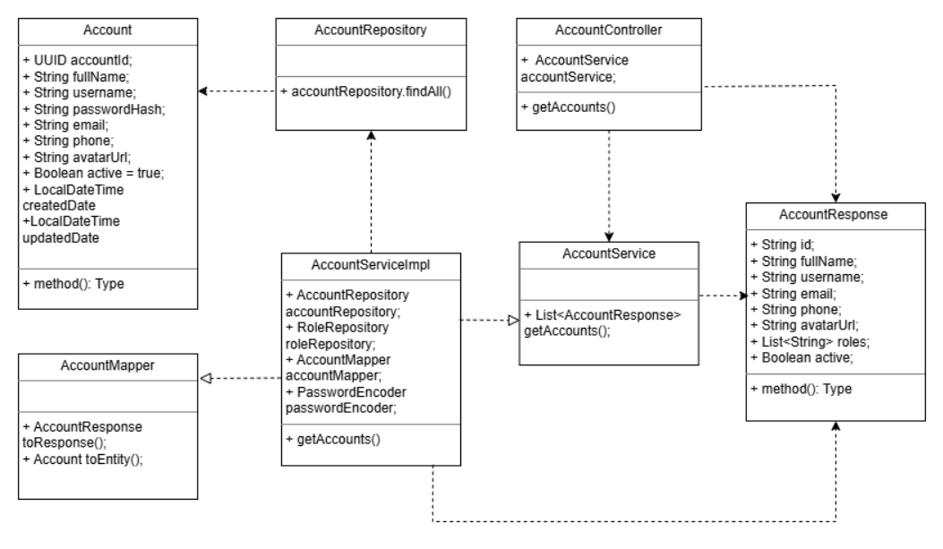

3.5.1.2. Sequence Diagram
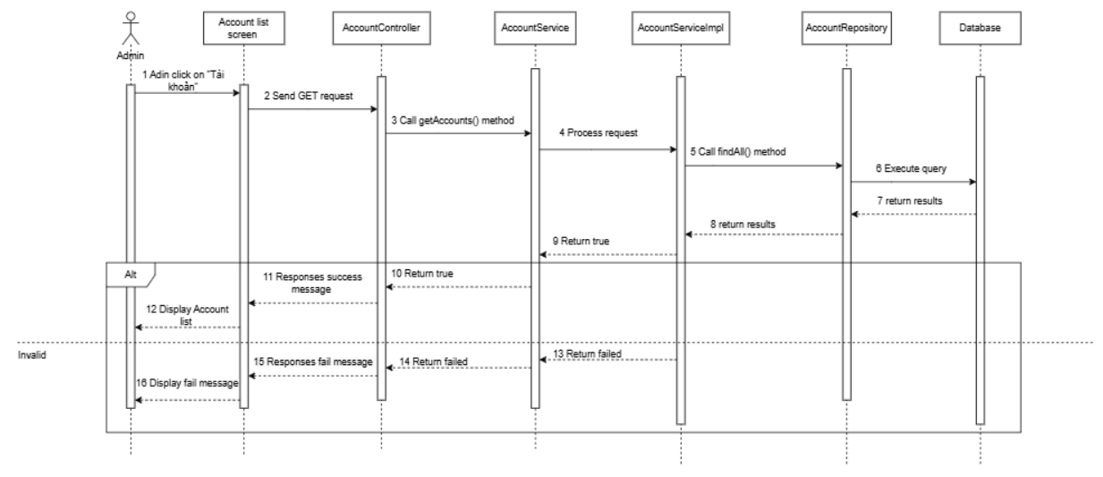

3.5.2 View account details

3.5.2.1. Class Diagram

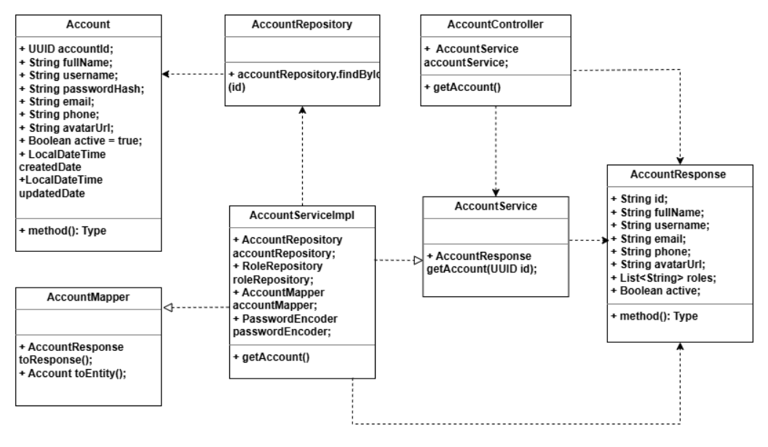

3.5.2.2. Sequence Diagram

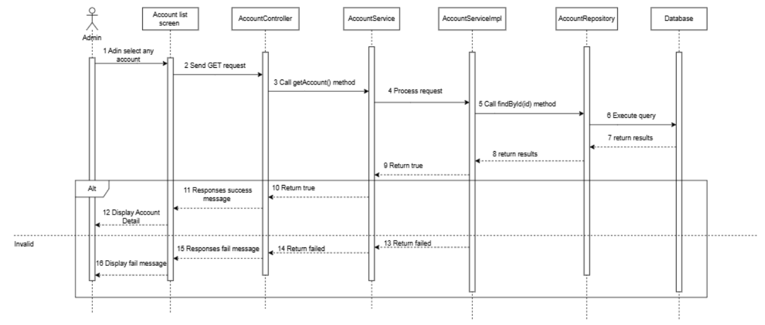

3.5.3 Add new account

3.5.3.1. Class Diagram

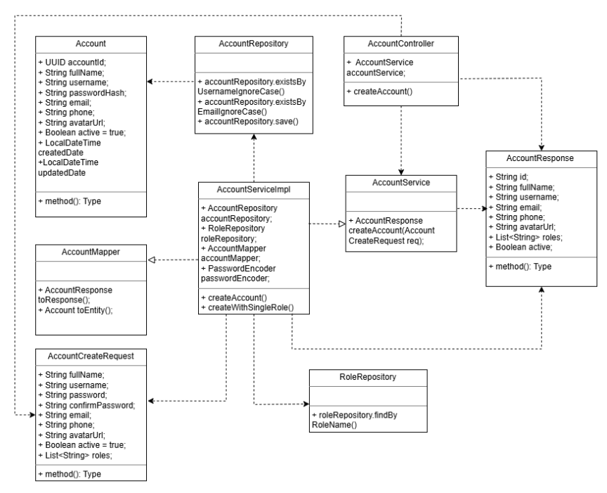

3.5.3.2. Sequence Diagram
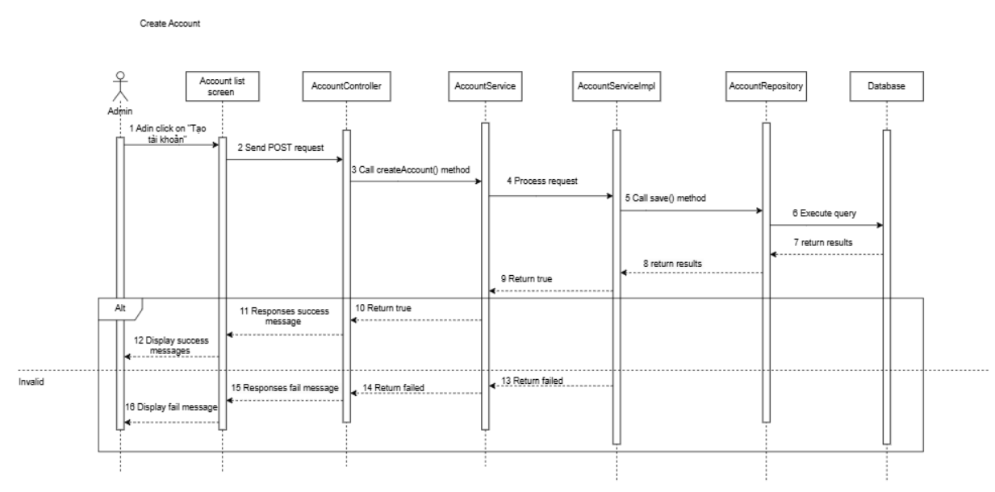

3.5.4 Edit account

3.5.4.1. Class Diagram
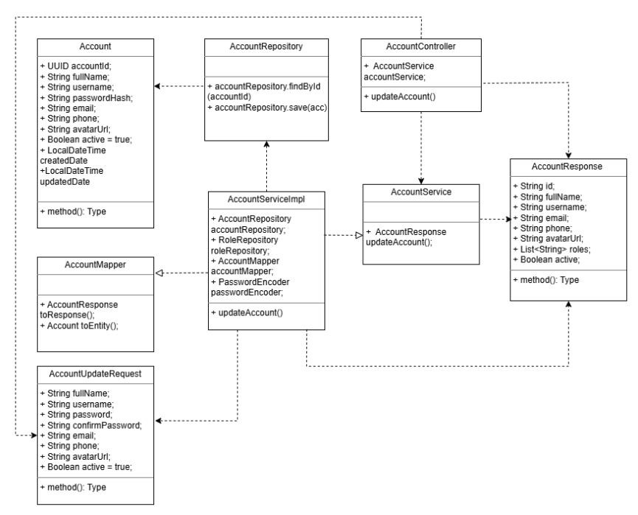

3.5.4.2. Sequence Diagram
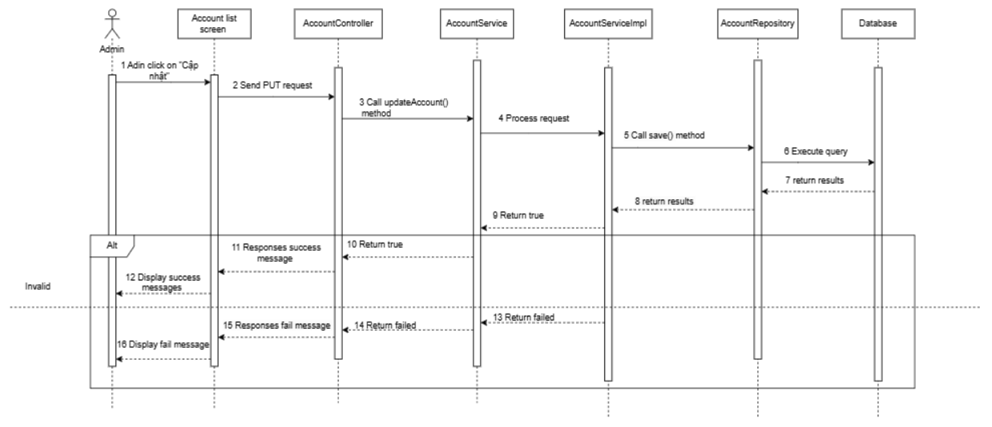

3.5.5 Delete account

3.5.5.1. Class Diagram
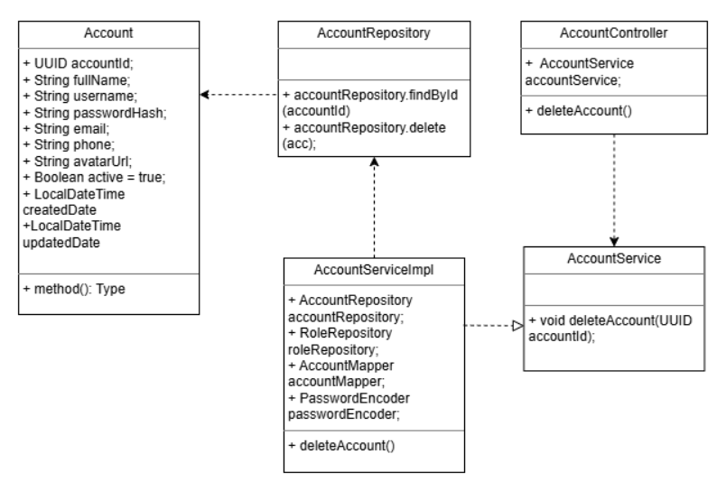

3.5.5.2. Sequence Diagram
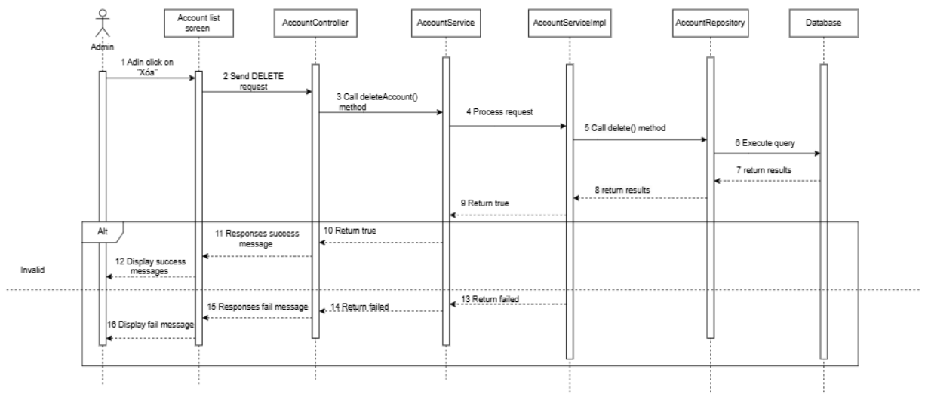

3.5.6 Search account

3.5.6.1. Class Diagram

3.5.6.2. Sequence Diagram

3.6 Role Management

3.6.1 View role list

3.6.1.1. Class Diagram
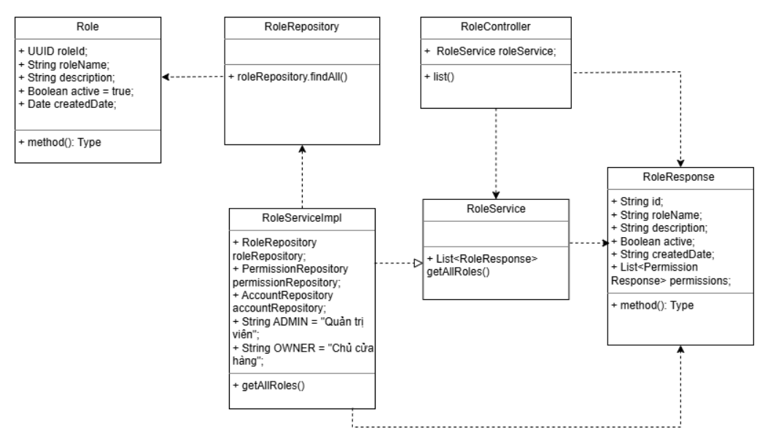

3.6.1.2. Sequence Diagram
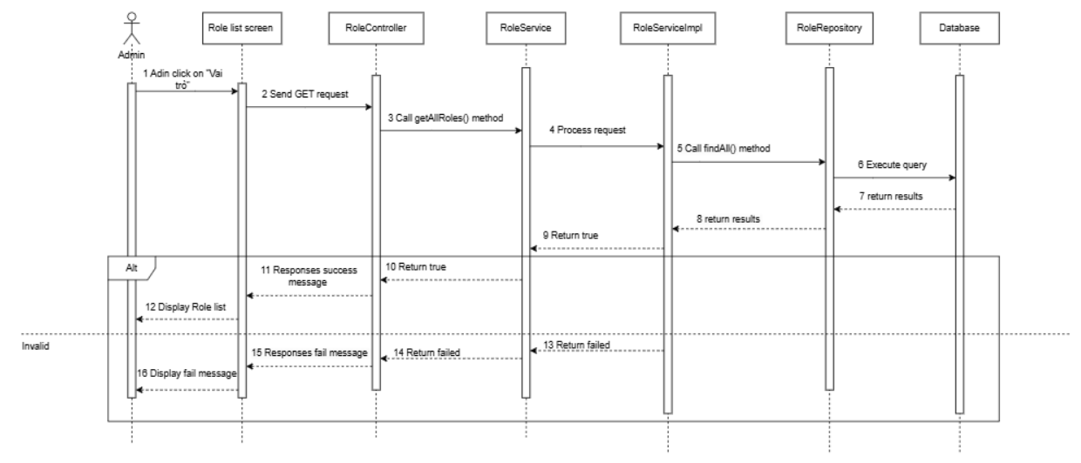

3.6.2 Add new role

3.6.2.1. Class Diagram
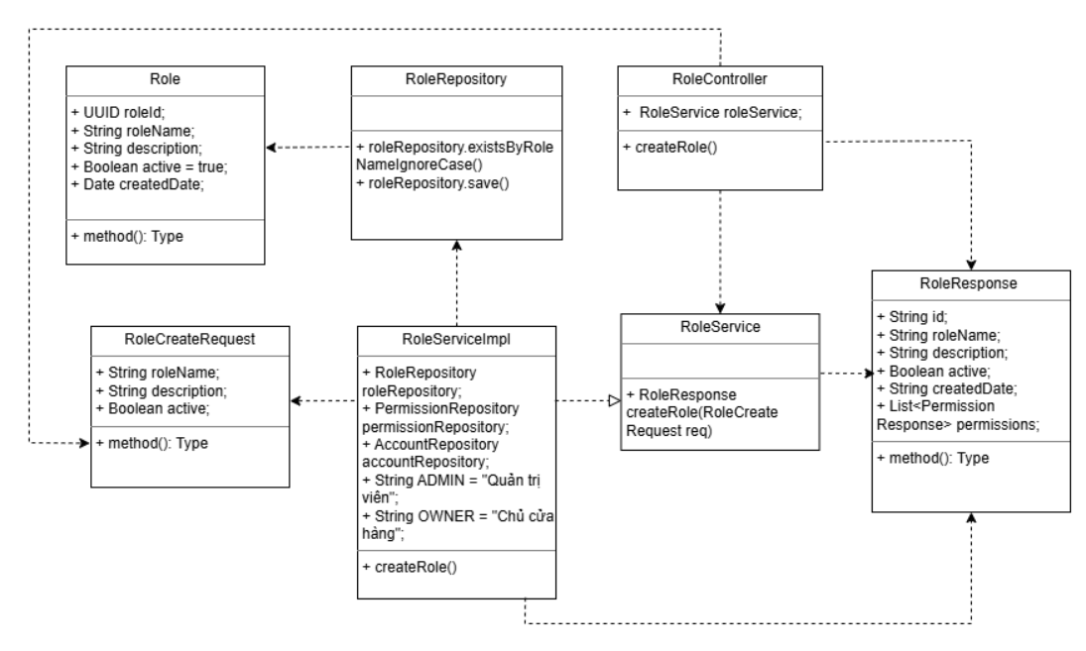

3.6.2.2. Sequence Diagram
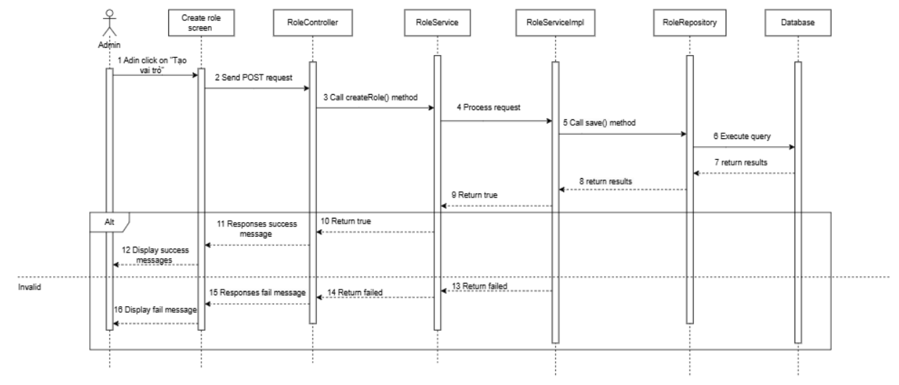

3.6.3 Edit role

3.6.3.1. Class Diagram
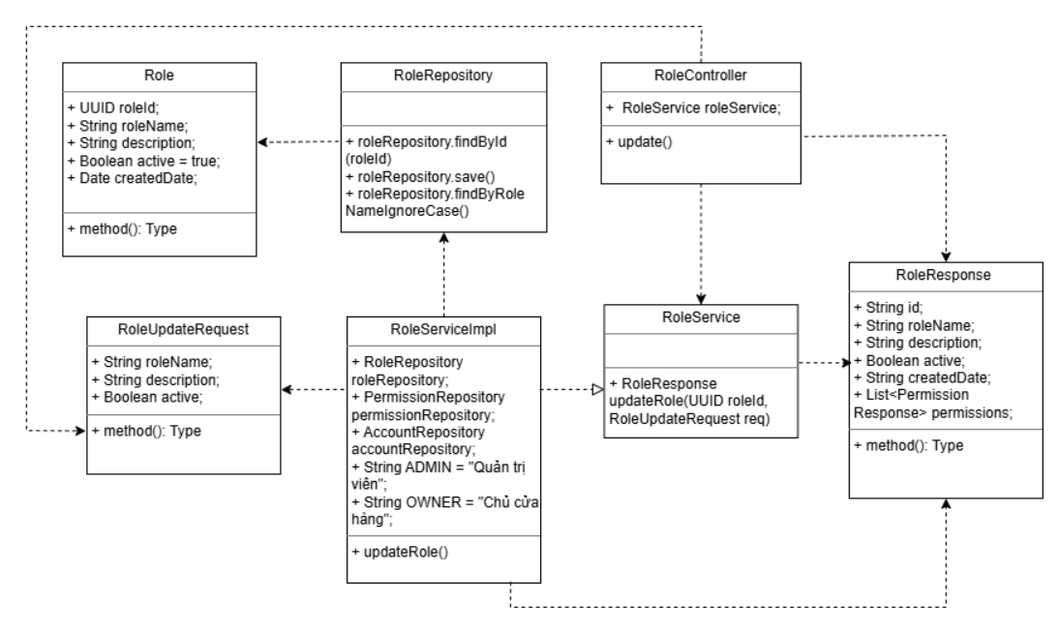

3.6.3.2. Sequence Diagram
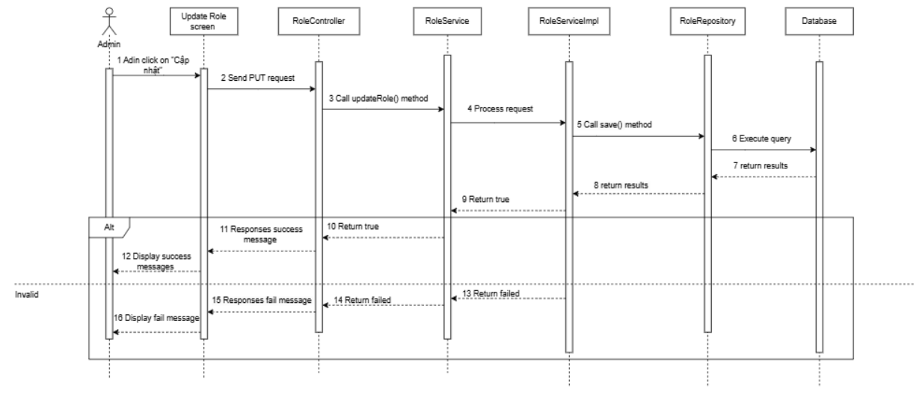

3.6.4 Delete role

3.6.4.1. Class Diagram
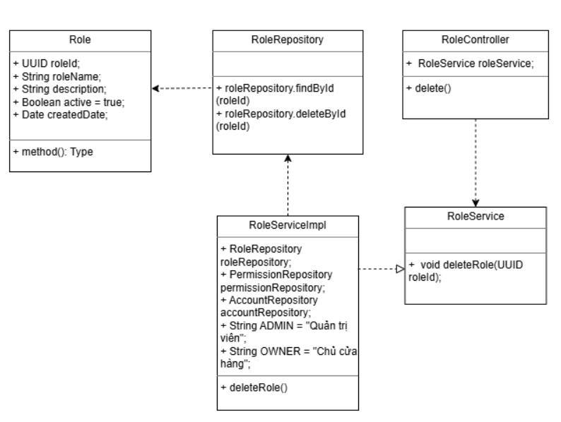

3.6.4.2. Sequence Diagram
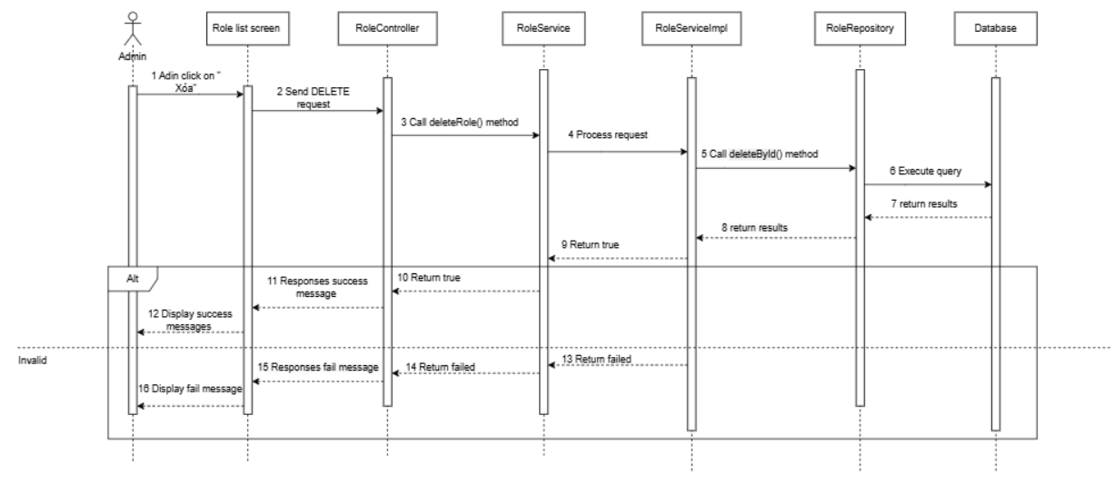

3.7 Supplier Management

3.7.1 View supplier list

3.7.1.1. Class Diagram

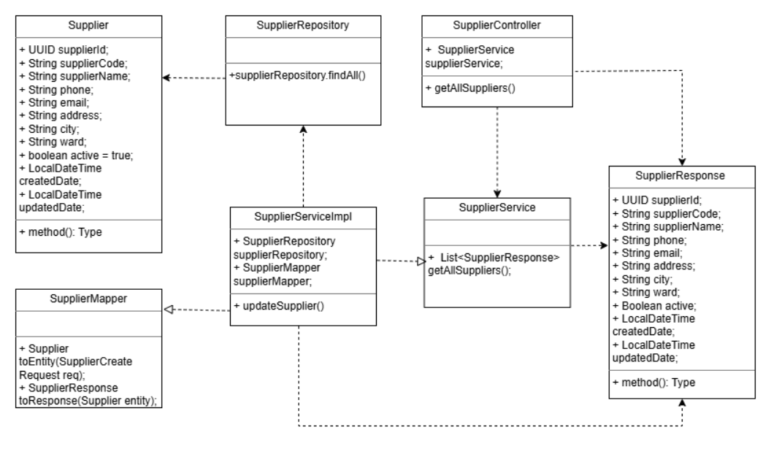

3.7.1.2. Sequence Diagram
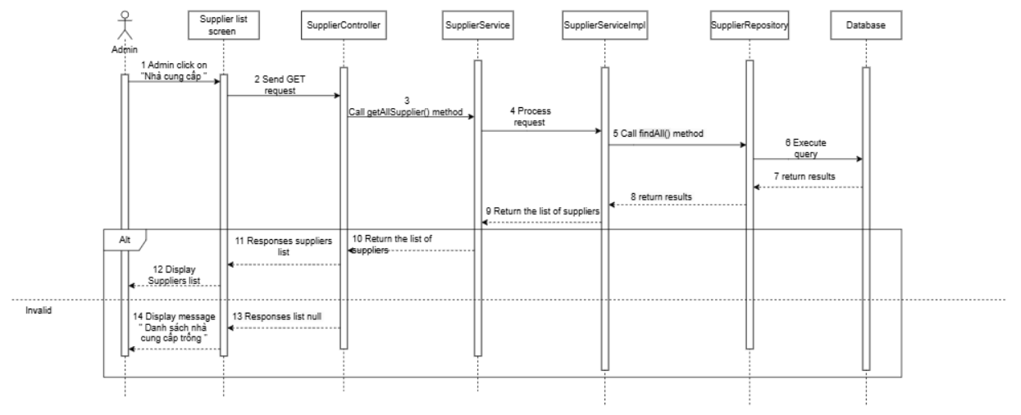

3.7.2 View supplier details

3.7.2.1. Class Diagram
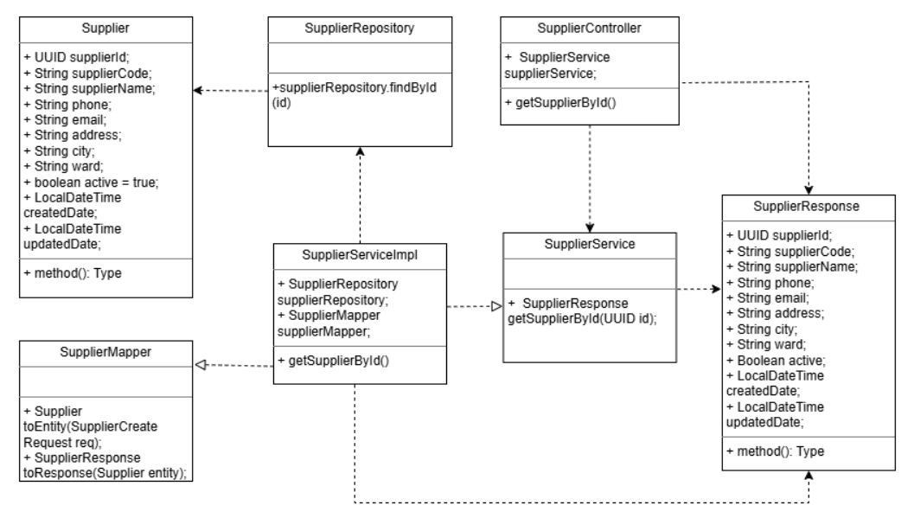

3.7.2.2. Sequence Diagram
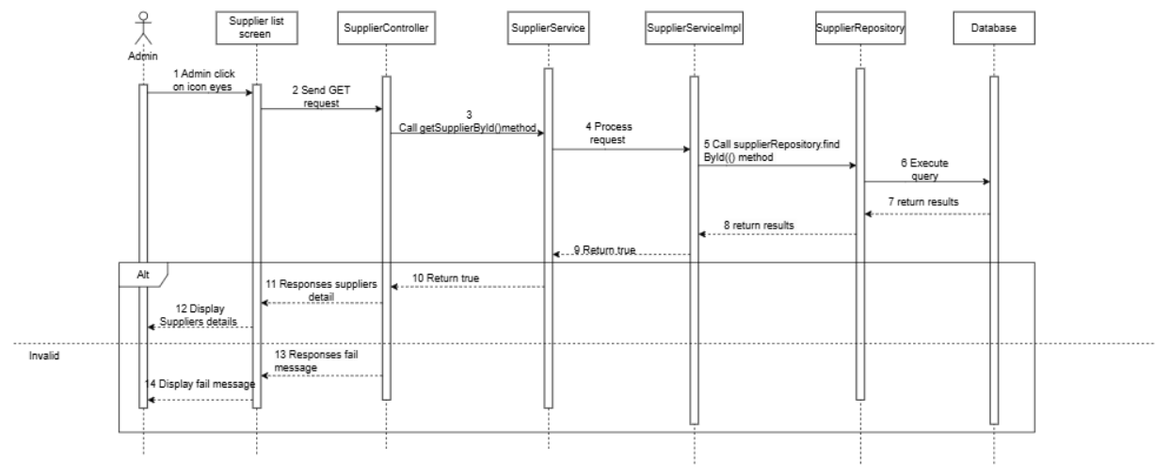

3.7.3 Create supplier

3.7.3.1. Class Diagram

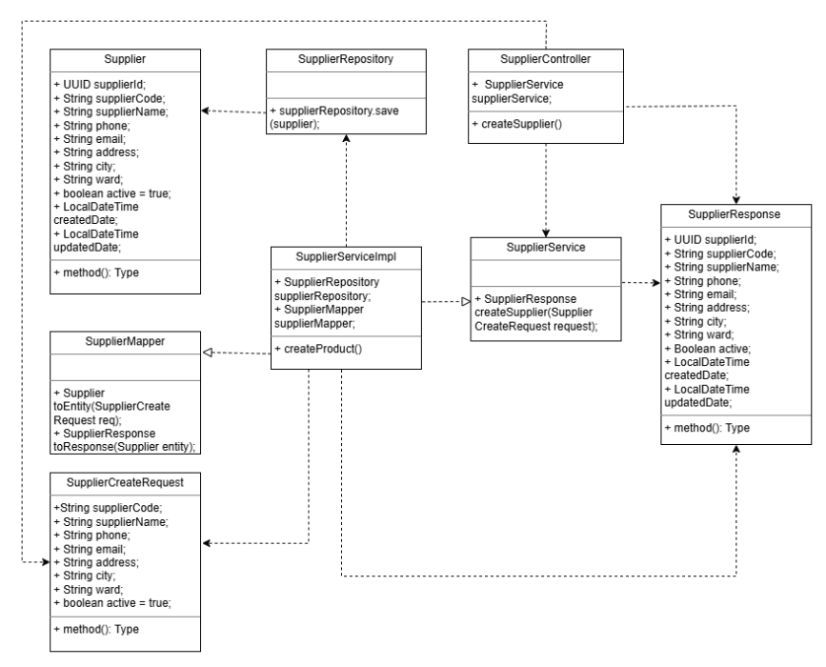

3.7.3.2. Sequence Diagram
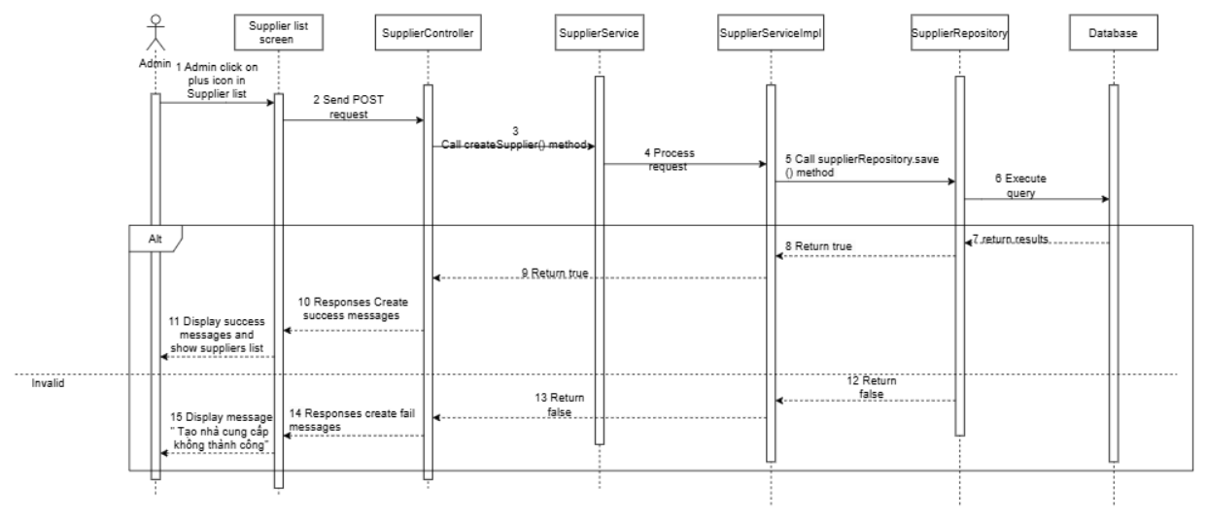

3.7.4 Update supplier

3.7.4.1. Class Diagram

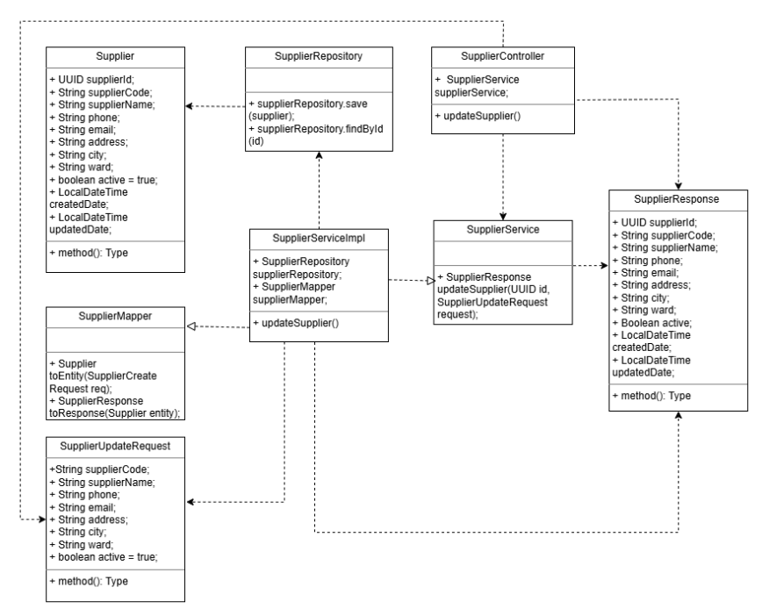

3.7.4.2. Sequence Diagram
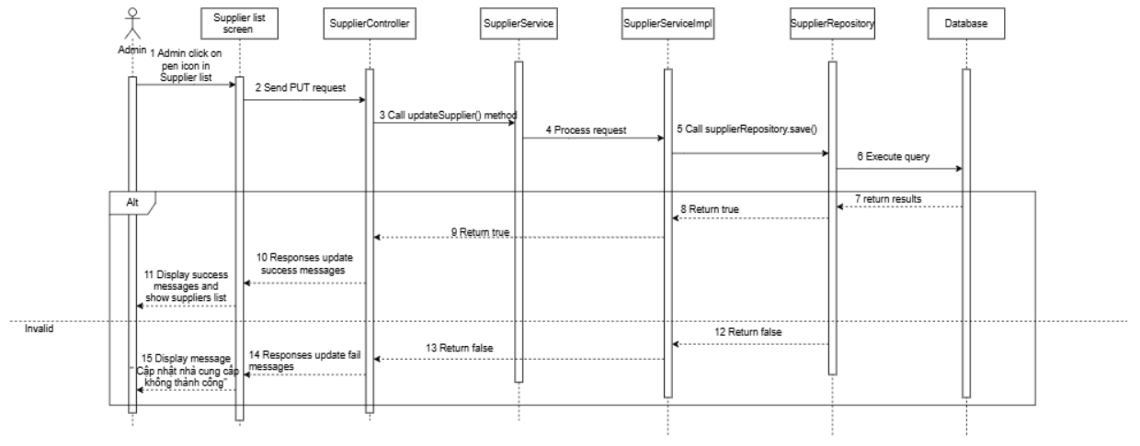

3.7.5 Search supplier

3.7.5.1. Class Diagram

3.7.5.2. Sequence Diagram
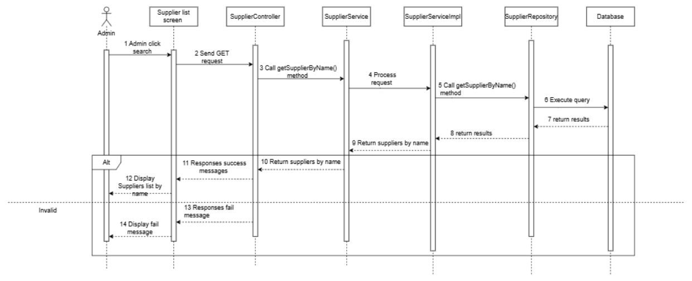

3.7.6 Delete supplier

3.7.6.1. Class Diagram

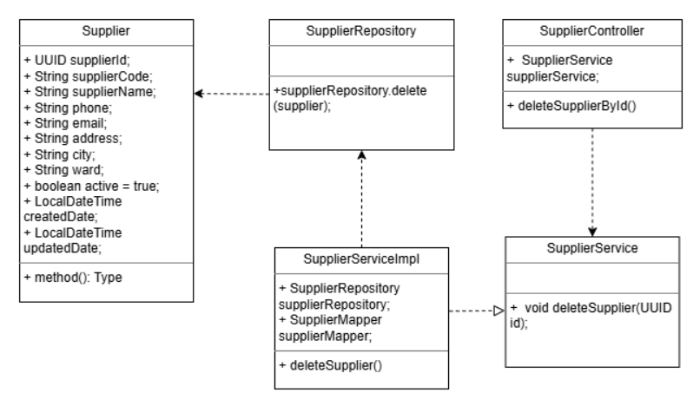

3.7.6.2. Sequence Diagram
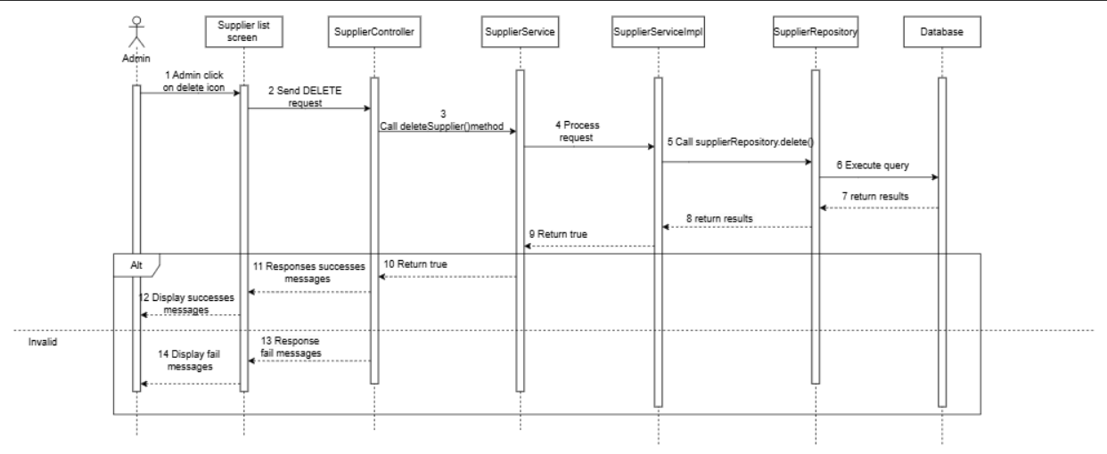

3.8 Customer Management

3.8.1 View customer list

3.8.1.1. Class Diagram

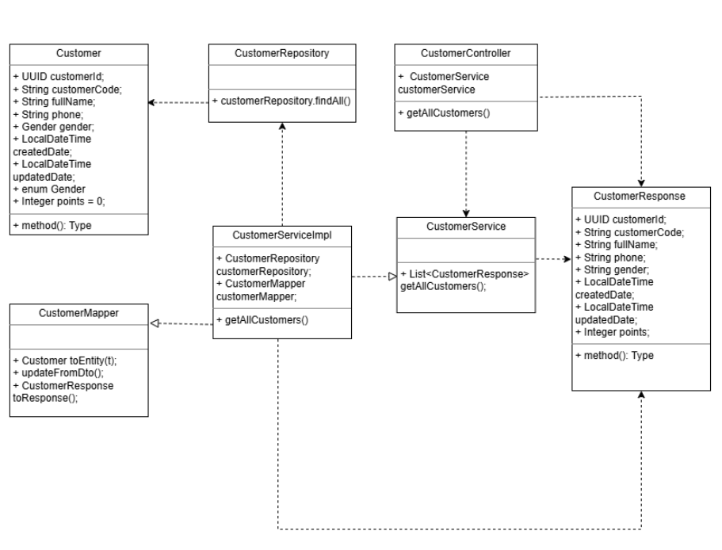

3.8.1.2. Sequence Diagram
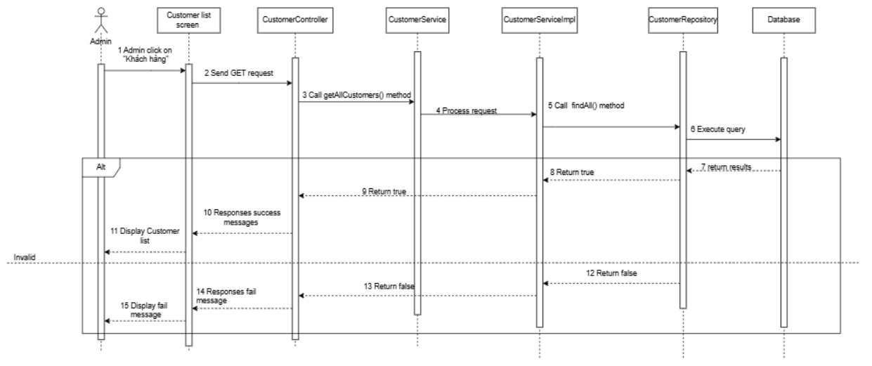

3.8.2 Add new customer

3.8.2.1. Class Diagram

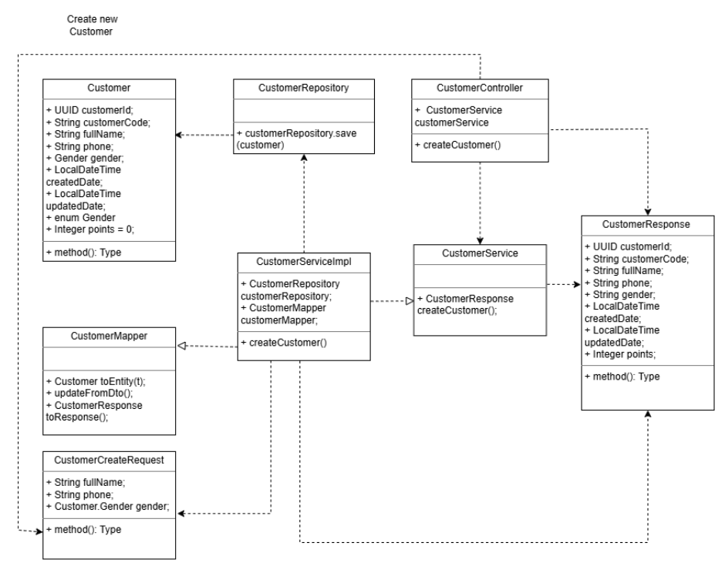

3.8.2.2. Sequence Diagram
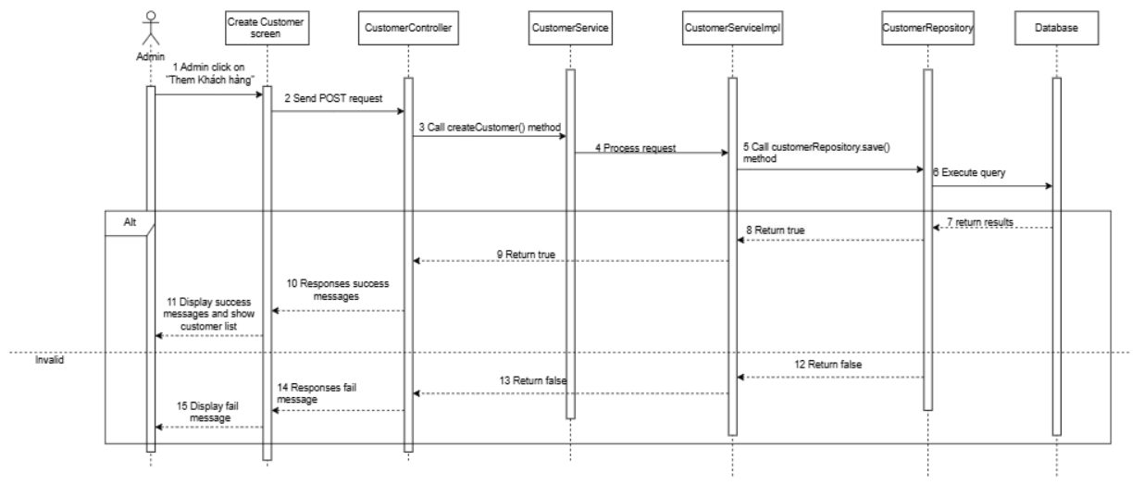

3.8.3 Edit customer

3.8.3.1. Class Diagram

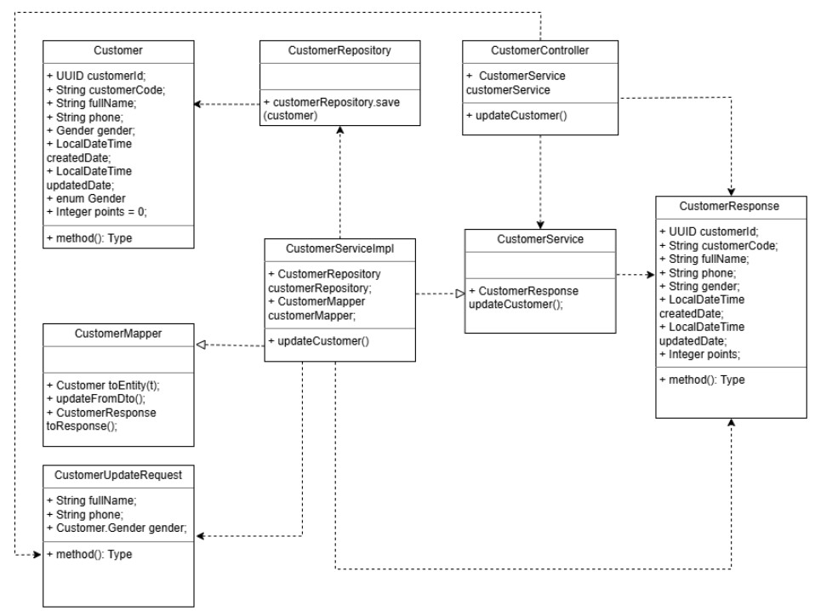

3.8.3.2. Sequence Diagram
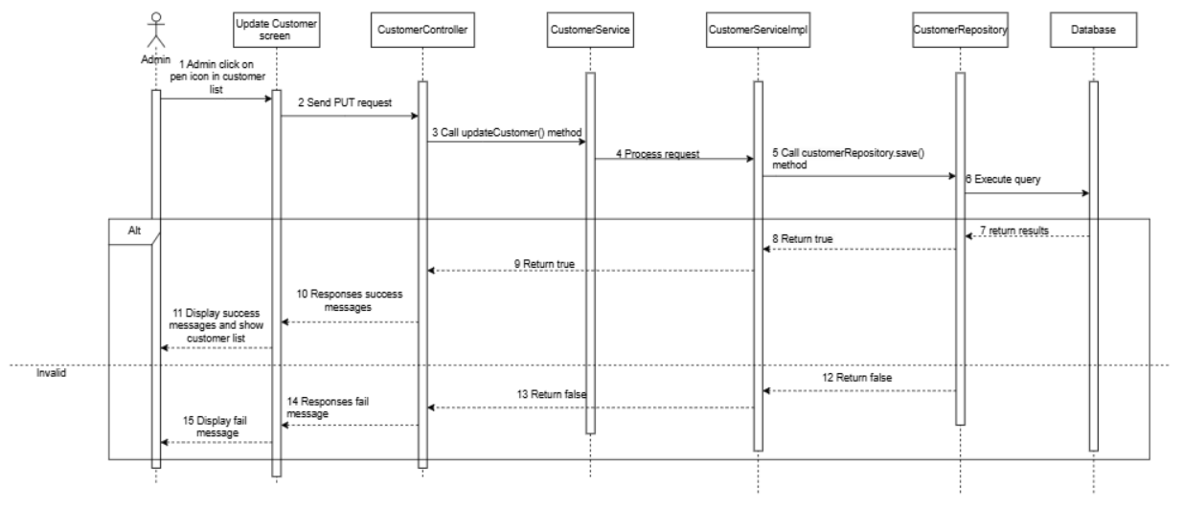

3.8.4 Delete customer

3.8.4.1. Class Diagram

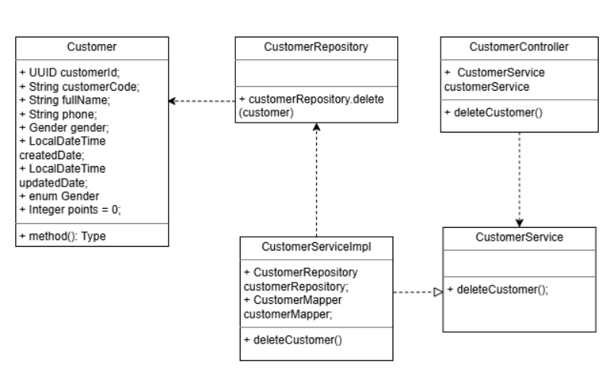

3.8.4.2. Sequence Diagram
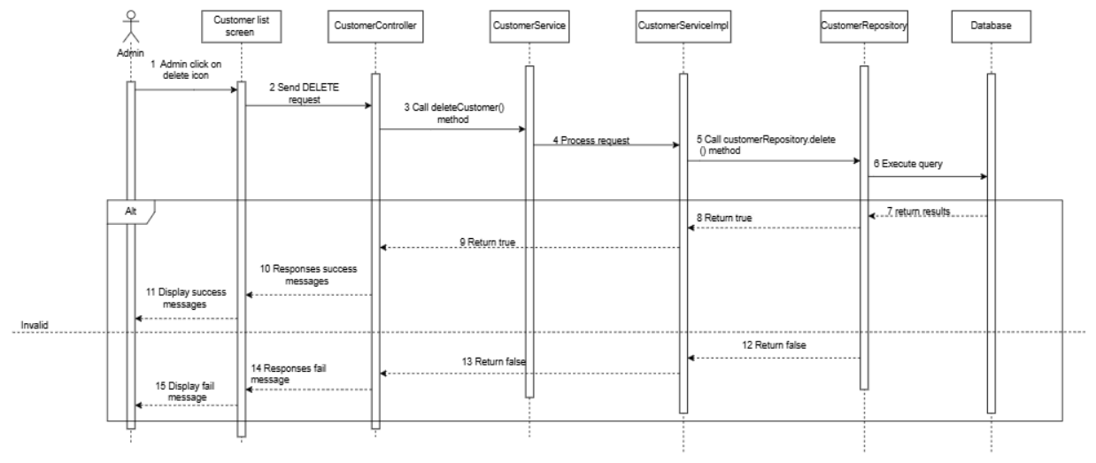

3.8.5 Search customer

3.8.5.1. Class Diagram

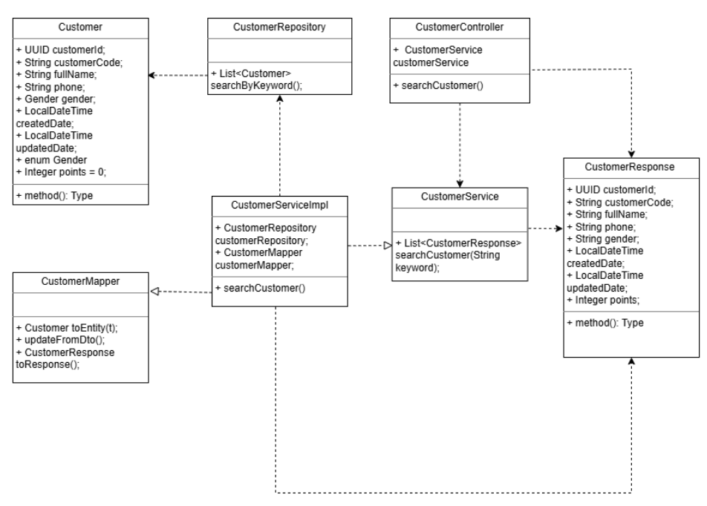

3.8.5.2. Sequence Diagram
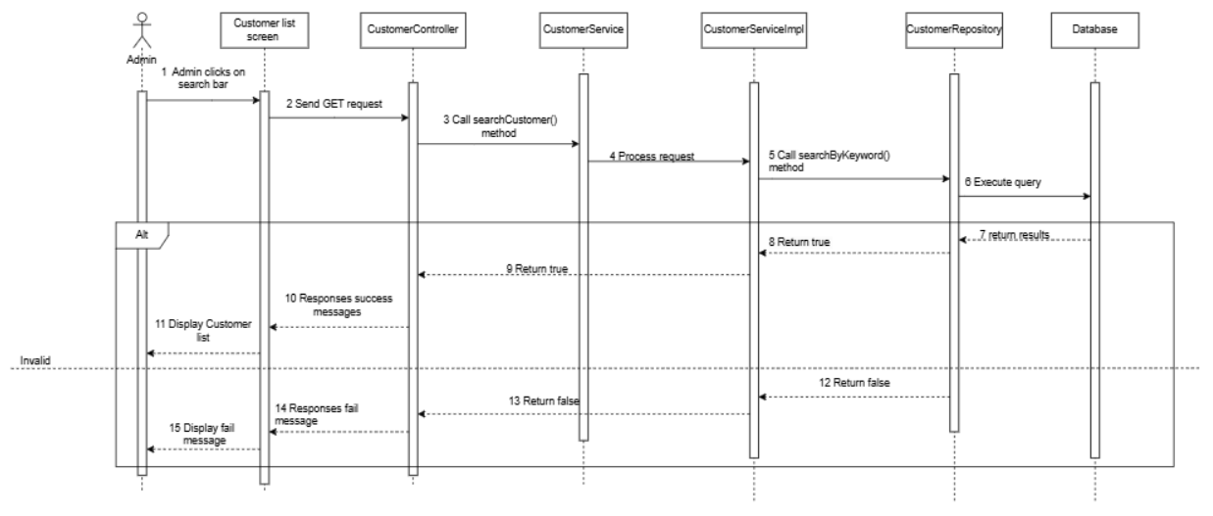

3.8.6 View customer detail

3.8.6.1. Class Diagram

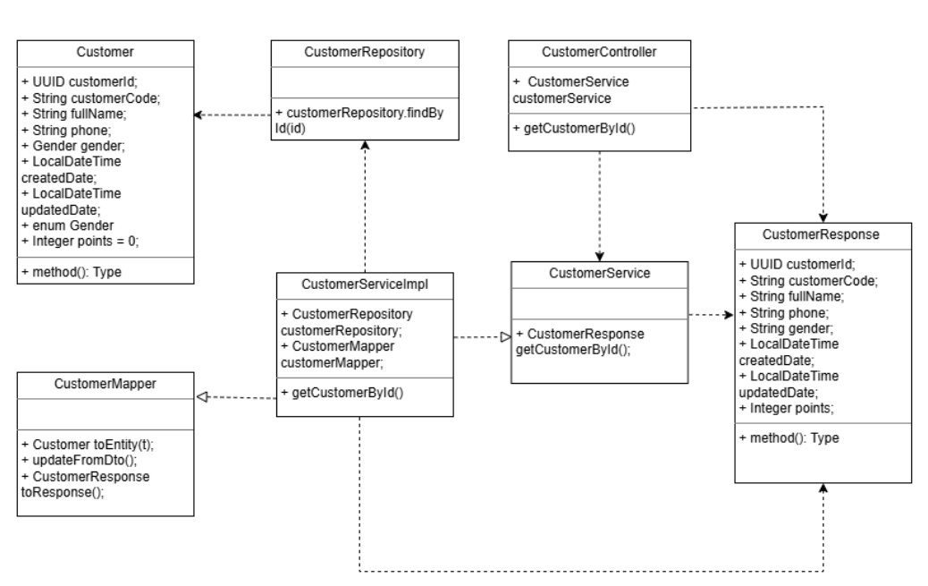

3.8.6.2. Sequence Diagram
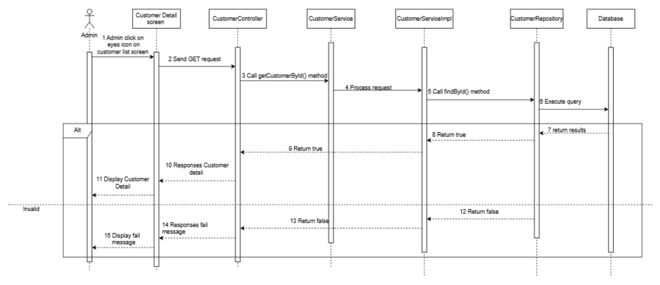

3.9 Purchase Order Management

3.9.1 View purchase order list

3.9.1.1. Class Diagram

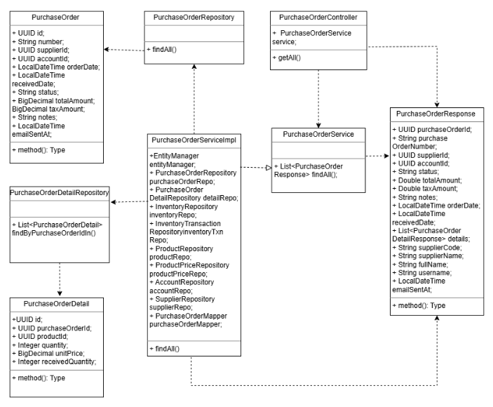

3.9.1.2. Sequence Diagram

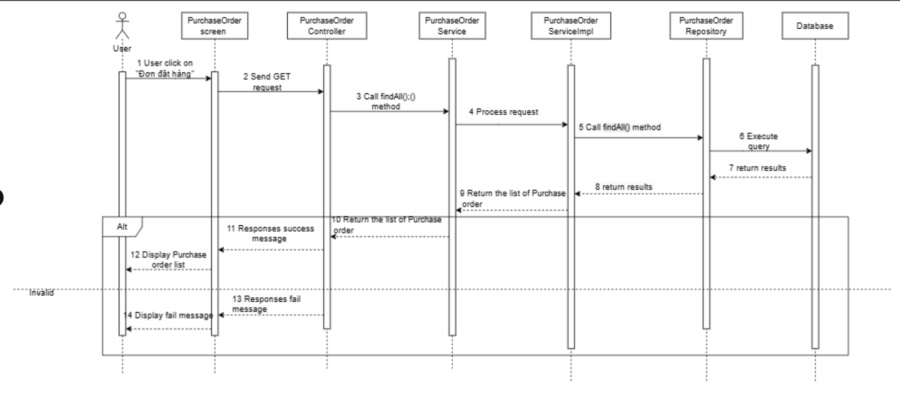

3.9.2 View purchase order detail

3.9.2.1. Class Diagram

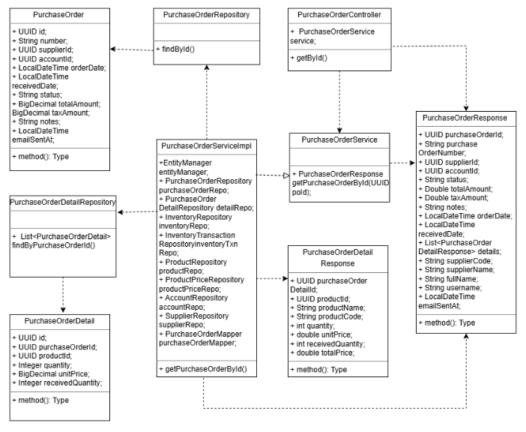

3.9.2.2. Sequence Diagram

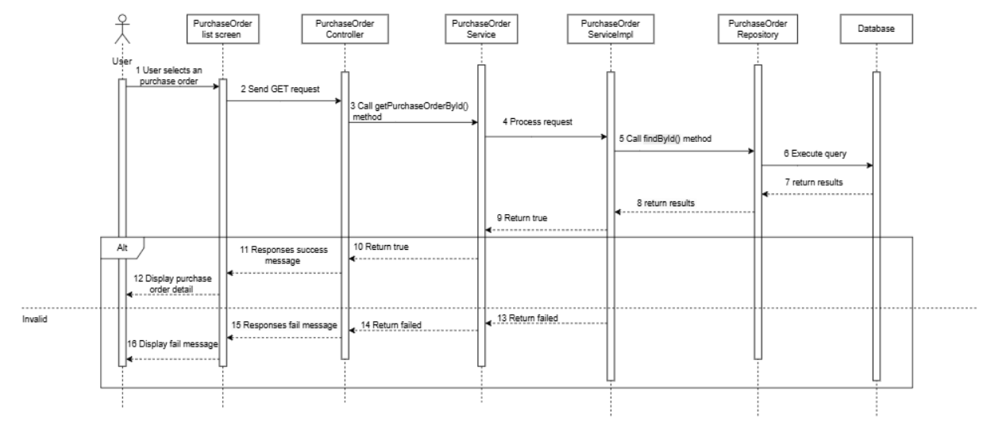

3.9.3 Create purchase order

3.9.3.1. Class Diagram

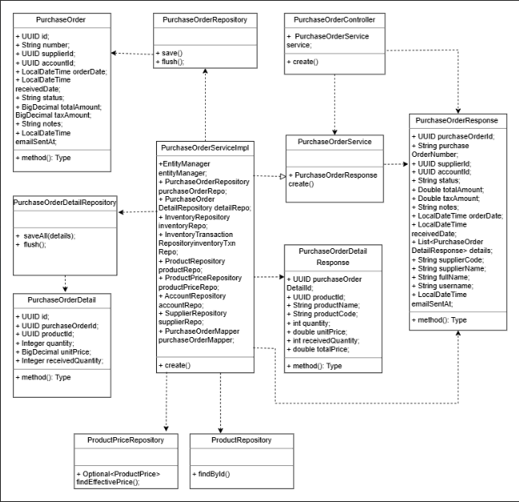

3.9.3.2. Sequence Diagram
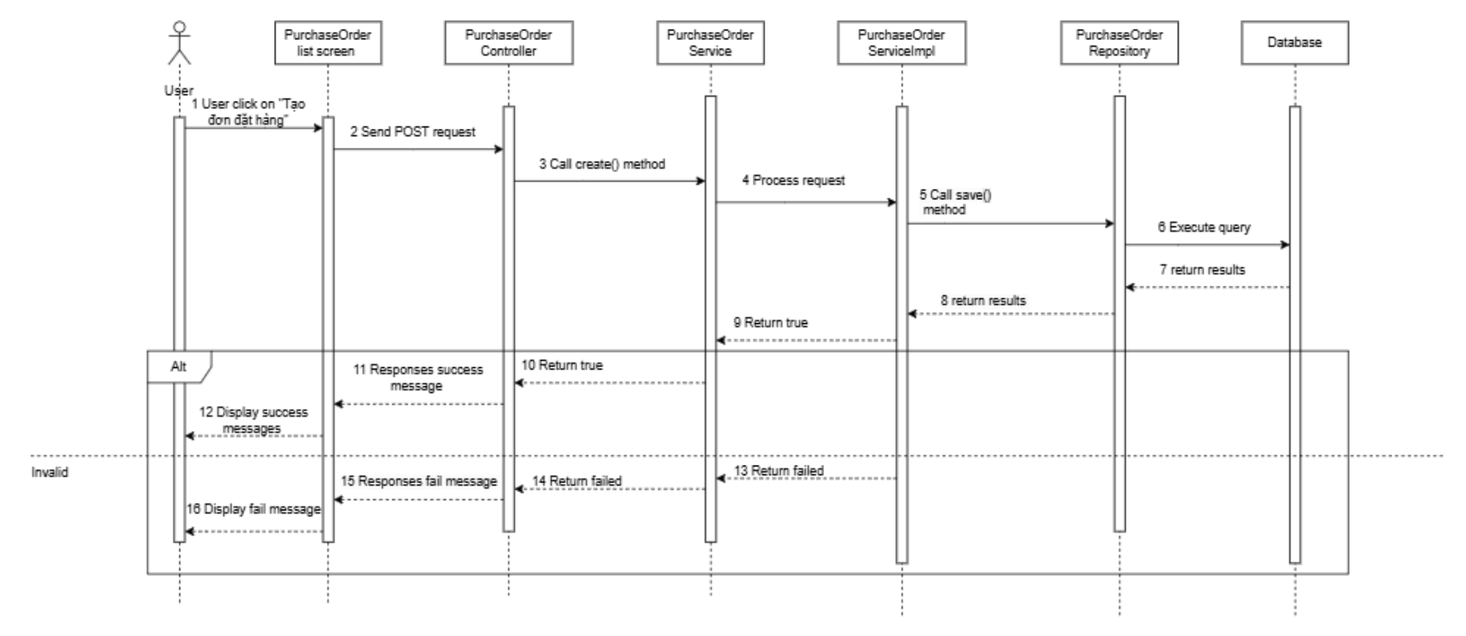

3.9.4 Update purchase order

3.9.4.1. Class Diagram
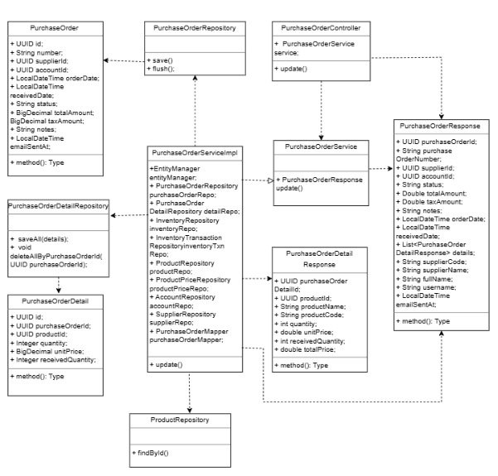

3.9.4.2. Sequence Diagram
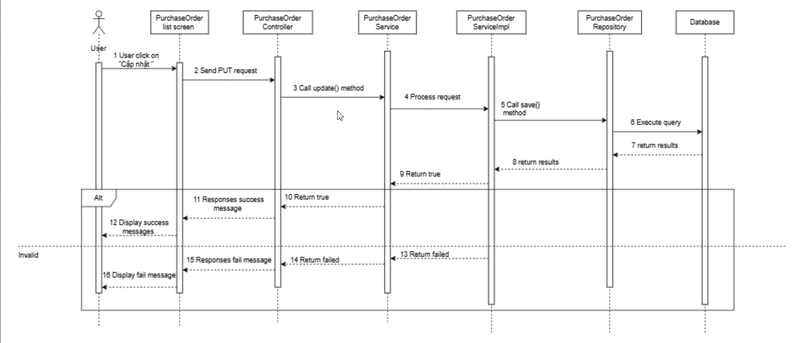

3.9.5 Search purchase order

3.9.5.1. Class Diagram
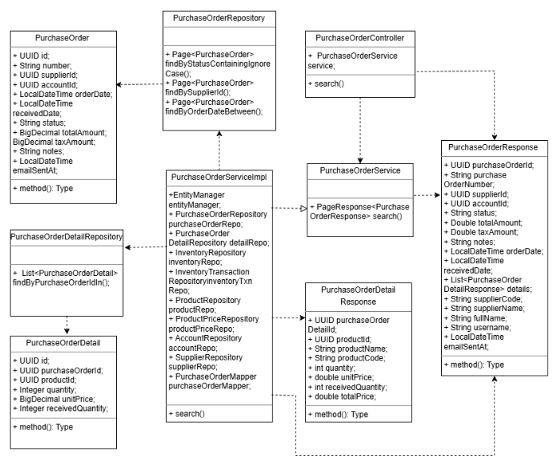

3.9.5.2. Sequence Diagram
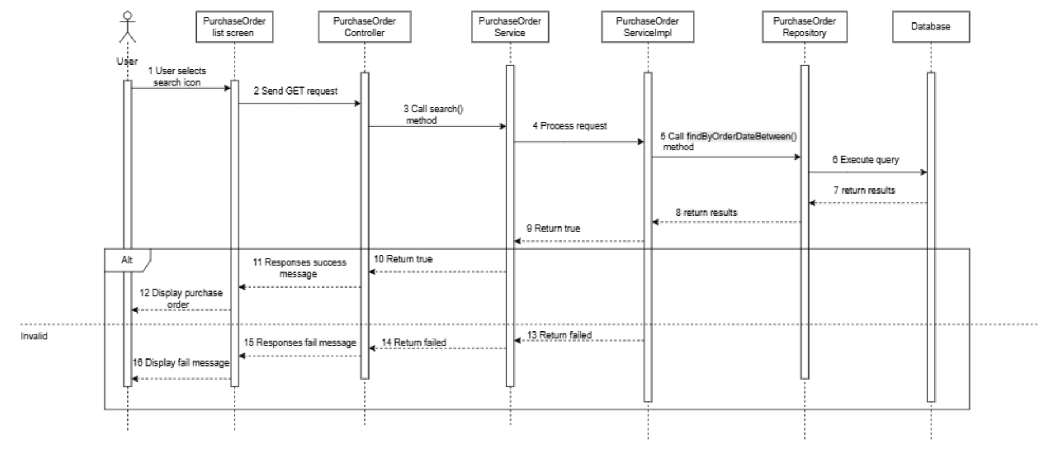

3.10 Promotion Management

3.10.1 View promotion list

3.10.1.1. Class Diagram
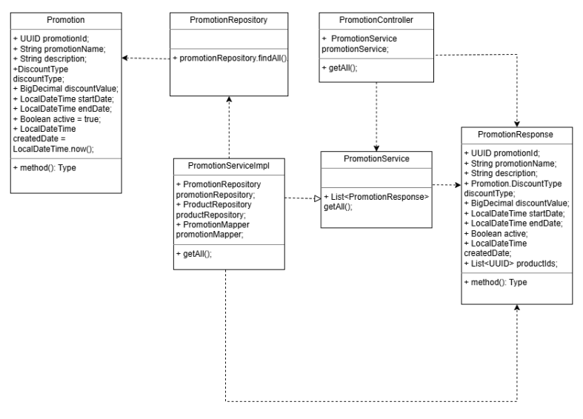

3.10.1.2. Sequence Diagram
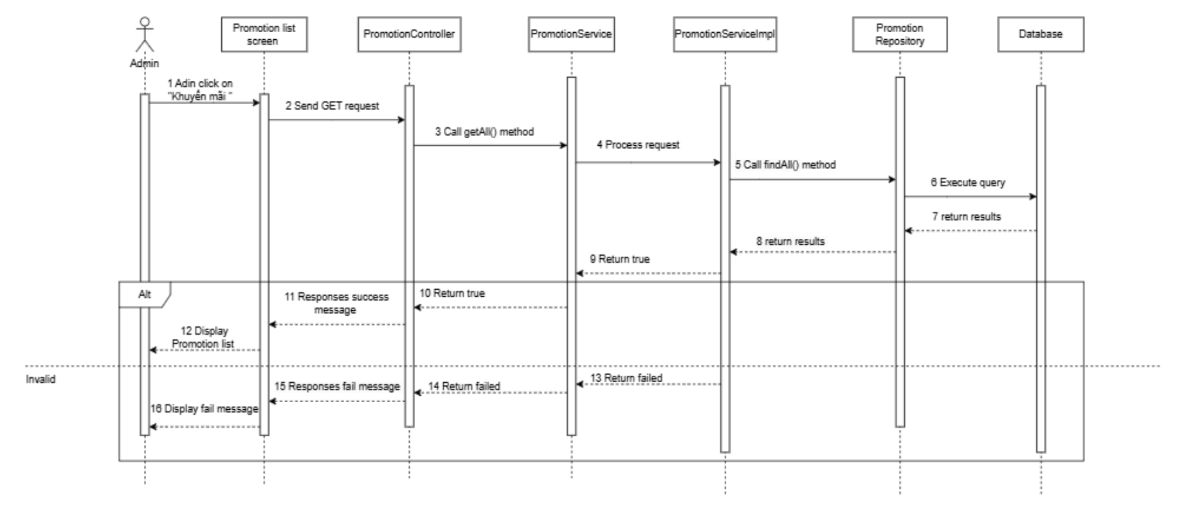

3.10.2 View promotion detail

3.10.2.1. Class Diagram

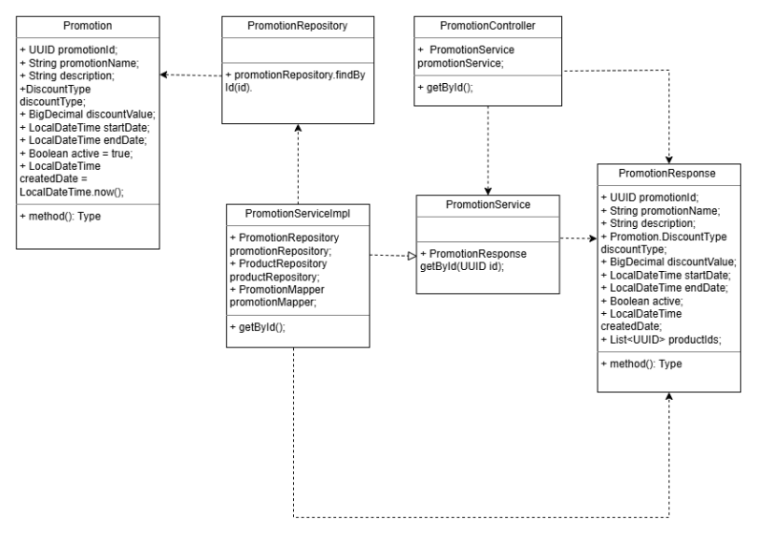

3.10.2.2. Sequence Diagram
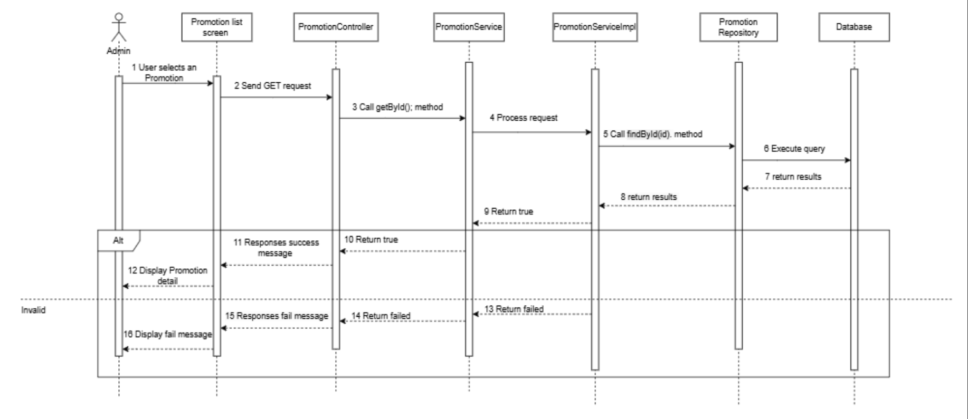

3.10.3 Add new promotion

3.10.3.1. Class Diagram

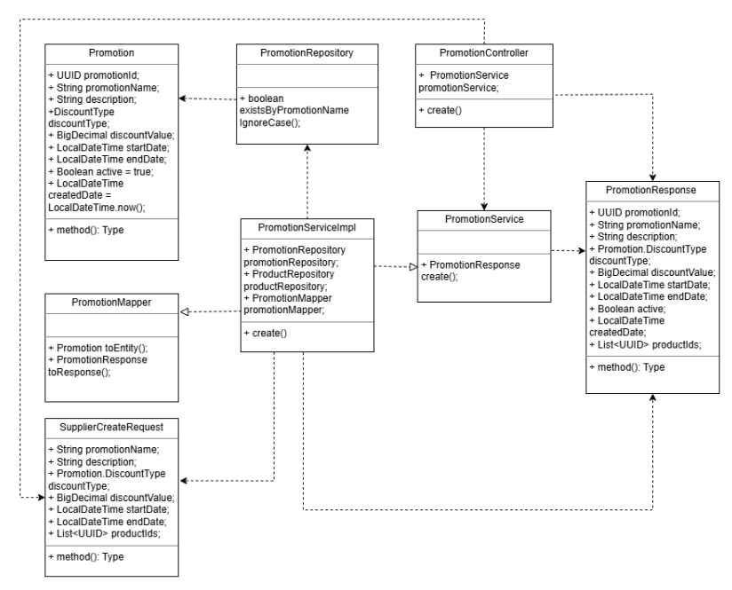

3.10.3.2. Sequence Diagram
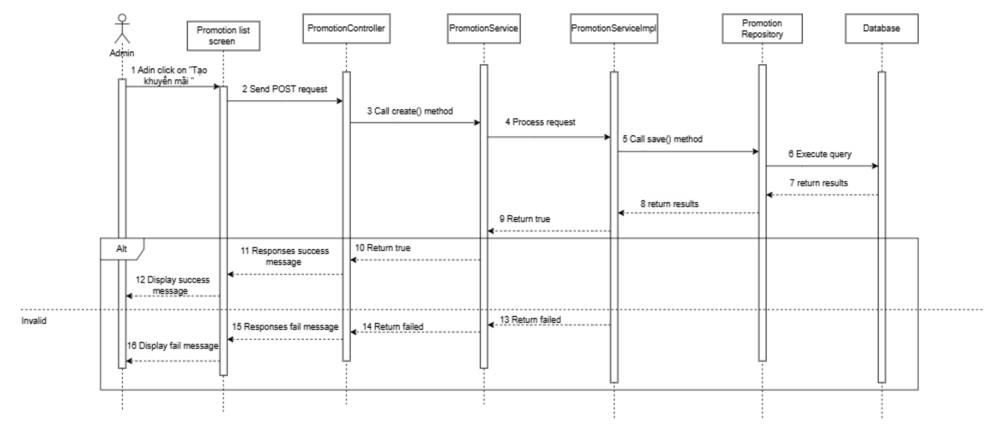

3.10.4 Edit promotion

3.10.4.1. Class Diagram

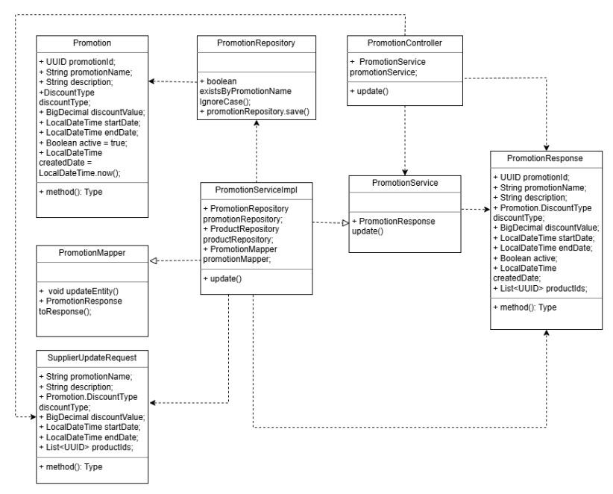

3.10.4.2. Sequence Diagram
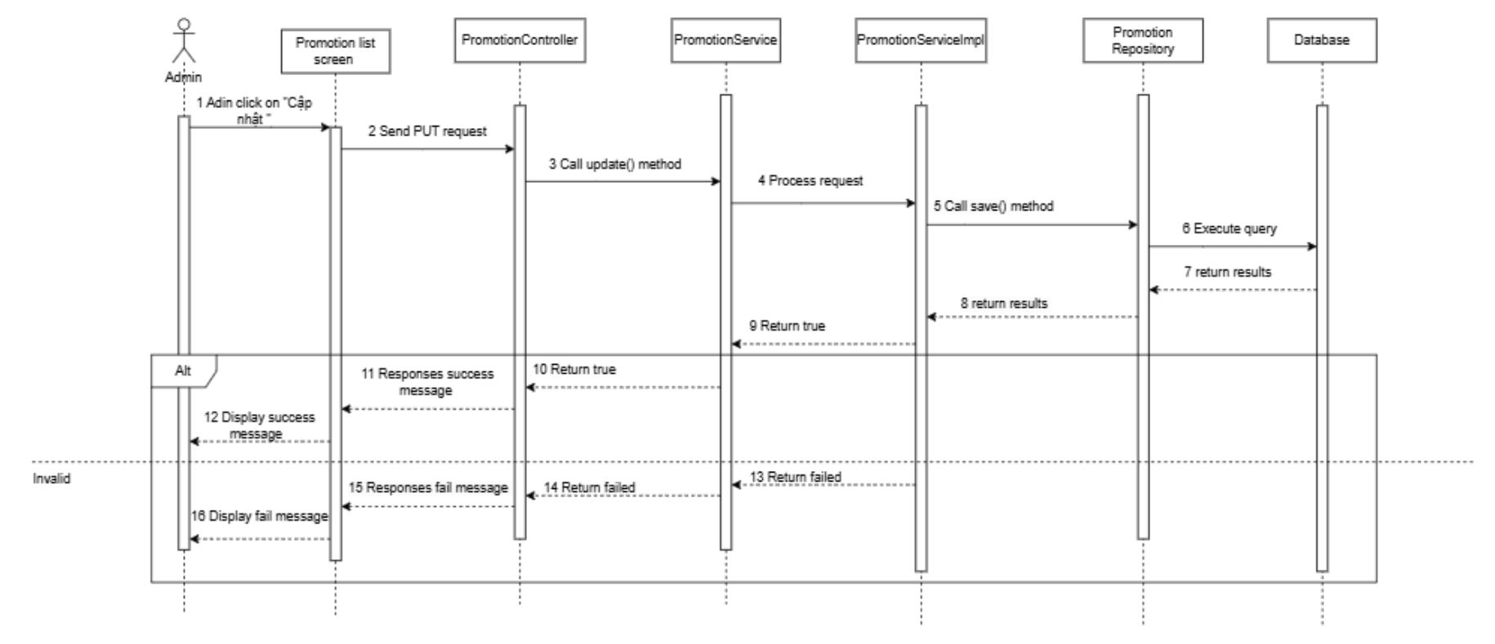

3.10.5 Search promotion

3.10.5.1. Class Diagram

3.10.5.2. Sequence Diagram
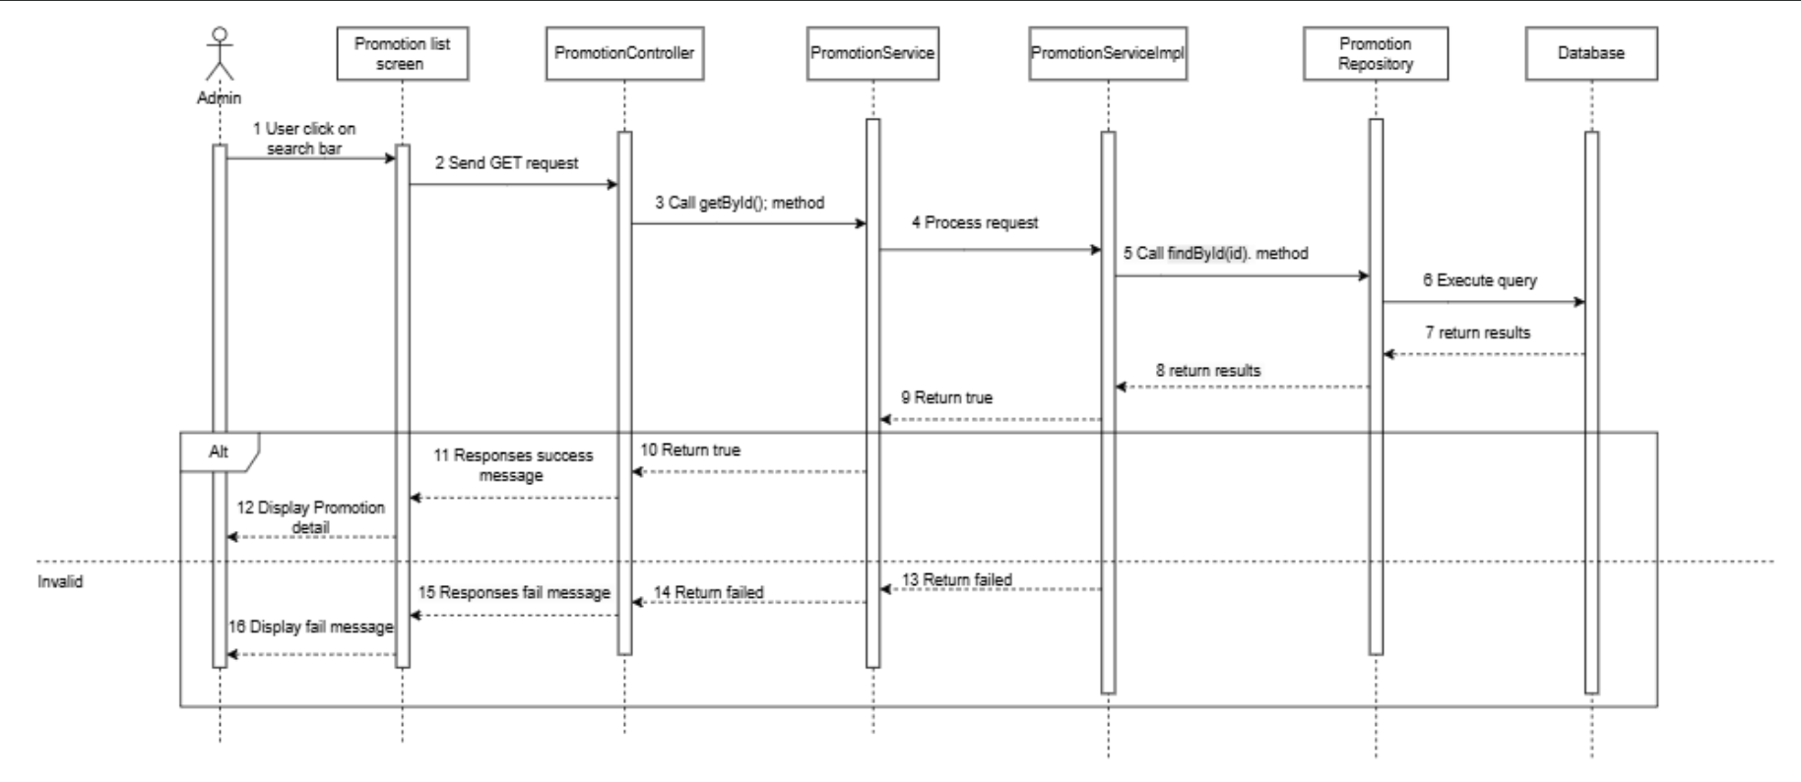

4. Class Specifications

4.1 Controller

4.1.1 CategoryController
- The CategoryController class handles all HTTP requests related to product categories.
- It acts as the REST API layer, receiving requests from clients, delegating business logic to the service layer (CategoryService), and returning standardized ApiResponse objects.
No | Name | Description
Attributes
1 | categoryService | Visibility: private  Type: CategoryService  Purpose: Dependency injected to perform category-related business logic.
Methods/Operations
1 | createCategory(request) | Visibility: public  Return: ApiResponse<CategoryResponse>  Purpose: Creates a new product category.  Parameters:  - request : CategoryCreateRequest — contains information about the new category (name, description, parent category, etc.).
2 | updateCategory(id, request) | Visibility: public  Return: ApiResponse<CategoryResponse>  Purpose: Updates an existing category by its ID.  Parameters:  - id : UUID — the unique identifier of the category to update.  - request : CategoryUpdateRequest — contains updated category information.
3 | getCategoryById(id) | Visibility: public  Return: ApiResponse<CategoryResponse>  Purpose: Retrieves category details by ID.  Parameters:  - id : UUID — the unique identifier of the category.
4 | getAllCategories() | Visibility: public  Return: ApiResponse<List<CategoryResponse>>  Purpose: Retrieves a list of all existing categories in the system.  Parameters: None.
5 | deleteCategoryById(id) | Visibility: public  Return: ApiResponse<String>  Purpose: Deletes a category by its ID.  Parameters:  - id : UUID — the unique identifier of the category to delete.

4.1.2 ProductController
- The ProductController class is responsible for managing all product-related API endpoints in the system.
- It acts as a REST controller that receives client requests, validates input data, delegates business logic to the ProductService, and returns results wrapped in a standardized ApiResponse object.

No | Name | Description
Attributes
1 | productService | Visibility: private  Type: ProductService  Purpose: Service dependency that handles business logic for product creation, updates, imports, and retrieval.
Methods/Operations
1 | createProduct(request) | Visibility: public  Return: ApiResponse<ProductResponse>  Purpose: Creates a new product entry in the system.  Parameters:  - request : ProductCreateRequest — contains product information such as name, price, description, and image file.
2 | updateProduct(id, request) | Visibility: public  Return: ApiResponse<ProductResponse>  Purpose: Updates existing product details by its unique ID.  Parameters:  - id : UUID — unique identifier of the product to update.  - request : ProductUpdateRequest — new data for updating the product.
3 | getAllProducts() | Visibility: public  Return: ApiResponse<List<ProductResponse>>  Purpose: Retrieves a list of all products. Access is restricted to users with the Admin role via @PreAuthorize.  Parameters: None.
4 | getProductById(id) | Visibility: public  Return: ApiResponse<ProductResponse>  Purpose: Retrieves detailed information of a specific product by its ID.  Parameters:  - id : UUID — unique identifier of the product.
5 | deleteProduct(id) | Visibility: public  Return: ApiResponse<String>  Purpose: Deletes a product from the system by its ID.  Parameters:  - id : UUID — unique identifier of the product to be deleted.
6 | importProducts(requests) | Visibility: public  Return: ApiResponse<List<ProductResponse>>  Purpose: Imports multiple products in bulk from provided data.  Parameters:  - requests : List<ProductImportRequest> — list of product data to import.
7 | getProductsBySupplierId(supplierId) | Visibility: public  Return: ApiResponse<List<ProductResponse>>  Purpose: Retrieves all products associated with a specific supplier.  Parameters:  - supplierId : UUID — unique identifier of the supplier.

4.1.3 AccountController
- The AccountController class handles all RESTful API endpoints related to user account management in the SnapBuy system.
- It provides functionalities such as account creation, retrieval, updates, password management, role assignment, and account deletion.
- Access to endpoints is controlled via Spring Security role-based annotations (@PreAuthorize).
No | Name | Description
Attributes
1 | accountService | Visibility: private  Type: AccountService  Purpose: Provides business logic for managing accounts, including creation, update, role assignment, and password changes.
Methods/Operations
1 | createAccount(req) | Visibility: public  Return: ApiResponse<AccountResponse>  Purpose: Creates a new user account.  Parameters:  - req : AccountCreateRequest — data for new account creation.
2 | getAccounts() | Visibility: public  Return: ApiResponse<List<AccountResponse>>  Purpose: Retrieves a list of all accounts (Admin only).
3 | getAccount(accountId) | Visibility: public  Return: ApiResponse<AccountResponse>  Purpose: Retrieves details of a specific account by its ID.  Parameters:  - accountId : UUID — unique identifier of the account.
4 | getMyInfo() | Visibility: public  Return: ApiResponse<AccountResponse>  Purpose: Retrieves information of the currently authenticated user.
5 | updateAccount(accountId, req) | Visibility: public  Return: ApiResponse<AccountResponse>  Purpose: Updates account information.  Parameters:  - accountId : UUID — ID of the account to be updated.  - req : AccountUpdateRequest — updated account data.
6 | deleteAccount(accountId) | Visibility: public  Return: ApiResponse<Void>  Purpose: Deletes an account by ID (Admin only).
7 | assignRole(accountId, roleId) | Visibility: public  Return: ApiResponse<AccountResponse>  Purpose: Assigns a role to a specific account (Admin only).  Parameters:  - accountId : UUID — account to assign the role.  - roleId : UUID — role to assign.
8 | changePassword(accountId, req) | Visibility: public  Return: ApiResponse<AccountResponse>  Purpose: Allows password change for a specified account.  Parameters:  - accountId : UUID — account whose password will be changed.  - req : ChangePasswordRequest — contains old and new passwords.
9 | changePasswordMe(req) | Visibility: public  Return: ApiResponse<Void>  Purpose: Allows the currently logged-in user to change their own password.
10 | createShopOwner(req) | Visibility: public  Return: ApiResponse<AccountResponse>  Purpose: Allows admin to create a new shop owner account.
11 | createStaff(req) | Visibility: public  Return: ApiResponse<AccountResponse>  Purpose: Allows a shop owner to create new staff accounts.
12 | updateStaffByOwner(staffId, req) | Visibility: public  Return: ApiResponse<AccountResponse>  Purpose: Allows a shop owner to update staff information.  Parameters:  - staffId : UUID — staff account ID.  - req : StaffOwnerUpdateRequest — updated staff data.
13 | updateStaffRolesByOwner(staffId, req) | Visibility: public  Return: ApiResponse<AccountResponse>  Purpose: Allows shop owners to update roles assigned to a staff member.
14 | adminUpdateAccount(accountId, req) | Visibility: public  Return: ApiResponse<AccountResponse>  Purpose: Allows admin to update any account details.
15 | unassignRole(accountId, roleId) | Visibility: public  Return: ApiResponse<Void>  Purpose: Removes an assigned role from an account (Admin or Shop Owner).

4.1.4 SupplierController
- The SupplierController class manages all RESTful API endpoints related to suppliers in the SnapBuy system.
- It provides endpoints to create, update, retrieve, and delete supplier records.
- This controller delegates all business logic to the SupplierService and returns standardized responses using the ApiResponse wrapper.
No | Name | Description
Attributes
1 | supplierService | Visibility: private  Type: SupplierService  Purpose: Handles supplier-related business logic, including creation, update, retrieval, and deletion operations.
Methods/Operations
1 | createSupplier(request) | Visibility: public  Return: ApiResponse<SupplierResponse>  Purpose: Creates a new supplier record.  Parameters:  - request : SupplierCreateRequest — contains supplier details to be created.
2 | updateSupplier(id, request) | Visibility: public  Return: ApiResponse<SupplierResponse>  Purpose: Updates an existing supplier by ID.  Parameters:  - id : UUID — unique identifier of the supplier to update.  - request : SupplierUpdateRequest — contains updated supplier data.
3 | getAllSuppliers() | Visibility: public  Return: ApiResponse<List<SupplierResponse>>  Purpose: Retrieves a list of all suppliers in the system.
4 | getSupplierById(id) | Visibility: public  Return: ApiResponse<SupplierResponse>  Purpose: Retrieves a specific supplier by its unique ID.  Parameters:  - id : UUID — unique supplier identifier.
5 | deleteSupplierById(id) | Visibility: public  Return: ApiResponse<String>  Purpose: Deletes a supplier by its ID. Returns a confirmation message upon success.  Parameters:  - id : UUID — unique supplier identifier.

4.1.5 CustomerController
- CustomerController is a REST controller responsible for handling all customer-related API operations such as creating, updating, retrieving, searching, and deleting customer information.

No | Name | Description
Attributes
1 | customerService | Visibility: private  Type: CustomerService  Purpose: Provides business logic for all customer operations.
Methods/Operations
1 | createCustomer(request) | Visibility: public  Return: ApiResponse<CustomerResponse>  Purpose: Creates a new customer.  Parameters:  • request : CustomerCreateRequest — contains customer creation data.
2 | getAllCustomers() | Visibility: public  Return: ApiResponse<List<CustomerResponse>>  Purpose: Retrieves all customers in the system.  Parameters: • None
3 | getCustomerById(id) | Visibility: public  Return: ApiResponse<CustomerResponse>  Purpose: Retrieves customer details by ID.  Parameters:  • id : UUID — customer identifier.
4 | updateCustomer(id, request) | Visibility: public  Return: ApiResponse<CustomerResponse>  Purpose: Updates an existing customer record.  Parameters:  • id : UUID — customer ID to update.  • request : CustomerUpdateRequest — updated customer data.
5 | deleteCustomer(id) | Visibility: public  Return: ApiResponse<String>  Purpose: Deletes a customer by ID.  Parameters:  • id : UUID — ID of the customer to delete.
6 | searchCustomer(keyword) | Visibility: public  Return: ApiResponse<List<CustomerResponse>>  Purpose: Searches customers using a keyword (name/phone/email).  Parameters:  • keyword : String — search keyword.
7 | getCustomerByPhone(phone) | Visibility: public  Return: ApiResponse<CustomerResponse>  Purpose: Retrieves customer details by phone number.  Parameters:  • phone : String — customer phone number.
8 | getCustomersByPoints(min, max, sort) | Visibility: public  Return: ApiResponse<List<CustomerResponse>>  Purpose: Retrieves customers filtered by point range and sorting order.  Parameters:  • min : Integer — minimum points (optional).  • max : Integer — maximum points (optional).  • sort : String — sorting order (“asc” or “desc”).

4.1.6 OrderController
- OrderController is a REST controller responsible for handling all order-related API operations such as creating orders, retrieving order details, searching orders, updating order statuses (hold, complete, cancel), and listing all orders in the system.

No | Name | Description
Attributes
1 | orderService | Visibility: privateType: OrderServicePurpose: Provides business logic for all order-related operations.
Methods/Operations
1 | createOrder(req) | Visibility: public  Return: ApiResponse  Purpose: Creates a new order in the system.  Parameters:  • req : OrderCreateRequest — contains data used to create an order.
2 | getOrder(id) | Visibility: public  Return: ApiResponse  Purpose: Retrieves order details by ID.  Parameters:  • id : UUID — unique identifier of the order.
3 | getAllOrders(searchTerm, orderStatus, from, to) | Visibility: public  Return: ApiResponse<List>  Purpose: Retrieves all orders or searches orders based on filters.  Parameters:  • searchTerm : String — keyword for searching (optional).  • orderStatus : String — status filter (optional).  • from : String — start date (optional, format: yyyy-MM-dd).  • to : String — end date (optional, format: yyyy-MM-dd).
4 | holdOrder(id) | Visibility: public  Return: ApiResponse  Purpose: Moves an order to On-Hold status.  Parameters:  • id : UUID — ID of the order.
5 | completeOrder(id) | Visibility: public  Return: ApiResponse  Purpose: Marks an order as Completed.  Parameters:  • id : UUID — ID of the order.
6 | cancelOrder(id) | Visibility: public  Return: ApiResponse  Purpose: Cancels the order.  Parameters:  • id : UUID — ID of the order to cancel.

4.1.7 PromotionController
- PromotionController is a REST controller responsible for managing promotion-related operations, including creating promotions, updating promotions, retrieving all promotions, and fetching promotion details by ID. Access to these APIs is restricted based on user roles ("Quản trị viên" and "Chủ cửa hàng").
No | Name | Description
Attributes
1 | promotionService | Visibility: private  Type: PromotionService  Purpose: Provides business logic for all promotion-related operations.
Methods/Operations
1 | create(request) | Visibility: public  Return: ApiResponse<PromotionResponse>  Purpose: Creates a new promotion.  Security: Only users with roles Quản trị viên or Chủ cửa hàng can perform this action.  Parameters:  • request : PromotionCreateRequest — contains promotion creation data.
2 | update(id, request) | Visibility: public  Return: ApiResponse<PromotionResponse>  Purpose: Updates an existing promotion by ID.  Security: Only users with roles Quản trị viên or Chủ cửa hàng can perform this action.  Parameters:  • id : UUID — unique identifier of the promotion to update.  • request : PromotionUpdateRequest — updated promotion data.
3 | getAll() | Visibility: public  Return: ApiResponse<List<PromotionResponse>>  Purpose: Retrieves all promotions in the system.  Security: Only users with roles Quản trị viên or Chủ cửa hàng can perform this action.  Parameters: • None
4 | getById(id) | Visibility: public  Return: ApiResponse<PromotionResponse>  Purpose: Retrieves detailed information of a promotion by ID.  Security: Only users with roles “Quản trị viên” or “Chủ cửa hàng” can perform this action.  Parameters:  • id : UUID — identifier of the promotion.

4.1.8 CustomerReportController
- CustomerReportController is a REST controller responsible for handling customer report operations, including generating daily reports, monthly reports, yearly reports, and custom-range reports.
- Access to these APIs is restricted to users with the roles “Administrator” or “Store Owner.”
No | Name | Description
Attributes
1 | customerReportService | • Visibility: private  • Type: CustomerReportService  • Purpose: Processes and generates customer reports based on different time periods.
Methods/Operations
1 | getDailyCustomerReport(date) | Visibility: public  Return: ApiResponse<CustomerReportResponse>  Purpose: Retrieves the customer report for a specific day.  Security: Accessible only to users with the roles Administrator or Store Owner.  Parameters:  • date : LocalDate — the date for which the report is requested.
2 | getMonthlyCustomerReport(year, month) | Visibility: public  Return: ApiResponse<CustomerReportResponse>  Purpose: Retrieves the customer report for a specific month and year.  Security: Accessible only to users with the roles Administrator or Store Owner.  Parameters:  • year : int — the year of the report.  • month : int — the month of the report.
3 | getYearlyCustomerReport(year) | Visibility: public  Return: ApiResponse<CustomerReportResponse>  Purpose: Retrieves the customer report for a full year.  Security: Accessible only to users with the roles Administrator or Store Owner.  Parameters:  • year : int — the year for the requested report.
4 | getCustomCustomerReport(startDate, endDate) | Visibility: public  Return: ApiResponse<CustomerReportResponse>  Purpose: Retrieves a customer report within a custom date range.  Security: Accessible only to users with the roles Administrator or Store Owner.  Parameters:  • startDate : LocalDate — starting date of the range.  • endDate : LocalDate — ending date of the range.

4.1.9 PosShiftController
- PosShiftController is a REST controller responsible for managing POS (Point-of-Sale) shift operations.
- It provides APIs for opening shifts, closing shifts, retrieving the current active shift, and listing shifts by account or status.
- Access to these APIs is restricted based on user roles, including Administrator, Store Owner, and Sales Staff, depending on the specific operation.
No | Name | Description
Attributes
1 | posShiftService | • Visibility: private  • Type: PosShiftService  • Purpose: Handles shift opening, closing, retrieving active shifts, and fetching shift histories
Methods/Operations
1 | current(principal) | Visibility: public  Return: ApiResponse<PosShiftResponse>  Purpose: Retrieves the currently active shift of the authenticated user.  Security: Roles allowed: Administrator, Store Owner, Sales Staff  Parameters:  • principal : User — authenticated user information used to identify the account.
2 | open(req, principal) | Visibility: public  Return: ApiResponse<PosShiftResponse>  Purpose: Opens a new POS shift for the current authenticated manager/owner.  Security: Roles allowed: Administrator, Store Owner  Parameters:  • req : PosShiftOpenRequest — contains initial cash and cash denominations.  • principal : User — authenticated user opening the shift.
3 | openForEmployee(req, principal) | Visibility: public  Return: ApiResponse<PosShiftResponse>  Purpose: Opens a POS shift on behalf of another employee.  Security: Roles allowed: Administrator, Store Owner  Parameters:  • req : PosShiftOpenForEmployeeRequest — includes employee account ID, initial cash, and cash denominations.  • principal : User — user performing the operation.
4 | close(req, principal) | Visibility: public  Return: ApiResponse<PosShiftResponse>  Purpose: Closes the current POS shift of the authenticated user.  Security: Roles allowed: Administrator, Store Owner, Sales Staff  Parameters:  • req : PosShiftCloseRequest — contains closing cash, notes, and denominations.  • principal : User — the user closing the shift.
5 | closeForEmployee(req, principal) | Visibility: public  Return: ApiResponse<PosShiftResponse>  Purpose: Allows administrators or store owners to close a shift on behalf of an employee.  Security: Roles allowed: Administrator, Store Owner  Parameters:  • req : PosShiftCloseForEmployeeRequest — includes employee account ID, closing cash, notes, and denominations.  • principal : User — the user performing the operation.
6 | myShifts(principal, status) | Visibility: public  Return: ApiResponse<List<PosShiftResponse>>  Purpose: Retrieves a list of all shifts belonging to the authenticated user.  Optionally filters by status (e.g., active, closed).  Security: Roles allowed: Administrator, Store Owner, Sales Staff  Parameters:  • principal : User — the authenticated user.  • status : String (optional) — filter condition for shift status.
7 | getByAccount(accountId, status) | Visibility: public  Return: ApiResponse<List<PosShiftResponse>>  Purpose: Retrieves shift history for a specific account (employee).  Security: Roles allowed: Administrator, Store Owner  Parameters:  • accountId : UUID — employee’s account ID.  • status : String (optional) — shift status filter.
8 | getAllActiveShifts(principal) | Visibility: public  Return: ApiResponse<List<PosShiftResponse>>  Purpose: Retrieves all currently active POS shifts across the store.  Useful for admins and store owners to monitor staff activity.  Security: Roles allowed: Administrator, Store Owner  Parameters:  • principal : User — authenticated user performing the operation.

4.1.10 PurchaseOrderController
- PurchaseOrderController is a REST controller responsible for managing purchase order operations, including creating purchase orders, updating them, approving, receiving goods, canceling, confirming, reverting approval, searching, deleting, and sending purchase order emails.
- Access to these APIs is restricted to users with specific roles such as Administrator, Store Owner, and Warehouse Staff.
No | Name | Description
Attributes
1 | service | •Visibility: private  • Type: PurchaseOrderService  • Purpose: Handles creation, updates, approval, receiving, searching, and deletion of purchase order
Methods/Operations
1 | create(req, principal) | Visibility: public  Return: ApiResponse<PurchaseOrderResponse>  Purpose: Creates a new purchase order.  Security: Roles allowed: Administrator, Store Owner, Warehouse Staff  Parameters:  • req : PurchaseOrderCreateRequest — purchase order creation details.  • principal : User — authenticated user.
2 | receive(id, req, principal) | Visibility: public  Return: ApiResponse<PurchaseOrderResponse>  Purpose: Marks a purchase order as received, updating received quantity, time, and notes.  Security: Roles allowed: Administrator, Store Owner, Warehouse Staff  Parameters:  • id : UUID — purchase order ID.  • req : PurchaseOrderReceiveRequest — receiving details.  • principal : User..
3 | cancel(id, principal) | Visibility: public  Return: ApiResponse<PurchaseOrderResponse>  Purpose: Cancels a purchase order.  Security: Roles allowed: Administrator, Store Owner, Warehouse Staff  Parameters:  • id : UUID — purchase order ID.  • principal : User.
4 | approve(id, req, principal) | Visibility: public  Return: ApiResponse<PurchaseOrderResponse>  Purpose: Approves a purchase order before goods are received.  Security: Roles allowed: Administrator, Store Owner  Parameters:  • id : UUID  • req : PurchaseOrderApproveRequest  • principal : User
5 | getAll() | Visibility: public  Return: ApiResponse<List<PurchaseOrderResponse>>  Purpose: Retrieves all purchase orders in the system.  Security: Roles allowed: Administrator, Store Owner, Warehouse Staff  Parameters: none.
6 | search(...) | Visibility: public  Return: ApiResponse<PageResponse<PurchaseOrderResponse>>  Purpose: Searches for purchase orders using filters such as status, supplier, date range, and pagination.  Security: Roles allowed: Administrator, Store Owner, Warehouse Staff  Parameters:  • status : String  • supplierId : UUID  • from : LocalDateTime  • to : LocalDateTime  • pagination arguments (page, size)
7 | searchByKeyword(...) | Visibility: public  Return: ApiResponse<PageResponse<PurchaseOrderResponse>>  Purpose: Searches for purchase orders using keyword + advanced filtering (order date, received date, status, sorting).  Security: Roles allowed: Administrator, Store Owner, Warehouse Staff  Parameters:  • keyword : String  • status : String  • date ranges for order and received dates  • pagination and sorting options
8 | getById(id) | Visibility: public  Return: ApiResponse<PurchaseOrderResponse>  Purpose: Retrieves details of a purchase order by ID.  Security: Roles allowed: Administrator, Store Owner, Warehouse Staff  Parameters:  • id : UUID
9 | update(id, req, principal) | Visibility: public  Return: ApiResponse<PurchaseOrderResponse>  Purpose: Updates a purchase order including items, quantities, notes, or supplier.  Security: Roles allowed: Administrator, Store Owner, Warehouse Staff  Parameters:  • id : UUID  • req : PurchaseOrderUpdateRequest  • principal : User
10 | confirm(id, req, principal) | Visibility: public  Return: ApiResponse<PurchaseOrderResponse>  Purpose: Confirms goods reception after approval (used mainly by management).  Security: Roles allowed: Administrator, Store Owner  Parameters:  • id : UUID  • req : PurchaseOrderReceiveRequest  • principal : User
11 | revert(id, req, principal) | Visibility: public  Return: ApiResponse<PurchaseOrderResponse>  Purpose: Reverts the purchase order back to Approved state.  Security: Roles allowed: Administrator, Store Owner  Parameters:  • id : UUID  • req : PurchaseOrderApproveRequest  • principal : User
12 | sendEmail(request) | Visibility: public  Return: ApiResponse<String>  Purpose: Sends a purchase order email to the supplier.  Security: Roles allowed: Administrator, Store Owner, Warehouse Staff  Parameters:  • request : PurchaseOrderEmailRequest

4.2 Service

4.1.1 CategoryServiceImpl
- CategoryServiceImpl is a service class responsible for implementing all business operations related to product categories.
- It handles creating categories, updating them, deleting them (including recursive deletion of child categories), toggling category status (activate/deactivate), and searching both parent and subcategories with pagination.
- This class interacts with the database through CategoryRepository and uses CategoryMapper for converting entities to DTOs.
No | Name | Description
Attributes
1 | categoryRepository | • Visibility: private  • Type: CategoryRepository  • Purpose: Database access for category operations
2 | categoryMapper | • Visibility: private  • Type: CategoryMapper  • Purpose: Mapping Category ↔ DTO
Methods/Operations
1 | createCategory(request) | Visibility: public  Return: CategoryResponse  Purpose: Creates a new category after validating the name and checking if the parent category exists.  Parameters:  • request : CategoryCreateRequest — category creation data.
2 | getAllCategories() | Visibility: public  Return: List<CategoryResponse>  Purpose: Retrieves all categories from the system.  Parameters:  • None
3 | getCategoryById(id) | Visibility: public  Return: CategoryResponse  Purpose: Retrieves detailed information about a specific category by ID.  Parameters:  • id : UUID — category identifier.
4 | updateCategory(id, request) | Visibility: public  Return: CategoryResponse  Purpose: Updates an existing category, including validation of name uniqueness and parent category existence.  Parameters:  • id : UUID — ID of the category to update.  • request : CategoryUpdateRequest — updated category data.
5 | deleteCategoryById(id) | Visibility: public  Return: void  Purpose: Deletes a category and recursively deletes all child categories associated with it.  Parameters:  • id : UUID — ID of the category to delete.
6 | toggleCategoryStatus(id) | Visibility: public  Return: CategoryResponse  Purpose: Toggles the activation status of a category (activate or deactivate).  When activating: enables all parent and child categories.  When deactivating: disables all child categories.  Parameters:  • id : UUID — category identifier.
7 | searchParentCategoriesByKeyword(keyword, pageable) | Visibility: public  Return: PageResponse<CategoryResponse>  Purpose: Searches parent categories by keyword with pagination support.  Parameters:  • keyword : String — search term.  • pageable : Pageable — pagination and sorting configuration.

4.1.2 ProductServiceImpl
- ProductServiceImpl is a service class responsible for handling all business logic related to product management.
- It supports product creation, updating, image handling, barcode validation, category & supplier relation checks, product importing, searching, deleting, retrieving by ID or barcode, and managing inventory & pricing defaults.
- It interacts with repositories for product, category, supplier, price, and inventory operations and uses ProductMapper for mapping entities to DTOs.
No | Name | Description
Attributes
1 | productRepository | • Visibility: private  • Type: ProductRepository  • Purpose: Provides data access and CRUD operations for product entities.
2 | categoryRepository | • Visibility: private  • Type: CategoryRepository  • Purpose: Fetches and validates category data, including parent/subcategory lookup.
3 | supplierRepository | • Visibility: private  • Type: SupplierRepository  • Purpose: Retrieves supplier information and checks supplier code/name consistency
4 | productPriceRepository | • Visibility: private  • Type: ProductPriceRepository  • Purpose: Manages product price history and retrieves the latest valid price
5 | inventoryRepository | • Visibility: private  • Type: InventoryRepository  • Purpose: Handles inventory data such as stock quantity, reorder points, and synchronization with product creation.
6 | productMapper | • Visibility: private  • Type: ProductMapper  • Purpose: Converts between product entities and DTO models for responses and requests.
7 | uploadDir | • Visibility: private  • Type: String  • Purpose: Stores the root upload directory path for saving product images; populated via configuration property (@Value("${upload.dir}")).
Methods/Operations
1 | createProduct(request) | Visibility: public  Return: ProductResponse  Purpose: Creates a new product including:  • validating category & supplier  • checking barcode uniqueness  • handling image upload  • setting initial inventory and price  Parameters:  • request : ProductCreateRequest
2 | updateProduct(id, request) | Visibility: public  Return: ProductResponse  Purpose: Updates product information, validates barcode, handles category/supplier updates, manages image replacement/removal.  Parameters:  • id : UUID — product ID  • request : ProductUpdateRequest
3 | getProductById(id) | Visibility: public  Return: ProductResponse  Purpose: Retrieves product details including category hierarchy, latest pricing, and inventory.  Parameters:  • id : UUID
4 | getProductByBarcode(barcode) | Visibility: public  Return: ProductResponse  Purpose: Retrieves product by barcode, checks whether product and its category are active, adds price & stock details.  Parameters:  • barcode : String
5 | getAllProducts() | Visibility: public  Return: List<ProductResponse>  Purpose: Retrieves all active products with active categories, including latest price & inventory.  Parameters:  • None
6 | deleteProduct(id) | Visibility: public  Return: void  Purpose: Deletes a product and its related records (prices, inventory).  Parameters:  • id : UUID
7 | importProducts(requests) | Visibility: public  Return: List<ProductResponse>  Purpose: Imports multiple products with detailed validation on:  • product code  • supplier code & name consistency  • category & subcategory creation or lookup  • barcode validation  • Creates product, default price, and inventory for each valid row.  Parameters:  • requests : List<ProductImportRequest>
8 | getProductsBySupplierId(supplierId) | Visibility: public  Return: List<ProductResponse>  Purpose: Retrieves active products belonging to a specific supplier, including pricing & inventory.  Parameters:  • supplierId : UUID
9 | toggleProductStatus(id) | Visibility: public  Return: ProductResponse  Purpose: Activates or deactivates a product (toggle).  Parameters:  • id : UUID
10 | buildProductPageResponse(productPage) | Visibility: private  Return: PageResponse<ProductResponse>  Purpose: Builds paginated product listing including:  • category hierarchy names  • latest price  • stock quantity  Parameters:  • productPage : Page<Product>

4.1.3 AccountServiceImpl
- AccountServiceImpl layer implementation responsible for managing user accounts, including creation, updating, authentication-related operations, role assignments, staff management, password changes, activation toggling, and account searching with pagination.
- The class enforces role-based access control (RBAC) using Spring Security annotations and provides strict validation rules for each operation.
No | Name | Description
Attributes
1 | accountRepository | • Visibility: private final  • Type: AccountRepository  • Purpose: Handles CRUD operations and custom queries for Account entities.
2 | roleRepository | • Visibility: private final  • Type: RoleRepository  • Purpose: Fetches and validates role information; used for assigning or updating user roles.
3 | accountMapper | • Visibility: private final  • Type: AccountMapper  • Purpose: Converts between Account entities and AccountResponse/DTOs.
4 | passwordEncoder | • Visibility: private final  • Type: PasswordEncoder  • Purpose: Hashes and verifies passwords securely.
5 | uploadDir | • Visibility: private  • Type: String  • Purpose: Stores directory path used for uploading avatar images (@Value("${upload.dir}")).
6 | FORBIDDEN_STAFF_ROLES | • Visibility: private static final  • Type: Set<String>  • Purpose: Stores restricted roles that staff cannot have (e.g., Admin, Owner).
Methods/Operations
1 | getCurrentUsername() | • Visibility: private  • Return: String  • Purpose: Retrieves currently authenticated username from Spring Security context.
2 | isAdmin() | • Visibility: private  • Return: boolean  • Purpose: Checks if current authenticated user has admin role.
3 | ensureActive(Role r) | • Visibility: private  • Return: void  • Purpose: Ensures role is active; throws exception if not.
4 | createAccount(req) | • Visibility: public  • Return: AccountResponse  • Purpose: Admin creates any account with a specified role (default: Owner).
5 | getMyInfo() | • Visibility: public  • Return: AccountResponse  • Purpose: Returns the currently logged-in user's information.
6 | getAccounts() | • Visibility: public  • Return: List<AccountResponse>  • Purpose: Admin retrieves all accounts in the system.
7 | getAccount(id) | • Visibility: public  • Return: AccountResponse  • Purpose: Admin/Owner/Seller retrieves account by ID.
8 | changePassword(accountId, req) | • Visibility: public  • Return: AccountResponse  • Purpose: Changes password for a specific account, verifying old password.
9 | assignRole(accountId, roleId) | • Visibility: public  • Return: AccountResponse  • Purpose: Assigns a new role to an account.
10 | unassignRole(accountId, roleId) | • Visibility: public  • Return: void  • Purpose: Removes a role from an account with special admin protections.
11 | getStaffByIdForOwner(staffId) | • Visibility: public  • Return: AccountResponse  • Purpose: Owner retrieves staff info while preventing access to admins/owners.
12 | adminUpdateAccount(accountId, req) | • Visibility: public  • Return: AccountResponse  • Purpose: Admin updates any account (personal info, roles, status, password).  - req : StaffOwnerUpdateRequest — updated staff data.
13 | updateAccount(accountId, req) | • Visibility: public  • Return: AccountResponse  • Purpose: User updates their own account; admin can update others.
14 | deleteAccount(accountId) | • Visibility: public  • Return: void  • Purpose: Admin deletes an account with protections for admin roles and self-deletion.
15 | toggleAccountStatus(accountId) | • Visibility: public  • Return: AccountResponse  • Purpose: Enables/disables account status (cannot disable own account).

4.1.4 SupplierServiceImpl
- Implementation of SupplierService responsible for managing supplier data.
- This class handles:
- Creating suppliers
- Updating supplier information
- Retrieving suppliers
- Enabling/disabling suppliers
- Deleting suppliers

No | Name | Description
Attributes
1 | supplierRepository | • Visibility: private final  • Type: SupplierRepository  • Purpose: Performs CRUD operations and custom queries for Supplier entities.
2 | supplierMapper | • Visibility: private final  • Type: SupplierMapper  • Purpose: Converts between Supplier entity objects and their corresponding request/response DTOs.
Methods/Operations
1 | createSupplier(request) | Visibility: public  Return: SupplierResponse  Purpose:  Creates a new supplier, sets creation/update timestamps, saves it to the database, and returns DTO.  Parameters:  • request : SupplierCreateRequest — Contains supplier name, contact info, and optional fields required for creation.
2 | updateSupplier(id, request) | Visibility: public  Return: SupplierResponse  Purpose:  Updates supplier fields based on request, refreshes updated timestamp, and saves changes.  Parameters:  • id : UUID — ID of the supplier to update  • request : SupplierUpdateRequest — Contains updated supplier fields (email, phone, name, etc.)
3 | getAllSuppliers() | Visibility: public  Return: List<SupplierResponse>  Purpose:  Returns all suppliers (active + inactive) for admin management.  Frontend will filter by active when showing in the dropdown.  Parameters:None.
4 | getSupplierById(id) | Visibility: public  Return: SupplierResponse  Purpose:  Retrieves supplier details by ID; throws exception if supplier does not exist.  Parameters:  • id : UUID — Unique identifier of the supplier to retrieve.
5 | toggleSupplierStatus(id) | Visibility: public  Return: SupplierResponse  Purpose:Toggles supplier status (active ↔ inactive), updates timestamp, saves result, returns new state.  Parameters:  • id : UUID — ID of the supplier whose status will change

4.1.5 CustomerServiceImpl
- CustomerServiceImpl is the concrete implementation of the CustomerService interface.
- This service manages customer lifecycle operations including creation, deletion, update, searching, status toggling, and loyalty point calculation.
No | Name | Description
Attributes
1 | EARN_DIVISOR | Visibility: private static final  Type: BigDecimal  Purpose: Defines how many currency units the customer must spend to earn 1 point
2 | customerRepository | Visibility: private final  Type: CustomerRepository  Purpose: Database access for customer operations.
3 | customerMapper | Visibility: private final  Type: CustomerMapper  Purpose: Converts Customer entities to DTOs and vice versa.
Methods/Operations
1 | createCustomer(request) | Visibility: public  Return: CustomerResponse  Purpose:  Creates a new customer, validates phone uniqueness, generates customer code, and saves to DB.  Parameters:  • request : CustomerCreateRequest — Contains customer info (name, phone, email, gender, DOB)
2 | generateCustomerCode() | Visibility: private synchronized  Return: String  Purpose:Generates an auto-increment customer code in format:  CUS + yyMMdd + incrementalNumber  Parameters:None
3 | getCustomerById(id) | Visibility: public  Return: CustomerResponse  Purpose:Retrieves customer details; throws exception if not found.  Parameters:  • id : UUID — ID of the customer to retrieve
4 | getAllCustomers() | Visibility: public  Return: List<CustomerResponse>  Purpose:Returns all customers.  Parameters:None
5 | updateCustomer(id, request) | Visibility: public  Return: CustomerResponse  Purpose:Updates customer data and ensures the phone is unique.  Parameters:  • id : UUID — ID of the customer to update  • request : CustomerUpdateRequest — Contains updated customer fields (phone, email, name, address, gender, DOB, etc.)
6 | deleteCustomer(id) | Visibility: public  Return: void  Purpose:Deletes customers from database.  Parameters:  • id : UUID — ID of the customer to delete
7 | searchCustomer(keyword) | Visibility: public  Return: List<CustomerResponse>  Purpose:Searches customers by name, phone, or code.  Parameters:  • keyword : String — Search keyword (can match name, phone, or customer code)
8 | getCustomerByPhone(phone) | Visibility: public  Return: CustomerResponse  Purpose:Retrieves customers by phone number.  Parameters:  • phone : String — Phone number to search for a customer
9 | normalizeRedeem(requestedUsePoints, currentPoints, payableBeforeRedeem) | Visibility: public  Return: int  Purpose:  Ensures the points the customer wants to redeem do not exceed:  • Their current points  • The payable amount  • Or negative values  Parameters:  • requestedUsePoints : int — Points customer wants to redeem  • currentPoints : int — Customer's current reward points  • payableBeforeRedeem : BigDecimal — Total bill before point redemption
10 | earnFromPayable(payableAfterRedeem) | Visibility: public  Return: int  Purpose:  Calculates points earned:  points = payableAfterRedeem / 500  Parameters:  • payableAfterRedeem : BigDecimal — Amount the customer pays after redeeming points
11 | getPoints(customerId) | Visibility: public  Return: int  Purpose:  Returns current reward points.  Parameters:  • customerId : UUID — Customer ID used to fetch points
12 | adjustPoints(customerId, delta) | Visibility: public  Return: int  Purpose:Adds or subtracts points but ensures points remain between 0 and Integer.MAX_VALUE.  Parameters:  • customerId : UUID — ID of the customer whose points to modify  • delta : int — Points to add (positive) or remove (negative)
13 | getCustomersByPoints(min, max, sort) | Visibility: public  Return: List<CustomerResponse>  Purpose:Retrieves customers whose points fall within a range and sorts them.  Parameters:  • min : Integer — Minimum point threshold  • max : Integer — Maximum point threshold  • sort : String — Sorting direction ("asc" or "desc")

4.1.6 OrderServiceImpl
- OrderServiceImpl is the implementation of the OrderService interface.
- It handles all business logic related to order processing in the POS system, including:
- Creating orders
- Calculating discounts, tax, loyalty points
- Updating inventory and recording stock transactions
- Integrating MoMo payment
- Order cancellation & refunds
- Completing orders & payment finalization
- Searching orders by filters
- Retrieving order history for current user or other accounts
No | Name | Description
Attributes
1 | orderRepository | Visibility: private final  Type: OrderRepository  Purpose: Database access for Order entities.
2 | orderDetailRepository | Visibility: private final  Type: OrderDetailRepository  Purpose: Access and store order item details.
3 | paymentRepository | Visibility: private final  Type: PaymentRepository  Purpose: Handle payment creation, updates, and status changes.
4 | productRepository | Visibility: private final  Type: ProductRepository  Purpose: Retrieve product information during order creation.
5 | inventoryRepository | Visibility: private final  Type: InventoryRepository  Purpose: Manage product stock levels.
6 | inventoryTransactionRepository | Visibility: private final  Type: InventoryTransactionRepository  Purpose: Log stock movement history.
7 | accountRepository | Visibility: private final  Type: AccountRepository  Purpose: Retrieve information about the user who creates or updates the order.
8 | customerRepository | Visibility: private final  Type: CustomerRepository  Purpose: Access customer data by phone or ID.
9 | productPriceRepository | Visibility: private final  Type: ProductPriceRepository  Purpose: Retrieve valid product pricing.
10 | orderMapper | Visibility: private final  Type: OrderMapper  Purpose: Convert Order entities into OrderResponse DTOs.
11 | accountMapper | Visibility: private final  Type: AccountMapper  Purpose: Map Account entity to respond to DTO.
12 | promotionService | Visibility: private final  Type: PromotionService  Purpose: Evaluate and calculate promotional discounts.
13 | posSettingsRepository | Visibility: private final  Type: PosSettingsRepository  Purpose: Retrieve loyalty point configuration from store owner settings.
14 | notificationSchedulerService | Visibility: private final  Type: NotificationSchedulerService  Purpose: Trigger low-stock notifications after order creation.
Methods/Operations
1 | resolveCurrentAccountId() | Visibility: private  Return: UUID  Purpose:Retrieve the currently authenticated account ID from SecurityContext.  Parameters: (none)
2 | getGuestCustomer() | Visibility: private  Return: Customer  Purpose:Return the default guest customer entity.  Parameters: (none)
3 | resolveCustomerStrict(phone) | Visibility: private  Return: Customer  Purpose:Resolve customer by phone; if null → guest customer; if not found → throw exception.  Parameters:  • phone : String — Customer phone number.
4 | createOrder(req) | Visibility: public  Return: OrderResponse  Purpose:Create a new order with full logic:  • Validate request & items  • Check stock  • Determine product price  • Apply item discount + promotional discount  • Apply bill discount + tax  • Calculate loyalty points  • Deduct inventory  • Create Order, OrderDetails, and Payment  • Handle MoMo integration  • Generate order number  • Trigger low-stock notification  Parameters:  • req : OrderCreateRequest — The order creation payload.
5 | getOrder(orderId) | Visibility: public  Return: OrderResponse  Purpose:Retrieve one order with details, payment info, and calculated subtotal.  Parameters:  • orderId : UUID — ID of the order.
6 | getAllOrders() | Visibility: public  Return: List<OrderResponse>  Purpose:  Retrieve all existing orders in the system.  Parameters: (none)
7 | searchOrders(searchTerm, orderStatus, fromDate, toDate) | Visibility: public  Return: List<OrderResponse>  Purpose:Search orders using keyword, status, and date range filters.  Parameters:  • searchTerm : String  • orderStatus : String  • fromDate : LocalDateTime  • toDate : LocalDateTime
8 | cancelOrder(orderId) | Visibility: public  Return: OrderResponse  Purpose:Cancel an order with logic:  • Restore inventory  • Restore redeemed points  • Adjust earned points  • Update order & payment status  Parameters:  • orderId : UUID — ID of the order to cancel.
9 | holdOrder(id) | Visibility: public  Return: OrderResponse  Purpose:  Move order into "Pending" status without modifying items.  Parameters:  • id : UUID — Order ID.
10 | completeOrder(id) | Visibility: public  Return: OrderResponse  Purpose:Complete the order and finalize payment.  Parameters:  • id : UUID
11 | finalizePaymentByReference(transactionReference) | Visibility: public  Return: void  Purpose:Complete payment based on MoMo transaction reference.  Parameters:  • transactionReference : String
12 | cancelOrderByReference(transactionReference) | Visibility: public  Return: void  Purpose:Cancel order when MoMo payment fails, restore inventory, update statuses.  Parameters:  • transactionReference : String
13 | finalizePayment(orderId) | Visibility: public  Return: void  Purpose:  Finalize the payment workflow:  • Confirm payment  • Apply loyalty points  • Update inventory transactions  • Update order & payment statuses  Parameters:  • orderId : UUID
14 | generateOrderNumber() | Visibility: private  Return: String  Purpose:Generate a daily-incrementing order number with format:ORDyyMMddXXX  Parameters: (none)
15 | getMyTodayOrderCount(paymentStatus) | Visibility: public  Return: Long  Purpose:Retrieve the number of orders created today by the logged-in account.  Parameters:  • paymentStatus : String
16 | getMyTodayRevenue(paymentStatus) | Visibility: public  Return: BigDecimal  Purpose:Get the total revenue of today for the current account.  Parameters:  • paymentStatus : String
17 | getMyOrdersByDateTimeRange(from, to) | Visibility: public  Return: List<OrderResponse>  Purpose:Retrieve orders created by the current account within a datetime range.  Parameters:  • from : LocalDateTime  • to : LocalDateTime
18 | getOrdersByAccountAndDateTimeRange(accountId, from, to) | Visibility: public  Return: List<OrderResponse>  Purpose:Retrieve orders for another account within a datetime range.  Parameters:  • accountId : UUID  • from : LocalDateTime  • to : LocalDateTime
19 | subtractInventoryOnly(product, quantity) | Visibility: private  Return: void  Purpose:Deduct stock quantity without creating a transaction record.  Parameters:  • product : Product  • quantity : int
20 | recordSaleTransaction(product, quantity, unitPrice, account, orderNumber, customerCode) | Visibility: private  Return: void  Purpose:Store a stock transaction record for items sold.  Parameters:  • product : Product  • quantity : int  • unitPrice : BigDecimal  • account : Account  • orderNumber : String  • customerCode : String
21 | addInventoryBack(product, quantity, account, notes) | Visibility: private  Return: void  Purpose:Restore stock when canceling or refunding an order.  Parameters:  • product : Product  • quantity : int  • account : Account  • notes : String

4.1.7 PromotionServiceImpl
- PromotionServiceImpl is the implementation of the PromotionService interface.
- This service manages promotional campaigns applied to products.
- Core responsibilities include:
- Creating and updating promotions
- Validating date ranges and preventing duplicate promotion names
- Assigning promotions to products
- Automatically deactivating expired promotions
- Computing discount percentages and discount amounts
- Triggering promotional notifications
- Managing promotion activation status
No | Name | Description
Attributes
1 | promotionRepository | Visibility: private final  Type: PromotionRepository  Purpose: Provides database access for promotions (CRUD, queries for active/expired promotions).
2 | productRepository | Visibility: private final  Type: ProductRepository  Purpose: Fetch products linked to promotions.
3 | promotionMapper | Visibility: private final  Type: PromotionMapper  Purpose: Converts Promotion entities to DTO responses and maps DTO requests to entities.
4 | notificationSchedulerService | Visibility: private final  Type: NotificationSchedulerService  Purpose: Schedules notifications for upcoming promotions and cancels notifications when promotions are disabled or deleted.
Methods/Operations
1 | create(request) | Visibility: public  Return: ApiResponse<PromotionResponse>  Purpose: Creates a new promotion.  Security: Only users with roles Quản trị viên or Chủ cửa hàng can perform this action.  Parameters:  • request : PromotionCreateRequest — contains promotion creation data.
2 | update(id, request) | Visibility: public  Return: ApiResponse<PromotionResponse>  Purpose: Updates an existing promotion by ID.  Security: Only users with roles Quản trị viên or Chủ cửa hàng can perform this action.  Parameters:  • id : UUID — unique identifier of the promotion to update.  • request : PromotionUpdateRequest — updated promotion data.
3 | getAll() | Visibility: public  Return: List<PromotionResponse>  Purpose:Fetch all promotions in the system (active and inactive).  Parameters: (none)
4 | getById(id) | Visibility: public  Return: PromotionResponse  Purpose:  Retrieve promotion details by ID. Throws an exception if not found.  Parameters:  • id : UUID — Promotion ID to retrieve
5 | deactivateExpired() | Visibility: public  Return: void  Purpose:Disable all active promotions whose end date has passed.  Saves all modified promotions back to the database.  Parameters: (none)
6 | togglePromotionStatus(id) | Visibility: public  Return: PromotionResponse  Purpose:Toggle activation status of a promotion.  When activated → schedule notifications  When deactivated → cancel notifications  Parameters:  • id : UUID — Promotion ID to toggle
7 | delete(id) | Visibility: public  Return: voi  Purpose:Delete a promotion permanently and cancel associated notifications.  Parameters:  • id : UUID — Promotion ID to delete
8 | scheduledDeactivateExpired() | Visibility: public  Return: void  Purpose:Scheduled task that runs every hour (cron: 0 0 * * * *) to deactivate expired active promotions.  Parameters: (none)
9 | computeBestDiscountPercent(productId, unitPrice, at) | Visibility: public  Return: BigDecimal  Purpose:Find the best discount percent for a product at a given time by comparing:  • Percent-based promotions  • Fixed-amount promotions converted to percent discount  Returns the highest discount among applicable promotions.  Parameters:  • productId : UUID — Product to evaluate  • unitPrice : BigDecimal — Original product price  • at : LocalDateTime — Time at which to check promotions
10 | computeBestDiscountInfo(productId, unitPrice, at) | Visibility: public  Return: DiscountInfoResponse  Purpose:Compute total combined discount amount and equivalent total percent discount from all promotions applied to the product at the given time.  Ensures discount never exceeds unit price.  Parameters:  • productId : UUID — Target product  • unitPrice : BigDecimal — Original price  • at : LocalDateTime — Timestamp to check valid promotions
11 | resolveProducts(productIds) | Visibility: private  Return: Set<Product>  Purpose:Convert a list of product IDs into a set of Product entities.  Throws exception if any product is missing.  Parameters:  • productIds : List<UUID> — List of product IDs to attach to promotion

4.1.8 PosShiftServiceImpl
- PosShiftServiceImpl is the implementation of the PosShiftService interface.
- This service manages POS (Point-of-Sale) cash shifts for employees and shop owners.
- Core responsibilities include:
- Opening and closing POS cash shifts
- Managing cash denominations for opening and closing
- Validating shift ownership and status
- Retrieving
No | Name | Description
Attributes
1 | accountRepository | Visibility: private final  Type: AccountRepository  Purpose: Access and query account data (employees, owners).
2 | posShiftRepository | Visibility: private final  Type: PosShiftRepository  Purpose: Manage POS shift records (open, close, search, filter).
3 | cashDenominationRepository | Visibility: private final  Type:ShiftCashDenominationRepository  Purpose: Store and retrieve cash denomination details for shifts.
Methods/Operations
1 | resolveAccountId(usernameOrEmail) | Visibility: private  Return: UUID  Purpose:Resolve an account ID using either username or email.  Throws exception if the account is not found.  Parameters:  • usernameOrEmail : String — The username or email to search
2 | toResponse(shift) | Visibility: private  Return: PosShiftResponse  Purpose:Convert a PosShift entity into a response object, including:  – Opening cash denominations  – Closing cash denominations  – Account and shift metadata  Parameters:  • s : PosShift — The POS shift entity to convert
3 | getCurrent(username) | Visibility: public  Return: PosShiftResponse  Purpose:Retrieve the most recent OPEN shift for the given account.  Parameters:  • username : String — Username of the employee/owner
4 | open(username, initialCash, cashDenominations) | Visibility: public  Return: PosShiftResponse  Purpose:Open a new shift for the employee currently logged in.  This method validates:  • No existing open shift  • Initial cash not negative  • Saves opening cash denominations.  Parameters:  • username : String — Account opening the shift  • initialCash : BigDecimal — Starting cash amount  • cashDenominations : List<CashDenominationRequest> — Opening cash breakdown
5 | openForEmployee() | Visibility: public  Return: PosShiftResponse  Purpose:Allows the shop owner to open a shift for an employee.  Validates that:  • Owner exists  • Employee does not already have an active shift  • Initial cash is valid  Parameters:  • ownerUsername : String — Username of the shop owner  • employeeAccountId : UUID — Target employee  • initialCash : BigDecimal — Amount at shift start  • cashDenominations : List<CashDenominationRequest> — Denomination details
6 | saveOpeningCashDenominations(shift, cashDenominations) | Visibility: private  Return: void  Purpose:Save all opening cash denominations for a newly opened shift.  Automatically calculates total value.  Parameters:  • shift : PosShift — The shift to attach denominations to  • cashDenominations : List<CashDenominationRequest>
7 | close(username, closingCash, note, cashDenominations) | Visibility: public  Return: PosShiftResponse  Purpose:Close the currently open shift for the employee.  Performs the following:  • Validates closing cash  • Sets closing time and status  • Saves closing cash denominations (replaces old ones)  Parameters:  • username : String — Account whose shift is closing  • closingCash : BigDecimal — Final cash amount  • note : String — Closing note/memo  • cashDenominations : List<CashDenominationRequest>
8 | closeForEmployee() | Visibility: public  Return: PosShiftResponse  Purpose:Shop owner closes an employee’s shift.  Similar to close() but performed by a supervisor.  Parameters:  • ownerUsername : String — The shop owner  • employeeAccountId : UUID — Target employee  • closingCash : BigDecimal — Counted final cash  • note : String — Note for the close action  • cashDenominations : List<CashDenominationRequest>
9 | getMyShifts(username, status) | Visibility: public  Return: List<PosShiftResponse>  Purpose:Retrieve all shifts of an account, optionally filtered by status (Open/Closed).  Parameters:  • username : String — Target account  • status : String — Optional status filter
10 | getShiftsByAccount(accountId, status) | Visibility: public  Return: List<PosShiftResponse>  Purpose:Retrieve shifts of a specific user ID (admin-level usage).  Parameters:  • accountId : UUID — Target account  • status : String — Optional filter
11 | getAllActiveShifts(ownerUsername) | Visibility: public  Return: List<PosShiftResponse>  Purpose:Fetch all currently open (active) shifts in the store.  This is typically used by the shop owner.  Parameters:  • ownerUsername : String — Owner’s username (authorization is checked in Controller)

4.1.9 PurchaseOrderServiceImpl
- PurchaseOrderController is a REST controller responsible for managing purchase order operations, including creating purchase orders, updating them, approving, receiving goods, canceling, confirming, reverting approval, searching, deleting, and sending purchase order emails.
- Access to these APIs is restricted to users with specific roles such as Administrator, Store Owner, and Warehouse Staff.
No | Name | Description
Attributes
1 | purchaseOrderRepository | Visibility: private  Type: PurchaseOrderRepository  Purpose: Handles CRUD operations and queries for purchase orders.
2 | purchaseOrderMapper | Visibility: private  Type: PurchaseOrderMapper  Purpose: Converts between PurchaseOrder entity and DTOs.
3 | productRepository | Visibility: private  Type: ProductRepository  Purpose: Provides database access for product data used in purchase orders.
4 | supplierRepository | Visibility: private  Type: SupplierRepository  Purpose: Retrieves supplier data for purchase order relationships.
5 | securityService / authenticationUtils (optional depending on your code) | Visibility: private  Type: Security Utility Component  Purpose: Extracts user info from Principal.
6 | emailService / mailSender / notificationService | Visibility: private  Type: varies  Purpose: Sends purchase-order-related notification emails.
Methods/Operations
1 | create(req, principal) | Visibility: public  Return: PurchaseOrderResponse  Purpose:Creates a new purchase order and assigns it to the authenticated user.  Parameters:  • req : PurchaseOrderCreateRequest — Contains supplierId, list of items, quantities, prices, notes.  • principal : Principal — Authenticated user creating the purchase order.
2 | receive(id, req, principal) | Visibility: public  Return: PurchaseOrderResponse  Purpose:Marks a purchase order as Received and updates product stock quantities.  Parameters:  • id : UUID — ID of the purchase order being received.  • req : PurchaseOrderReceiveRequest — Contains received quantities, notes, and timestamps.  • principal : Principal — User
3 | cancel(id, principal) | Visibility: public  Return: void or PurchaseOrderResponse (depending on your implementation)  Purpose:Cancels a purchase order that is not yet received or approved.  Parameters:  • id : UUID — ID of the purchase order to cancel.  • principal : Principal — User requesting cancellation.
4 | approve(id, req, principal) | Visibility: public  Return: PurchaseOrderResponse  Purpose:Approves a purchase order before it is sent to the supplier.  Parameters:  • id : UUID — ID of the purchase order to approve.  • req: PurchaseOrderApproveRequest — Approval note, status, optional changes to items.  • principal : Principal — User performing the approval.
5 | getAll() | Visibility: public  Return: List<PurchaseOrderResponse>  Purpose:Returns all purchase orders (for admin or reporting).  Parameters:(none)
6 | search(...) | Visibility: public  Return: List<PurchaseOrderResponse>  Purpose:Searches purchase orders using multiple filters.  Parameters:  Depending on your controller, typical filters include:  • supplierId : UUID — Filter by supplier.  • status : String — Filter by Approved, Pending, Received, Cancelled.  • fromDate : LocalDate — Start of date range.  • toDate : LocalDate — End of date range.  • minTotal : BigDecimal — Minimum total amount.  • maxTotal : BigDecimal — Maximum total amount.
7 | searchByKeyword(...) | Visibility: public  Return: List<PurchaseOrderResponse>  Purpose:Performs text search on purchase order code, supplier name, createdBy, notes.  Parameters:  keyword : String — Free-text search term.
8 | getById(id) | Visibility: public  Return: PurchaseOrderResponse  Purpose:  Retrieves detailed information for a single purchase order.  Parameters:  id : UUID — Purchase order ID.
9 | update(id, req, principal) | Visibility: public  Return: PurchaseOrderResponse  Purpose:Updates purchase order information before approval/receiving.  Parameters:  • id : UUID — ID of the purchase order to update.  • req : PurchaseOrderUpdateRequest — Updated item list, quantities, prices, notes.  • principal : Principal — Authenticated user performing the update.
10 | confirm(id, req, principal) | Visibility: public  Return: PurchaseOrderResponse  Purpose:Confirms the purchase order status, usually after approval.  Parameters:  • id : UUID — Purchase order ID.  • req : PurchaseOrderConfirmRequest — Confirm data such as delivery date or additional notes.  • principal : Principal — User confirming.
11 | revert(id, req, principal) | Visibility: public  Return: PurchaseOrderResponse  Purpose:Reverts purchase order status or stock changes (depending on business rules).  Parameters:  • id : UUID — Purchase order ID.  • req : PurchaseOrderRevertRequest — Revert reason and target previous state.  • principal : Principal — User requesting revert.
12 | sendEmail(request) | Visibility: public  Return: void or EmailResponse  Purpose:Sends purchase order information (e.g., PDF or details) to supplier email.  Parameters:  • request : PurchaseOrderEmailRequest — Supplier email, PO ID, email content, attachments.

4.3 Entity

4.3.1 Account
- Account represents a system user, including authentication info, personal info, status flags, timestamps, and assigned roles.
- It is mapped to the database table accounts.
No | Name | Description
Attributes
1 | accountId | Visibility: private  Type: UUID  Mapped Column: account_id  Purpose: Unique identifier for the account. Generated automatically.
2 | fullName | Visibility: private  Type: String  Mapped Column: full_name  Constraints: not null, max length 100  Purpose: The full display name of the user.
3 | username | Visibility: private  Type: String  Mapped Column: username  Constraints: not null, unique, max length 50  Purpose: Login username for authentication.
4 | passwordHash | Visibility: private  Type: String  Mapped Column: password_hash  Constraints: not null  Purpose: Stores encrypted password hash (never plain text).
5 | email | Visibility: private  Type: String  Mapped Column: email  Constraints: nullable, not unique (usernames must be unique instead)  Purpose: User email address for communication or login support.
6 | phone | Visibility: private  Type: String  Mapped Column: phone  Constraints: max length 15  Purpose: Contact phone number.
7 | avatarUrl | Visibility: private  Type: String  Mapped Column: avatar_url  Constraints: max length 500  Purpose: URL to the user’s avatar/profile image.
8 | active | Visibility: private  Type: Boolean  Mapped Column: active  Default: true  Purpose: Determines whether the account is active or locked.
9 | createdDate | Visibility: private  Type: LocalDateTime  Mapped Column: created_date  Default: now()  Purpose: Timestamp when account was created.
10 | updatedDate | Visibility: private  Type: LocalDateTime  Mapped Column: updated_date  Default: now()  Purpose: Timestamp when account was last updated.
11 | tokenVersion | Visibility: private  Type: Integer  Mapped Column: token_version  Default: 0  Purpose:Used to invalidate old JWT tokens when user resets password or logs out from all devices.
12 | roles | Visibility: private  Type: Set<Role>  Relation: @ManyToMany (Lazy)  Join Table: account_roles  join: account_id  inverse: role_id  Purpose: Represents assigned roles/permissions for the account.
Methods/Operations
1 | prePersist() | prePersist()  Visibility: public  Return: void  Purpose: Automatically initializes:accountId,createdDate, updatedDate when the entity is first inserted.
2 | preUpdate() | Visibility: public  Return: void  Purpose: Updates updatedDate timestamp before entity update.

4.3.2 Category
- Category represents a product classification in the system.
- It supports hierarchical categorization (via parentCategoryId), descriptive metadata, and active/inactive status.
No | Name | Description
Attributes
1 | categoryId | Visibility: private  Type: UUID  Mapped Column: category_id (uniqueidentifier)  Constraints: auto-generated, primary key  Purpose: Unique identifier for the category.
2 | categoryName | Visibility: private  Type: String  Mapped Column: category_name  Constraints: not null, max length 100  Purpose: The display name of the category.
3 | description | Visibility: private  Type: String  Mapped Column: description (TEXT)  Constraints: nullable  Purpose: Detailed description or notes about the category.
4 | parentCategoryId | Visibility: private  Type: UUID  Mapped Column: parent_category_id  Constraints: nullable  Purpose: ID of the parent category (used for hierarchical categories).
5 | active | Visibility: private  Type: Boolean  Mapped Column: active  Constraints: not null, default true  Purpose: Indicates whether the category is active or disabled.
6 | createdDate | Visibility: private  Type: LocalDateTime  Mapped Column: created_date  Constraints: not null, default now()  Purpose: Timestamp when the category was created.
7 | updatedDate | Visibility: private  Type: LocalDateTime  Mapped Column: updated_date  Constraints: not null, auto-updated  Purpose: Timestamp of the most recent update to the category.

4.3.3 Customer
- Customer represents a registered or walk-in buyer within the system.
- It stores personal information, contact data, gender classification, loyalty points, activity status, and creation/update timestamps.
No | Name | Description
Attributes
1 | customerId | Visibility: private  Type: UUID  Mapped Column: customer_id (uniqueidentifier)  Constraints: primary key, auto-generated  Purpose: Unique identifier for the customer.
2 | customerCode | Visibility: private  Type: String  Mapped Column: customer_code  Constraints: unique  Purpose: Auto-generated human-readable code for identifying the customer.
3 | fullName | Visibility: private  Type: String  Mapped Column: full_name  Constraints: nullable  Purpose: Customer's full display name.
4 | phone | Visibility: private  Type: String  Mapped Column: phone  Constraints: nullable  Purpose: Customer's phone number for contact and lookup.
5 | gender | Visibility: private  Type: Gender (Enum)  Mapped Column: gender  Constraints: nullable  Purpose: Indicates the customer's gender (Male, Female, Other).
6 | createdDate | Visibility: private  Type: LocalDateTime  Mapped Column: created_date  Constraints: not updatable (updatable = false)  Purpose: Timestamp when the customer record was created.
7 | updatedDate | Visibility: private  Type: LocalDateTime  Mapped Column: updated_date  Constraints: nullable  Purpose: Timestamp of the most recent update to the customer record.
8 | points | Visibility: private  Type: Integer  Mapped Column: points  Constraints: not null, default = 0  Purpose: Loyalty reward points accumulated by the customer.
9 | active | Visibility: private  Type: Boolean  Mapped Column: active  Constraints: nullable, default = true  Purpose: Indicates whether the customer account is active or deactivated.

4.3.4 Inventory
- Inventory represents the stock management record for a product.
- It tracks available quantity, stock thresholds (minimum, maximum), reorder levels, and the last update timestamp.
- Each inventory entry is linked to exactly one product.
No | Name | Description
Attributes
1 | inventoryId | Visibility: private  Type: UUID  Mapped Column: inventory_id  Constraints: auto-generated primary key  Purpose: Unique identifier for the inventory record.
2 | product | Visibility: private  Type: Product  Relation: @OneToOne  Mapped Column: product_id  Constraints: not null, unique  Purpose: The product associated with this inventory entry.
3 | quantityInStock | Visibility: private  Type: Integer  Mapped Column: quantity_in_stock  Constraints: not null  Purpose: Current available stock quantity of the product.
4 | minimumStock | Visibility: private  Type: Integer  Mapped Column: minimum_stock  Constraints: nullable  Purpose: Minimum stock threshold before triggering restocking alerts.
5 | maximumStock | Visibility: private  Type: Integer  Mapped Column: maximum_stock  Constraints: nullable  Purpose: Maximum stock limit to avoid oversupply.
6 | reorderPoint | Visibility: private  Type: Integer  Mapped Column: reorder_point  Constraints: nullable  Purpose: Stock level at which the system should trigger a reorder.
7 | lastUpdated | Visibility: private  Type: LocalDateTime  Mapped Column: last_updated  Constraints: nullable  Purpose: Timestamp of the most recent stock update.

4.3.5 InventoryTransaction
- InventoryTransaction represents a historical record of stock movements for a product.
- It tracks import/export actions, the related account, reference documents, pricing, and timestamp.
- This entity is essential for auditing, inventory reconciliation, and tracking product flow.
No | Name | Description
Attributes
1 | transactionId | Visibility: private  Type: UUID  Mapped Column: transaction_id  Constraints: primary key, auto-generated, not updatable  Purpose: Unique identifier for the inventory transaction.
2 | product | Visibility: private  Type: Product  Relation: @ManyToOne  Mapped Column: product_id  Constraints: not null  Purpose: The product involved in this stock movement.
3 | account | Visibility: private  Type: Account  Relation: @ManyToOne  Mapped Column: account_id  Constraints: not null  Purpose: The account that performed or recorded the transaction.
4 | transactionType | Visibility: private  Type: String  Mapped Column: transaction_type  Constraints: not null, max length 20  Purpose: Defines the type of transaction, e.g., “Import”, “Export”, “Return”, “Sale”.
5 | quantity | Visibility: private  Type: Integer  Mapped Column: quantity  Constraints: not null  Purpose: Quantity of product affected by the transaction.
6 | unitPrice | Visibility: private  Type: BigDecimal  Mapped Column: unit_price  Constraints: nullable  Purpose: Unit price at the time of transaction (useful for valuation and reporting).
7 | referenceType | Visibility: private  Type: String  Mapped Column: reference_type  Constraints: nullable  Purpose: Type of document/reference associated with the transaction (e.g., "Order", "ImportReceipt").
8 | referenceId | Visibility: private  Type: UUID  Mapped Column: reference_id  Constraints: nullable  Purpose: ID of the document related to this transaction.
9 | notes | Visibility: private  Type: String  Mapped Column: notes  Constraints: max length 500  Purpose: Additional notes providing transaction details.
10 | transactionDate | Visibility: private  Type: LocalDateTime  Mapped Column: transaction_date  Constraints: nullable  Purpose: Date and time when the transaction occurred.

4.3.6 Notification
- Notification represents a system-generated alert for accounts or shops.
- It stores notification type, message content, read-state tracking, references to related documents, and metadata for auditing.
- This entity is essential for informing users about important system events such as orders, inventory levels, and purchase order workflows.
No | Name | Description
Attributes
1 | id | Visibility: private  Type: UUID  Mapped Column: notification_id  Constraints: primary key, auto-generated  Purpose: Unique identifier for the notification entry.
2 | type | Visibility: private  Type: NotificationType (enum)  Mapped Column: type  Constraints: not null, stored as string  Purpose: Defines the category of notification (e.g., order, system, low stock, purchase order states).
3 | message | Visibility: private  Type: String  Mapped Column: message  Constraints: not null, max length 255  Purpose: Short message summarizing the notification.
4 | description | Visibility: private  Type: String  Mapped Column: description  Constraints: max length 500  Purpose: Detailed explanation supporting the main message.
5 | isRead | Visibility: private  Type: Boolean  Mapped Column: is_read  Constraints: not null  Purpose: Indicates whether the notification has been read by the user.
6 | shopId | Visibility: private  Type: UUID  Mapped Column: shop_id  Constraints: nullable  Purpose: References the shop where this notification is applicable (if any).
7 | accountId | Visibility: private  Type: UUID  Mapped Column: account_id  Constraints: nullable  Purpose: References the account that owns this notification.
8 | createdAt | Visibility: private  Type: LocalDateTime  Mapped Column: created_at  Constraints: auto-filled, not updatable  Purpose: Timestamp indicating when the notification was created.
9 | referenceId | Visibility: private  Type: UUID  Mapped Column: reference_id  Constraints: nullable  Purpose: ID referencing a related entity (e.g., order, purchase order, inventory transaction).

4.3.7 Order
- Order represents a customer purchase order in the system.
- It stores details about the buyer, staff who created the order, financial amounts, status tracking, timestamps, and its relationships to order details and payments.
No | Name | Description
Attributes
1 | orderId | Visibility: private  Type: UUID  Mapped Column: order_id  Purpose: Unique identifier for the order. Automatically generated.
2 | orderNumber | Visibility: private  Type: String  Mapped Column: order_number  Constraints: not null, unique, max length 20  Purpose: Human-readable unique order reference code.
3 | customer | Visibility: private  Type: Customer (ManyToOne)  Mapped Column: customer_id  Purpose: Links the order to a customer (optional).
4 | account | Visibility: private  Type: Account (ManyToOne)  Mapped Column: account_id  Constraints: not null  Purpose: Staff account who created or processed the order.
5 | orderDate | Visibility: private  Type: LocalDateTime  Mapped Column: order_date  Purpose: Timestamp of when the order was created.
6 | orderStatus | Visibility: private  Type: String  Mapped Column: order_status  Constraints: max length 20  Purpose: Tracks the order processing status (e.g., New, Completed, Cancelled).
7 | paymentStatus | Visibility: private  Type: String  Mapped Column: payment_status  Constraints: max length 20  Purpose: Indicates payment state (Paid, Unpaid, Partial).
8 | totalAmount | Visibility: private  Type: BigDecimal  Mapped Column: total_amount  Constraints: precision 18, scale 2  Purpose: Total payable amount after taxes and discounts.
9 | discountAmount | Visibility: private  Type: BigDecimal  Mapped Column: discount_amount  Purpose: Amount reduced through discounts.
10 | taxAmount | Visibility: private  Type: BigDecimal  Mapped Column: tax_amount  Purpose: Tax applied to the order.
11 | pointsRedeemed | Visibility: private  Type: Integer  Mapped Column: points_redeemed  Purpose: Loyalty points used by the customer.
12 | pointsEarned | Visibility: private  Type: Integer  Mapped Column: points_earned  Purpose: Loyalty points granted after purchase.
13 | notes | Visibility: private  Type: String  Mapped Column: notes  Constraints: max length 500  Purpose: Optional remarks about the order.
14 | createdDate | Visibility: private  Type: LocalDateTime  Mapped Column: created_date  Purpose: Timestamp when the record was inserted.
15 | updatedDate | Visibility: private  Type: LocalDateTime  Mapped Column: updated_date  Purpose: Timestamp when the record was last updated.
16 | orderDetails | Visibility: private  Type: List<OrderDetail>  Relationship: OneToMany (mappedBy="order")  Purpose: List of item details belonging to the order.
17 | payments | Visibility: private  Type: List<Payment>  Relationship: OneToMany (mappedBy="order")  Purpose: Payment transactions for the order.
Methods/Operations
1 | onCreate() | Visibility: public (lifecycle callback)  Return: void  Purpose: Initializes createdDate and updatedDate before the entity is persisted.  Parameters: none
2 | onUpdate() | Visibility: public (lifecycle callback)  Return: void  Purpose: Updates the updatedDate timestamp before the entity is updated.  Parameters: none

4.3.8 OrderDetail
- OrderDetail represents an individual product line within an order.
- It stores product information, quantity, pricing, discounts, and supports calculated totals for financial processing.
No | Name | Description
Attributes
1 | orderDetailId | Visibility: private  Type: UUID  Mapped Column: order_detail_id  Purpose: Unique identifier for the order detail entry.
2 | order | Visibility: private  Type: Order (ManyToOne)  Mapped Column: order_id  Constraints: not null  Purpose: Links the line item to its parent order.
3 | product | Visibility: private  Type: Product (ManyToOne)  Mapped Column: product_id  Constraints: not null  Purpose: Specifies the product being purchased.
4 | quantity | Visibility: private  Type: Integer  Mapped Column: quantity  Constraints: not null  Purpose: Number of units purchased for this product.
5 | unitPrice | Visibility: private  Type: BigDecimal  Mapped Column: unit_price  Constraints: precision 18, scale 2, not null  Purpose: Price per unit at the time of purchase.
6 | discount | Visibility: private  Type: BigDecimal  Mapped Column: discount  Constraints: precision 5, scale 2  Purpose: Percentage discount applied to this line item.
7 | getTotalPrice (Transient) | Visibility: public  Type: BigDecimal  Annotation: @Transient  Purpose: Dynamically calculates total price after discount using unitPrice × quantity − discount.
Methods/Operations
1 | getTotalPrice() | Visibility: public  Return: BigDecimal  Purpose: Calculates final line total with discount applied.  Logic:  • price = unitPrice × quantity  • discountRate = discount / 100  • total = price − (price × discountRate)  Parameters: none

4.3.9 Payment
- Payment represents a payment transaction associated with an order.
- It stores payment method, amount, transaction references, and supports lifecycle initialization through @PrePersist.
No | Name | Description
Attributes
1 | paymentId | Visibility: private  Type: UUID  Mapped Column: payment_id  Constraints: not null, updatable = false  Purpose: Unique identifier for the payment transaction.
2 | order | Visibility: private  Type: Order (ManyToOne)  Mapped Column: order_id  Constraints: not null  Purpose: Links this payment to the related order.
3 | paymentMethod | Visibility: private  Type: String  Mapped Column: payment_method  Constraints: not null  Purpose: Indicates the method used (e.g., Cash, Card, E-wallet).
4 | paymentDate | Visibility: private  Type: LocalDateTime  Mapped Column: payment_date  Constraints: not null  Purpose: Timestamp when the transaction occurred.
5 | amount | Visibility: private  Type: BigDecimal  Mapped Column: amount  Constraints: not null, precision 18, scale 2  Purpose: Amount paid in the transaction.
6 | paymentStatus | Visibility: private  Type: String  Mapped Column: payment_status  Constraints: not null  Purpose: Status of payment (e.g., PENDING, COMPLETED, FAILED).
7 | transactionReference | Visibility: private  Type: String  Mapped Column: transaction_reference  Purpose: Stores external payment gateway reference or receipt number.
8 | notes | Visibility: private  Type: String  Mapped Column: notes  Purpose: Additional payment notes or descriptions.
9 | createdDate | Visibility: private  Type: LocalDateTime  Mapped Column: created_date  Constraints: not null  Purpose: Timestamp when payment record was created.
Methods/Operations
1 | prePersist() | Visibility: package-private (default)  Annotation: @PrePersist  Return: void  Purpose: Automatically initializes default values before persisting the payment record.  Behavior:  • Sets paymentDate = now if null.  • Sets createdDate = now if null.  • Sets paymentStatus = "PENDING" if null.  Parameters: none

4.3.10 PosSettings
- PosSettings represents configuration settings for a POS (Point of Sale) system.
- It stores tax percentage, discount percentage, loyalty reward percentage, and is linked uniquely to an account.
- The entity also supports automatic lifecycle timestamping through @PrePersist and @PreUpdate
No | Name | Description
Attributes
1 | settingsId | Visibility: private  Type: UUID  Mapped Column: settings_id  Generated: UUID strategy  Purpose: Unique identifier for POS settings record.
2 | account | Visibility: private  Type: Account (ManyToOne)  Mapped Column: account_id  Constraints: not null, unique = true  Purpose: Defines the account these POS settings belong to (1 account → 1 settings).
3 | taxPercent | Visibility: private  Type: BigDecimal  Mapped Column: tax_percent  Constraints: not null, precision 5, scale 2  Purpose: Tax rate (%) applied to orders.
4 | discountPercent | Visibility: private  Type: BigDecimal  Mapped Column: discount_percent  Constraints: not null, precision 5, scale 2  Purpose: Default discount percentage applied in POS.
5 | loyaltyPointsPercent | Visibility: private  Type: BigDecimal  Mapped Column: loyalty_points_percent  Constraints: not null, precision 5, scale 2  Purpose: Percentage used to calculate loyalty reward points.
6 | createdDate | Visibility: private  Type: LocalDateTime  Mapped Column: created_date  Constraints: not null  Purpose: Timestamp when record was first created.
7 | updatedDate | Visibility: private  Type: LocalDateTime  Mapped Column: updated_date  Constraints: not null  Purpose: Timestamp when record was last updated.
Methods/Operations
1 | onCreate() | Visibility: protected  Annotation: @PrePersist  Return: void  Purpose: Initializes timestamps when the entity is first persisted.  Behavior:  • createdDate = now  • updatedDate = now  Parameters: none
2 | onUpdate() | Visibility: protected  Annotation: @PreUpdate  Return: void  Purpose: Updates modified timestamp before updating the entity.  Behavior:  • updatedDate = now  Parameters: none

4.3.11 PosShift
- PosShift represents a POS (Point of Sale) cash register shift session.
- It tracks information such as opening and closing cash amounts, shift status, time of opening/closing, responsible accounts, and associated cash denominations.
- The entity also supports automatic timestamping and lifecycle management via @PrePersist and @PreUpdate.
No | Name | Description
Attributes
1 | shiftId | Visibility: private  Type: UUID  Column: shift_id (uniqueidentifier)  Generated: AUTO  Purpose: Unique identifier for the POS shift.
2 | account | Visibility: private  Type: Account (ManyToOne)  Column: account_id  Constraints: nullable = false  Purpose: The account/store this shift belongs to.
3 | openedBy | Visibility: private  Type: Account (ManyToOne)  Column: opened_by_account_id  Purpose: Staff member who opened the shift.
4 | initialCash | Visibility: private  Type: BigDecimal  Column: initial_cash  Constraints: not null  Purpose: Amount of cash at the beginning of the shift.
5 | closingCash | Visibility: private  Type: BigDecimal  Column: closing_cash  Purpose: Amount of cash at shift closing.
6 | openedAt | Visibility: private  Type: LocalDateTime  Column: opened_at  Purpose: Timestamp when the shift was opened.
7 | closedAt | Visibility: private  Type: LocalDateTime  Column: closed_at  Purpose: Timestamp when the shift was closed.
8 | status | Visibility: private  Type: String  Column: status  Length: 10  Purpose: Current status of the shift (e.g., “Mở”, “Đóng”).
9 | closingNote | Visibility: private  Type: String  Column: closing_note  Purpose: Optional note provided at shift closure.
10 | createdDate | Visibility: private  Type: LocalDateTime  Column: created_date  Purpose: Timestamp when the shift record was created.
11 | updatedDate | Visibility: private  Type: LocalDateTime  Column: updated_date  Purpose: Timestamp when the shift was last updated.
12 | cashDenominations | Visibility: private  Type: List<ShiftCashDenomination>  Relation: OneToMany (mappedBy = "shift")  Cascade: ALL  Purpose: Money denominations counted for this shift.
Methods/Operations
1 | onCreate() | Visibility: package-private  Annotation: @PrePersist  Return: void  Purpose: Initialize default values when the entity is first saved.  Behavior:  • Set openedAt if null  • Set createdDate if null  • Set updatedDate if null  • Set default status = "Mở" if null
2 | onUpdate() | Visibility: package-private  Annotation: @PreUpdate  Return: void  Purpose: Update the timestamp before modifying the record.  Behavior:  • Update updatedDate = now()

4.3.12 Product
- Product represents an item available in the store's inventory.
- It contains essential information such as product name, code, barcode, category, supplier, pricing-related metadata, and active status.
- The entity also supports automatic timestamping through @PrePersist and @PreUpdate.
No | Name | Description
Attributes
1 | productId | Visibility: private  Type: UUID  Column: product_id (uniqueidentifier)  Generated: AUTO  Purpose: Unique identifier for the product.
2 | productName | Visibility: private  Type: String  Column: product_name  Constraints: not null, length = 200  Purpose: Name of the product.
3 | productCode | Visibility: private  Type: String  Column: product_code  Constraints: unique, not null, length = 50  Purpose: Unique internal code for the product.
4 | barcode | Visibility: private  Type: String  Column: barcode  Constraints: unique, nullable  Purpose: Barcode number for scanning and identification.
5 | description | Visibility: private  Type: String  Column: description (NVARCHAR(MAX))  Purpose: Detailed description of the product.
6 | category | Visibility: private  Type: Category  Relation: ManyToOne  Column: category_id  Constraints: not null  Purpose: Category to which the product belongs.
7 | supplier | Visibility: private  Type: Supplier  Relation: ManyToOne  Column: supplier_id  Purpose: Supplier providing this product.
8 | unit | Visibility: private  Type: String  Column: unit  Default: "Piece"  Purpose: Unit of measurement (e.g., Piece, Box, Pack).
9 | dimensions | Visibility: private  Type: String  Column: dimensions  Length: 50  Purpose: Product dimensions or size metadata.
10 | imageUrl | Visibility: private  Type: String  Column: image_url  Length: 500  Purpose: URL to the product image.
11 | active | Visibility: private  Type: Boolean  Column: active  Default: true  Purpose: Whether the product is active/available for sale.
12 | createdDate | Visibility: private  Type: LocalDateTime  Column: created_date  Purpose: Timestamp when the product was created.
13 | updatedDate | Visibility: private  Type: LocalDateTime  Column: updated_date  Purpose: Timestamp when the product was last updated.
Methods/Operations
1 | onCreate() | Visibility: package-private  Annotation: @PrePersist  Return: void  Purpose: Set initial timestamps for the product.  Behavior:  • Set createdDate = now() if null  • Set updatedDate = now() if null
2 | onUpdate() | Visibility: package-private  Annotation: @PreUpdate  Return: void  Purpose: Automatically update timestamp.  Behavior:  • Set updatedDate = now()

4.3.13 ProductPrice
- ProductPrice represents the pricing structure of a product, supporting multiple price histories over time.
- Each entry defines a unit price, cost price, and the effective time range (validFrom → validTo).
- This allows the system to track old prices, current prices, and future scheduled prices.
No | Name | Description
Attributes
1 | priceId | Visibility: private  Type: UUID  Column: price_id (uniqueidentifier)  Generated: AUTO  Purpose: Unique identifier for the price record.
2 | product | Visibility: private  Type: Product  Relation: ManyToOne  Column: product_id  Constraint: not null  Purpose: The product this price belongs to.
3 | unitPrice | Visibility: private  Type: BigDecimal  Column: unit_price  Constraint: not null, precision = 18, scale = 2  Purpose: Selling price of the product.
4 | costPrice | Visibility: private  Type: BigDecimal  Column: cost_price  Precision: 18, scale = 2  Purpose: Cost price (import price) for profit calculation.
5 | validFrom | Visibility: private  Type: LocalDateTime  Column: valid_from  Constraint: not null  Purpose: Start date/time when the price becomes effective.
6 | validTo | Visibility: private  Type: LocalDateTime  Column: valid_to  Purpose: End date/time when the price expires. Null = still active.
7 | createdDate | Visibility: private  Type: LocalDateTime  Column: created_date  Purpose: Timestamp of when the record was created.
Methods/Operations
1 | onCreate() | Visibility: package-private  Annotation: @PrePersist  Return: void  Purpose: Initialize timestamps when the record is created.  Behavior:  • If createdDate == null, set createdDate = now()

4.3.14 Promotion
- Promotion represents a discount program applied to one or multiple products.
- It supports percentage-based or fixed-amount discounts, time-based activation, and multi-product associations.
- Promotions are validated by date range, discount type, and active/inactive status.
No | Name | Description
Attributes
1 | promotionId | Visibility: private  Type: UUID  Column: promotion_id  Generated: AUTO  Purpose: Unique identifier of the promotion.
2 | promotionName | Visibility: private  Type: String  Column: promotion_name (max 200 chars)  Constraint: not null  Purpose: Name/title of the promotion.
3 | description | Visibility: private  Type: String  Column: description (500 chars)  Purpose: Optional detailed description of the promotion.
4 | discountType | Visibility: private  Type: DiscountType (ENUM)  Column: discount_type  Constraint: not null  Purpose: Defines how the discount is applied (percentage or fixed amount).
5 | discountValue | Visibility: private  Type: BigDecimal  Column: discount_value  Constraint: not null, precision 18, scale 2  Purpose: Value of the discount (percentage or fixed money).
6 | startDate | Visibility: private  Type: LocalDateTime  Constraint: not null  Purpose: Start date and time when promotion becomes valid.
7 | endDate | Visibility: private  Type: LocalDateTime  Constraint: not null  Purpose: End date and time when promotion expires.
8 | active | Visibility: private  Type: Boolean  Default: true  Purpose: Indicates if the promotion is currently active.
9 | createdDate | Visibility: private  Type: LocalDateTime  Default: now()  Purpose: Timestamp when the promotion was created.
10 | products | Visibility: private  Type: Set<Product>  Relation: ManyToMany  Join Table: promotion_product  Purpose: Products affected by the promotion.
Methods/Operations
1 | prePersist() | Visibility: public  Annotation: @PrePersist  Return: void  Purpose: Initializes default values before entity is persisted.  Behavior:  • Auto-generate promotionId if null  • Set createdDate if null  • Set active = true if null
2 | getLabel() (inside Enum) | Visibility: public  Return: String  Purpose: Returns Vietnamese label for the discount type.
3 | fromValue(String) (inside Enum) | Visibility: public static  Return: DiscountType  Purpose: Creates DiscountType enum from a string label or enum name.  Throws: IllegalArgumentException when invalid.

4.3.15 PurchaseOrder
- PurchaseOrder represents an inbound purchase request placed with a supplier.
- It stores supplier information, order details, pricing, taxes, received date, workflow status, and email tracking.
- This entity is central to inventory replenishment and supports multi-step approval and receiving processes.
No | Name | Description
Attributes
1 | id | Visibility: private  Type: UUID  Column: purchase_order_id  Generated: AUTO  Purpose: Unique identifier for the purchase order.
2 | number | Visibility: private  Type: String  Column: purchase_order_number  Constraint: not null, unique  Purpose: System-generated or user-defined purchase order number.
3 | supplierId | Visibility: private  Type: UUID  Column: supplier_id  Constraint: not null  Purpose: References the supplier for this order.
4 | accountId | Visibility: private  Type: UUID  Column: account_id  Constraint: not null  Purpose: ID of the staff/account creating the order.
5 | orderDate | Visibility: private  Type: LocalDateTime  Purpose: Date/time when the purchase order was created.
6 | receivedDate | Visibility: private  Type: LocalDateTime  Purpose: Date/time when goods were fully/partially received.
7 | status | Visibility: private  Type: String  Column: status  Purpose: Current state of the purchase order (e.g., Draft, Pending Approval, Approved, Received, Canceled).
8 | totalAmount | Visibility: private  Type: BigDecimal  Column: total_amount (18,2)  Purpose: Total value of the purchase order.
9 | taxAmount | Visibility: private  Type: BigDecimal  Column: tax_amount (18,2)  Purpose: Calculated tax amount associated with the order.
10 | notes | Visibility: private  Type: String  Column: notes  Purpose: Additional comments or instructions.
11 | emailSentAt | Visibility: private  Type: LocalDateTime  Column: email_sent_at  Purpose: Timestamp when the purchase order email was sent to the supplier.

4.3.16 PurchaseOrderDetail
- PurchaseOrderDetail represents an item line inside a Purchase Order.
- It stores product information, ordered quantity, unit price, and quantity received.
- This entity is used to calculate totals, track receiving progress, and support reconciliation with inventory.
No | Name | Description
Attributes
1 | id | Visibility: private  Type: UUID  Column: purchase_order_detail_id  Generated: AUTO  Purpose: Unique identifier for each purchase order line item.
2 | purchaseOrderId | Visibility: private  Type: UUID  Column: purchase_order_id  Constraint: not null  Purpose: References the parent purchase order.
3 | productId | Visibility: private  Type: UUID  Column: product_id  Constraint: not null  Purpose: Identifies the product being ordered.
4 | quantity | Visibility: private  Type: Integer  Constraint: not null  Purpose: Quantity of the product requested in the order.
5 | unitPrice | Visibility: private  Type: BigDecimal  Column: unit_price (18,2)  Constraint: not null  Purpose: Purchase price per unit for the product.
6 | receivedQuantity | Visibility: private  Type: Integer  Column: received_quantity  Purpose: Quantity actually received during stock intake; used to track partial deliveries.

4.3.17 Role
- Role represents an authorization role within the system.
- It defines a set of permissions used for access control.
- A role can be assigned to multiple accounts, allowing flexible permission grouping.
- Each role includes metadata such as name, description, active status, and creation date.
No | Name | Description
Attributes
1 | roleId | Visibility: private  Type: UUID  Column: role_id (uniqueidentifier)  Generated: AUTO  Purpose: Unique identifier for the role.
2 | roleName | Visibility: private  Type: String  Column: role_name  Constraint: not null, length 50  Purpose: System-defined role name (e.g., ADMIN, STAFF, MANAGER).
3 | description | Visibility: private  Type: String  Column: nvarchar(max)  Purpose: Optional description explaining the purpose and usage of the role.
4 | active | Visibility: private  Type: Boolean  Default: true  Purpose: Indicates whether this role is active and can be assigned to users.
5 | createdDate | Visibility: private  Type: Date  Column: created_date  Purpose: Timestamp when the role was created.
6 | permissions | Visibility: private  Type: Set<Permission>  Relation: Many-to-Many  Join Table: role_permission  Purpose: Collection of permissions assigned to the role.

4.3.18 Supplier
- Supplier represents a vendor or provider of products in the system.
- It stores essential business information such as supplier code, name, contact details, address, and status.
- This entity is used for managing purchase orders, product sourcing, and supplier communication.
No | Name | Description
Attributes
1 | supplierId | Visibility: private  Type: UUID  Column: supplier_id (uniqueidentifier)  Generated: AUTO  Purpose: Unique identifier of the supplier.
2 | supplierCode | Visibility: private  Type: String  Column: supplier_code  Constraint: unique  Purpose: Custom supplier code used for system lookup.
3 | supplierName | Visibility: private  Type: String  Constraint: not null  Purpose: Name of the supplier company or individual.
4 | phone | Visibility: private  Type: String  Purpose: Supplier phone number for contact.
5 | email | Visibility: private  Type: String  Purpose: Supplier email address.
6 | address | Visibility: private  Type: String  Purpose: Street address of the supplier.
7 | city | Visibility: private  Type: String  Purpose: City where the supplier operates.
8 | ward | Visibility: private  Type: String  Purpose: Ward/area information for location details.
9 | active | Visibility: private  Type: boolean  Default: true  Purpose: Indicates whether the supplier is active in the system.
10 | createdDate | Visibility: private  Type: LocalDateTime  Column: created_date  Constraint: not updatable  Purpose: Timestamp when the supplier record was created.
11 | updatedDate | Visibility: private  Type: LocalDateTime  Column: updated_date  Purpose: Timestamp when the supplier was last updated.

